

Biodiversity Report

Commonwealth land at Badgerys Creek
Prepared for Western Sydney Unit
Department of Infrastructure and Regional Development

October 2014

Executive Summary
This biodiversity report of Commonwealth-owned land at Badgerys Creek has been prepared by SMEC Australia Pty Ltd (SMEC) on behalf of the Western Sydney Unit (WSU) of the Department of Infrastructure and Regional Development. The survey builds upon a substantial body of existing information about the site to provide an updated baseline of the status and condition of biodiversity.
In particular, this report focuses on describing the flora and fauna of the Badgerys Creek site, including nationally and state-listed threatened species and ecological communities and listed migratory species potentially on or utilising the site.
The methods included a detailed review of relevant literature, ecological databases, reports and vegetation mapping. Ecological surveys were undertaken on the 22, 23 and 25 September 2014 to provide a ‘snapshot’ of biodiversity values, ground-truth vegetation and describe broad habitat types. Ecological surveys of the site focused on identifying threatened flora and fauna habitat and the validation of previous vegetation mapping within the study area.
It is estimated that approximately 437 hectares of native vegetation occurs in the study area. The majority of mapped vegetation in the study area is Shale Plains Woodland and Shale Hills Woodland, both components of Cumberland Plain Woodland and included in the EPBC listing for Cumberland Plain Shale Woodlands and Shale-Gravel Transition Forest and the TSC Act listing for Cumberland Plain Woodlands. Only the larger, higher condition remnants of Cumberland Plain Woodlands are likely to meet the condition thresholds of the EPBC Act determination.
A small amount of Shale Gravel Transition Forest has been identified from recent field survey. Shale Gravel Transition Forest is listed separately under the TSC Act but is included in the EPBC listing for Cumberland Plain Shale Woodlands and Shale-Gravel Transition Forest. A small area of Moist Shale Woodland has also been identified in the study area during field survey. This vegetation community is listed separately under the TSC Act and is part of the EPBC listing for Western Sydney Dry Rainforest and Moist Woodland on Shale.
The condition of vegetation remnants in the supplement to the Draft EIS was largely described as poor to very poor, however, using current condition assessment methods, field survey undertaken in preparation of this report found that the vast majority of sites visited would be classified as moderate to good condition.
The presence of four individuals of Pultenaea parviflora was confirmed in the study area where sixty-eight (68) individuals had been previously recorded in the same location. A significant reduction in the size of this population has occurred since the 1999 EIS. This reduction appears most likely due to observed road widening and possibly fencing works between the road reserve and adjoining paddock.
Marsdenia viridiflora subsp. viridiflora was also previously recorded in the study area. Field surveys undertaken by SMEC, confirmed the presence of one individual where it had been previously located and new records were also found in a second location.
There is potential habitat in the study area for a further seven threatened flora species and one endangered population, including five species listed under the EPBC Act.
The study area contains low to moderate quality fauna habitat, including riparian vegetation, open woodland and grassland vegetation. Badgerys Creek has been identified as a potential wildlife corridor in a number of local and regional planning documents.
Potential habitat is available within the study area for 26 threatened fauna species including the Cumberland Plain Land Snail, woodland birds, microchiropteran bats and the Grey-headed Flying-fox. Six of the threatened fauna species with potential habitat in the study area are listed under the EPBC Act. There is also potential habitat for seven migratory species in the study area.
Biodiversity values within the study area are of national, state, regional and local significance. A diverse range of vegetation communities (all threatened) occur across both low-lying plains and hilly terrain in the south-west. The majority of EPBC listed vegetation in the study area likely to meet condition thresholds occurs as larger remnants with >76% of the total area in patches of >5 ha and around 40% in patches of >25 ha. There is relatively good connectivity between remnants along drainage-lines and roadsides, particularly in the northern and western parts. Patch size and connectivity within the study area is generally higher than evident on adjoining lands to the north and north-west, comparable to lands to the south and lower than to the west and east.
Management measures have been recommended to help protect EECs, threatened flora and fauna habitat. Recommended management measures include weed control, fencing of good condition remnants, reduction in grazing pressure, protection of hollow bearing and habitat trees and stormwater management.
This report provides a baseline for any future environmental assessment, however a number of information gaps have been identified resulting from changes to legislative status of biota present in the study area, changes in standards required for environmental survey and assessment, and improved species knowledge.
The information gaps identified include vegetation communities and condition that have not been accurately described for the study area at the level of detail required for any future environmental assessment. There is a lack of recent survey effort for threatened flora and fauna with survey results from the late 1990’s too old for use in future environmental assessment and unlikely to be accepted by regulatory authorities except as background information.
To address these information gaps it is recommended that any future environmental assessment includes detailed vegetation survey, vegetation community and condition mapping and targeted threatened flora and fauna survey for species likely to occur in the study area. Future environmental assessment should be guided by current Commonwealth and State standards and guidelines for vegetation and species survey and assessment.

Table of Contents
Executive Summary i
Table of Contents iii
Tables iii
Figures iv
Acronyms v
1 Introduction 7
2 Previous investigations 11
3 Relevant Legislation and Guidelines 15
4 Methodology 27
5 Existing Environment 33
6 Key findings and information gaps 81
7 Recommendations 85
8 References and Bibliography 91
Appendix 1: Vegetation community descriptions 97
Appendix 2: Field survey results 101
Appendix 3: Threatened flora and fauna species with the potential to occur in the study area. 110
Appendix 4: Survey Guidelines for species with a moderate to high likelihood of occurence in the study area 151
Appendix 5: Risk matrix – species likelihood of occurrence 163

Tables
Table 1: Species that are known or are likely to have habitat within the study area and surrounds 16
Table 2: NSW (Draft) Biodiversity Strategy (2010 – 2015) key themes and targets 25
Table 3: Description of vegetation within each zone 36
Table 4: Weeds of National Significance 48
Table 5: Fragmentation analysis of candidate EPBC listed vegetation 53
Table 6: Vegetation communities in the study area 55
Table 7: Threatened Ecological Communities in the study area 55
Table 8: Comparison of condition assessment results draft EIS 1999 and SMEC field survey 2014 57
Table 9: Recent survey details for Pultenaea parviflora and Marsdenia viridiflora subsp. viridiflora 66
Table 10: EPBC koala guidelines habitat assessment tool 78
Table 11: Recommended management measures for the Badgerys Creek site 87
Table 12: Vegetation community equivalences 100
Table 13: Data collected during vegetation plot assessments 101
Table 14: Site attributes 104
Table 15: Fauna species recorded during September 2014 field survey 107
Table 16 Threatened fauna and flora species with the potential to occur in the study area 111

Figures
Figure 1: Location of the Study Area 9
Figure 2: Existing vegetation mapping (NPWS 2002f) 31
Figure 3: Survey sites and candidate EPBC listed CPW 32
Figure 4: Vegetation communities and condition 50
Figure 5: EECs within the study area. 64
Figure 6: Threatened species records in and surrounding the study area. 69
Figure 7: Pultenaea parviflora and Marsdenia viridiflora subsp. viridiflora records in and surrounding the study area. 70
Figure 8: Key Fish Habitat 74
Figure 9: Draft EPBC Act referral guidelines for koala (DoE 2013a) 76

Acronyms
Acronyms | Definition
CAMBA | China-Australia Migratory Birds Agreement
cm | Centimetres
CPW | Cumberland Plain Woodland
DoE | Department of the Environment
DIRD | Department of Infrastructure and Regional Development
EEC | Endangered Ecological Community
EP&A Act | Environmental Planning and Assessment Act 1979
EPBC Act | Environmental Protection and Biodiversity Conservation Act 1999
FM Act | Fisheries Management Act 1994
ha | hectare
JAMBA | Japan-Australia Migratory Birds Agreement
km | Kilometres
KTP | Key Threatening Process
LEP | Local Environmental Plan
LGA | Local Government Area
m | Meters
MNES | Matters of National Environmental Significance
MSW | Moist Shale Woodland
MU | Mapping Unit
NPWS | National Parks and Wildlife Service, NSW
NSW | New South Wales
OEH | Office of Environment and Heritage, NSW.
PCT | Plant Community Type
ROTAP | Rare or Threatened Australian Plants
SEPP | State Environmental Planning Policy
SGTF | Shale Gravel Transition Forest
Site or study area | Commonwealth-owned land at Badgerys Creek
SMEC | Snowy Mountains Engineering Corporation
TEC | Threatened Ecological Community
TSC Act | Threatened Species Conservation Act 1995 (NSW)
WoNS | Weeds of National Significance
WSU | Western Sydney Unit

- Introduction
  - Background
This biodiversity report of Commonwealth-owned land at Badgerys Creek has been prepared by SMEC Australia Pty Ltd (SMEC) on behalf of the Western Sydney Unit (WSU) of the Department of Infrastructure and Regional Development. The survey builds upon a substantial body of existing information about the site to provide an updated baseline of the status and condition of biodiversity.
In particular, this report focuses on describing the flora and fauna of the Badgerys Creek site, including nationally and state-listed threatened species and ecological communities and listed migratory species potentially on or utilising the site.
The biodiversity values of the Badgerys Creek site have been the subject of a number of past investigations. This includes environmental investigations undertaken for the Draft Environmental Impact Statement (EIS) that was completed in 1997 and the Supplement to the Draft EIS completed in 1999, both under the Environment Protection (Impact of Proposals) Act 1974. The purpose of this report is to build upon the previous work relating to the biodiversity values of the site and to bring the knowledge up to date. This current work interprets the findings of the survey in the context of current Commonwealth and NSW legislation and guidance materials.
  - Objectives of the investigation
The objectives of this biodiversity investigation are to:
- Update existing baseline environmental information for the Commonwealth-owned land at Badgerys Creek and specifically the status and condition of the site’s flora, fauna, cultural heritage and hydrological features.
- Undertake a review of published documentation and a desktop study of flora and fauna relevant to the biodiversity study area, identifying species and communities that may be present.
- Conduct a field survey (flora survey and fauna habitat assessment) of the study area, with particular attention to species, populations and ecological communities listed under the Environment Protection and Biodiversity Conservation (EPBC) Act 1999, Threatened Species Conservation (TSC) Act 1995 and Fisheries Management (FM) Act 1994.
- Identify the national, state and regional significance of these biodiversity values in the broader environmental context of the area surrounding the site.
- Analyse any changes in status and condition since the last field surveys undertaken in the late 1990s and particularly in the context of the requirements of the Environment Protection and Biodiversity Conservation Act 1999.
- Provide baseline data to inform any future environmental assessment(s).
- Provide a benchmark against which past and future surveys can be compared.
- Identify measures for managing threatened biota at the site.
- Make recommendations for possible future site survey program(s) for vegetation communities, flora and fauna.
The biodiversity report will be used to assist the Commonwealth to identify, analyse and consider options available for the existing and future management of the site.
  - Study area
The study area for this biodiversity investigation consists of Commonwealth-owned land at Badgerys Creek as shown in Figure 1. The study area includes the creeks bordering the site and the land immediately adjacent to The Northern Road. It also takes in the area surrounding the land in order to provide a broader context for the survey, particularly with regard to biodiversity.
The study area is located within the Liverpool LGA and is about 50 kilometres west of the Sydney CBD, 15 kilometres west of the Liverpool town centre, and about 12 kilometres south of Penrith. To the west of the site lies the Nepean River and the Blue Mountains, including the Greater Blue Mountains World Heritage Area. The site is adjacent to the north-western boundary of the South West Growth Centre and at the far western edge of the Western Sydney Employment Area.
The land is about 1,700 hectares in size and is currently tenanted. There are about 250 short term residential rural and commercial leases. Commercial leases include grazing, horse agistment, a winery, shop, piggery, duck farm and market gardens. The majority of the properties are rural residential of about two hectares or greater.
The general area is undulating, with rolling hills and valleys, large areas of grassland, and some areas of flat land. The main land uses are various agricultural purposes and low density rural residential development. The study area is within the catchment of South Creek which flows generally northward into the Hawkesbury River.

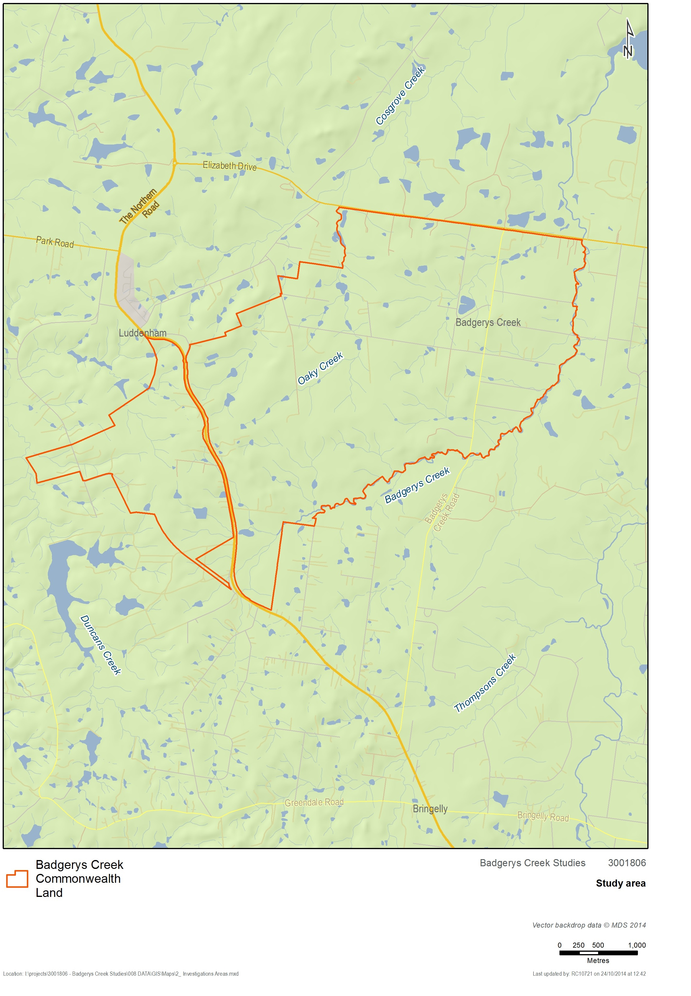
Figure 1: Location of the Study Area

Previous investigations
  - Second Sydney Airport Draft EIS & Supplements
The Second Sydney Airport Draft EIS and Supplementary reports identified biodiversity values of national, state and regional significance at the Badgerys Creek site. Biodiversity values identified in these investigations and their status at that time (1999) are summarised below.
    - National
  - Cumberland Plain Woodland
The Draft EIS and Supplement identified 315 hectares of Cumberland Plain Woodland (CPW) within 46 separate remnants in the study area. About 73 hectares of CPW was assessed as being in moderate condition with the remainder being in poor to very poor condition (48 out of 53 remnants visited). None of the CPW in the study area was assessed as being in good condition. The Draft EIS describes remnants within the study area as of ‘regional significance’. Cumberland Plain Woodland was listed as an Endangered Ecological Community under Schedule 1 of the Commonwealth Endangered Species Protection Act 1992 and Schedule 1 of the NSW Threatened Species Conservation Act 1995 (TSC Act).
Cumberland Plain Woodland has since been listed (in 2009) as a Critically Endangered Ecological Community under the Environment Protection and Biodiversity Conservation Act 1999 (EPBC Act). It is now referred to under the EPBC Act as Cumberland Plain Shale Woodlands and Shale-Gravel Transition Forest.
  - Pultenaea parviflora
The Draft EIS and Supplement identified one plant species of national significance in the study area. Pultenaea parviflora was at the time listed on Schedule 2 (Vulnerable) of the Commonwealth Endangered Species Protection Act 1992. The population was recorded as consisting of approximately 68 individuals occurring on both sides of Longleys Road between Ferndale and Taylors Road.
The population was assessed as being small in size, in good condition and at the southern limit of the species’ distribution which is predominantly the northern Cumberland Plain.
    - State
  - Sydney Coastal River-flat Forest
The Draft EIS and Supplement identified about 19 hectares of River-flat Forest within 17 separate remnants in the study area. All of the River-flat Forest vegetation in the study area was assessed as being in poor to very poor condition. River-flat Forest was listed as the Endangered Ecological Community Sydney Coastal River Flat Forest under Schedule 1 of the TSC Act. It has since (in 2004) been incorporated into the River-flat Eucalypt Forest on Coastal Floodplains EEC.
Although this vegetation in the study area was in poor condition, it is present along Badgerys Creek and was assessed as having regional significance as a riparian wildlife corridor.
  - Cumberland Plain Land Snail
The Cumberland Plain Land Snail was, and still is, listed as endangered under Schedule 1 of the TSC Act. Over 90 individual Cumberland Plain Land Snails were observed within 14 Cumberland Plain Woodland remnants within the Badgerys Creek site during surveys undertaken for the supplementary report. The populations of Cumberland Plain Land Snail present in the study area though fragmented were considered to represent a ‘cluster’ of state significance. These populations are thought to be at the western edge of the known distribution of the species.
  - Green and Golden Bell Frog
The Green and Golden Bell Frog was, and still is, listed as Endangered under the TSC Act. The Supplement to the Draft EIS included targeted surveys and assessment of potential Green and Golden Bell Frog habitat. These investigations concluded that the survey results, previous surveys, and National Parks and Wildlife Service (1998) records for the local area indicated that the Green and Golden Bell Frog is not likely to be present within the sites of the airport options. Based on available information, the Supplementary report concluded that the airport sites are not considered to be significant habitat for the Green and Golden Bell Frog or critical for the survival of the species. Since the 1999 EIS, the Green and Golden Bell Frog has also been listed as vulnerable under the EPBC Act.
  - Eastern Bentwing-bat and Eastern False Pipistrelle
The Eastern Bentwing-bat and Eastern False Pipistrelle were recorded at the Badgerys Creek site during surveys for the Supplement. They were both listed as Vulnerable under Schedule 2 of the TSC Act. There was little discussion of the value of the habitat in the study area for these species in a regional or state context with the report stating that they are mobile species whose regional distribution is poorly known but they are likely to be uncommon. The impact assessment provided did not conclude whether the airport options as proposed in the Supplement to the EIS, would affect the regional distribution of these species.
    - Regional
The Draft EIS and Supplement identified a number of species as being of ‘regional significance’. There is no statutory basis for this status, however, a number of these species have since been listed under the EPBC Act and/or TSC Act.
The Supplementary report lists 48 flora species and 38 fauna species recorded in the study area as being ‘regionally significant’ meaning the Badgerys Creek site is considered to make a substantial contribution to conservation at the Regional level (rather than at the State level).
Benson and McDougall (1991), Benson (1992), Keith (1994) and Bofeldt (1996) are used in the supplement as authorities on species and vegetation of regional significance. Regional significance for fauna is assessed by referring to relevant government reports, consulting experts familiar with the area, referring to the literature and by drawing upon previous field experience of the consultants. Species of regional significance identified in the Western Sydney Urban Bushland Biodiversity Survey reports (NPWS 1997) have also been included.
  - Marsdenia viridiflora subsp. viridiflora
Marsdenia viridiflora subsp. viridiflora was identified in the Draft EIS as a flora species of regional significance. This species is now listed as an endangered population under the TSC Act, ‘Marsdenia viridiflora R. Br. subsp. viridiflora population in the Bankstown, Blacktown, Camden, Campbelltown, Fairfield, Holroyd, Liverpool and Penrith local government areas’.
  - Migratory species
Species listed under International Treaties are those listed under the Japan-Australia Migratory Birds Agreement (JAMBA) and the China-Australia Migratory Birds Agreement (CAMBA).
The Draft EIS and Supplementary report found that the study has potential habitat for five species listed under international agreements. These are the Great Egret, Cattle Egret, Latham’s Snipe, Fork-tailed Swift and White-throated Needletail. These species are now considered MNES under the EPBC Act.
  - Aquatic habitat
The Draft EIS and Supplementary report found that the aquatic value of the Badgerys Creek site was low overall although the streams are of ‘local’ significance. Major habitat degradation was apparent in all streams examined. High flows had facilitated bank erosion and carried high loads of suspended solids which rendered the stream turbid.
Water quality throughout the site was found to be generally poor. This included low levels of dissolved oxygen which were often found to be below the level recommended for support of aquatic fauna, presumably from processes of organic decay and algal respiration. Despite this introduced fish species Gambusia and Carp were found to be common.
High levels of total nitrogen and phosphorous were found at a majority of sample locations, exceeding ANZECC guidelines. High numbers of algal cells were found at selected sites. This was broadly attributed to influences such as agricultural runoff and discharge from intensive farming.
Assessment of aquatic macro invertebrates found an average of 32 percent of animals from the most sensitive category and only 22 percent of animals from the pollutant tolerant group. This suggests that the ecosystem was slightly impoverished but still allows development of sensitive fauna.
  - Western Sydney Urban Bushland Biodiversity Survey
The Western Sydney Urban Bushland Biodiversity Survey (WSUBBS), published in 1997, outlines the type and status of urban bushland in Western Sydney. The study discusses general trends and changes associated with flora and fauna in the area, with specific reference to historic and ongoing threats and conservation and management measures.
While the WSUBBS does not focus on specific areas it does provide an overview of the status of flora, fauna and ecological communities found within and around the Commonwealth-owned land at Badgerys Creek. In particular, the survey notes that Cumberland Plain Woodland (listed as endangered in 1997, rather than the current critically endangered) was under particular threat from clearing for agricultural and residential purposes, alongside several other threats (e.g. invasive species, declining water quality etc.)
The WSUBBS briefly discusses the Badgerys Creek Corridor between The Northern Road and Elizabeth Drive. The report notes the presence of Swamp Oak Forest dominated by Casuarina glauca intergrading with Red Gum-Cabbage Gum Forest and indicates three species considered to be vulnerable in western Sydney that have been recorded in the area: Angophora subvelutina, Eriochloa pseudoacrotricha and Eucalyptus amplifolia. Recommendations arising from the WSUBBS report include the protection of vulnerable plant species and protection of the riparian corridor generally.

Relevant Legislation and Guidelines
  - Commonwealth
    - Environment Protection and Biodiversity Conservation Act 1999
The Environment Protection and Biodiversity Conservation Act 1999 (EPBC Act) is the Australian Government’s central piece of environmental legislation and commenced operation on 16 July 2000. It provides the legal framework to protect and manage nationally and internationally important flora, fauna, ecological communities and heritage places defined in the Act as matters of national environmental significance. In addition, the EPBC Act confers jurisdiction over actions that have a significant impact on the environment where the actions affect, or are taken on, Commonwealth land or are undertaken by the Commonwealth or a Commonwealth agency (even if that significant impact is not on one of the nine matters of ‘national environmental significance’).
The nine matters of national environmental significance (MNES) to which the EPBC Act applies are:
- world heritage properties
- national heritage places
- wetlands of international importance (often called 'Ramsar' wetlands after the international treaty under which such wetlands are listed)
- nationally threatened species and ecological communities
- migratory species
- Commonwealth marine areas
- the Great Barrier Reef Marine Park
- nuclear actions (including uranium mining)
- a water resource, in relation to coal seam gas development and large coal mining development.
MNES considered in this biodiversity report include listed threatened species, populations and ecological communities as well as migratory species protected under international agreements. Particular consideration has been given to threatened biota that occur or could occur in the study area.
  - Cumberland Plain Recovery Plan
The Cumberland Plain Recovery Plan has been prepared under the Commonwealth Environment Protection and Biodiversity Conservation Act 1999 (EPBC Act) and the NSW Threatened Species Conservation Act 1995 (TSC Act) to promote the recovery of threatened species, populations and ecological communities on the Cumberland Plain. The recovery plan aims to guide investment in the recovery of the threatened biodiversity of Western Sydney, and to inform future urban planning decisions.
The Cumberland Plain Recovery Plan addresses the following species that are known or are likely to have habitat within the study area and surrounds:
Table 1: Species that are known or are likely to have habitat within the study area and surrounds
Species/population/community | EPBC Act status | TSC Act status
Flora species
Allocasuarina glareicola | Endangered | Endangered
Dillwynia tenuifolia | Vulnerable | Vulnerable
Juniper-leaved Grevillea (Grevillea juniperina subsp. juniperina) | - | Vulnerable
Micromyrtus minutiflora | Vulnerable | Endangered
Sydney Plains Greenhood (Pterostylis saxicola) | Endangered | Endangered
Pultenaea parviflora | Vulnerable | Endangered
Fauna species
Cumberland Plain Land Snail (Meridolum corneovirens) | - | Endangered
Populations
Marsdenia viridiflora R. Br subsp. viridiflora population in the Bankstown, Blacktown, Camden, Fairfield, Holroyd, Liverpool and Penrith LGAs. | - | Endangered
Ecological communities
Cumberland Plain Woodland (listed under the EPBC Act as Cumberland Plain Shale Woodlands and Shale-Gravel Transition Forest) | Critically Endangered | Critically Endangered
Shale Gravel Transition Forest (listed under the EPBC Act as Cumberland Plain Shale Woodlands and Shale-Gravel Transition Forest) | Critically Endangered | Endangered
Moist Shale Woodland (listed under the EPBC Act as Western Sydney Dry Rainforest and Moist Woodland on Shale). | Critically Endangered | Endangered
River-flat Eucalypt Forest (previously Sydney Coastal River Flat Forest) Endangered | - | Endangered

  - Species Recovery Plans
There are species specific national recovery plans in place for the following EPBC listed threatened species that have potential habitat in the study area:

- Large-eared Pied Bat
- Swift Parrot
- Glossy Black Cockatoo
- Regent Honeyeater
- Persoonia nutans
- Pimelea spicata
- Acacia pubescens

  - Key Threatening Processes
The EPBC Act provides for the identification and listing of key threatening processes. A threatening process is defined as a key threatening process if it threatens or may threaten the survival, abundance or evolutionary development of a native species or ecological community
The following Key Threatening Processes listed under the EPBC Act are likely to be operating within the study area:
- Aggressive exclusion of birds from potential woodland and forest habitat by over-abundant noisy miners (Manorina melanocephala)
- Competition and land degradation by rabbits.
- Dieback caused by the root-rot fungus (Phytophthora cinnamomi).
- Infection of amphibians with chytrid fungus resulting in chytridiomycosis.
- Land clearance.
- Loss and degradation of native plant and animal habitat by invasion of escaped garden plants, including aquatic plants.
- Predation by European red fox.
  - Threat Abatement Plans
Threat abatement plans provide for the research, management, and any other actions necessary to reduce the impact of a listed key threatening process on native species and ecological communities. Threat abatement plans potentially relevant to the study area include:
- Threat abatement plan for competition and land degradation by rabbits.
- Threat abatement plan for disease in natural ecosystems caused by Phytophthora cinnamomi.
- Threat abatement plan for infection of amphibians with chytrid fungus resulting in chytridiomycosis.
- Threat abatement plan for predation by European red fox.
    - National Biodiversity Conservation Strategy
Australia‘s Biodiversity Conservation Strategy (2010-2030) identifies three priorities for action to help stop, and then reverse, the current decline in Australia‘s biodiversity.
- Engaging all Australians in biodiversity conservation.
- Building Ecosystem Resilience in a changing climate.
- Getting measurable results.
The Strategy describes ‘ecosystem resilience’ as the capacity of an ecosystem to respond to changes and disturbances, yet retain its basic functions and structures. It lists a number of threats to ecosystem resilience that are relevant to the study area, including:
- Habitat loss, degradation and fragmentation.
- Invasive species.
- Unsustainable use and management of natural resources.
- Changes to the aquatic environment and water flows.
- Changing fire regimes.
- Climate change.
A priority action identified in the strategy is building ecosystem resilience in a changing climate by:
- Protecting diversity.
- Maintaining and re-establishing ecosystem functions.
- Reducing threats to biodiversity.
    - National Weeds Strategy
Under the National Weeds Strategy, 32 Weeds of National Significance (WoNS) have been identified by Australian governments based on their invasiveness, potential for spread and environmental, social and economic impacts. Individual landowners and managers are ultimately responsible for managing WoNS. Presence of WoNS in the study area is discussed in Section 5.3.2.
    - EPBC Significant Impact Guidelines 1.1 (Matters of National Environmental Significance)
The significant impact guidelines provide overarching guidance on determining whether an action is likely to have a significant impact on a matter protected under national environment law, the EPBC Act.
The purpose of these guidelines is to assist any person who proposes to take an action to decide whether or not they should submit a referral to the Australian Government Department of the Environment (DoE) for a decision by the Australian Government Environment Minister on whether assessment and approval is required under the EPBC Act.
Under the EPBC Act an action will require approval from the minister if the action has, will have, or is likely to have, a significant impact on a matter of national environmental significance. These guidelines outline a ‘self-assessment’ process, including detailed criteria, to assist persons in deciding whether or not referral may be required.
These guidelines would be applied during any future environmental assessment.
    - EPBC Significant Impact Guidelines 1.2: Actions on, or impacting upon, Commonwealth land, and actions by Commonwealth agencies.
These guidelines assist in deciding whether or not to submit a referral to the DoE for a decision by the Australian Government Environment Minister on whether assessment and approval is required under the EPBC Act.
The guidelines apply to:
- any person who proposes to take an action which is either situated on Commonwealth land or which may impact on Commonwealth land, and/or
- representatives of Commonwealth agencies who propose to take an action that may impact on the environment anywhere in the world.
The guidelines outline a ‘self-assessment’ process to assist in determining whether an action is likely to have a significant impact on the environment and are to be considered in conjunction with the EPBC Significant Impact Guidelines 1.1, which deal with matters of national environmental significance.
    - Draft EPBC Act Referral Guidelines for the Vulnerable Koala
These guidelines aim to provide guidance to proponents regarding whether an action is likely to require referral to the Commonwealth Department of the Environment due to impacts on the koala. In doing so the guidelines seek to:
- Promote avoidance and mitigation of significant impacts on the koala.
- Promote and ensure the recovery of the koala through the regulatory requirements of the EPBC Act.
- Promote a clear, consistent and transparent approach for proponents deciding whether to refer an action to the Department for approval and assessment of significant impacts on the koala.
- Promote streamlined decision-making and approval processes.
As the study area is identified as known or likely/potential habitat for the koala these guidelines may be important in any future environmental assessment. Should the koala be identified as likely to be present on the site, the potential impact of proposed activities on the species would need to be considered as part of the assessment.
An initial application of the guidelines has been undertaken based upon feed tree species identified during initial site inspections (Section 5.12.1 ). In this instance the process identified that a referral to the DoE would not be required. It is however advised that this process is repeated for any future environmental assessment in order to confirm these findings. It is also recommended that koala feed trees are specifically searched for and noted when undertaking surveys on behalf of the EIS in order to better inform this process.
    - Significant Impact Guidelines for the Green and Golden Bell Frog
This policy statement is designed to assist in determining whether a proposed action is likely to have a significant impact on the green and golden bell frog. This policy statement provides guidance to project proponents on how they can meet applicable legal obligations of the EPBC Act. It guides the user through several phases broadly based around the following questions:
- Does the site support the green and golden bell frog?
- What impacts (direct and indirect) could result from the action?
- Could any of these impacts exceed the impact thresholds?
- What measures could be taken to reduce the level of impact?
These guidelines also include best practice survey methodology. It is recommended that any amphibian surveys undertaken at the site take account of these during design and implementation.
Advice on avoidance or mitigation of significant impacts upon green and golden bell frog populations and individuals are also provided. It is recommended that these potential actions are recognised early for the existing and future management of the site and in any future environmental assessment.
    - EPBC Act Administrative Guidelines on Significance - Supplement for the Grey-headed Flying-fox
The purpose of this document is to provide general guidance to assist in determining whether a proposed activity is likely to have a significant impact on the grey-headed flying fox and whether a referral to DoE is required. These guidelines provide guidance to project proponents on how they can meet applicable legal obligations of the EPBC Act.
Whilst the guidelines are aimed primarily at the 2003-2004 fruiting season it also provides pertinent information on the ecology of the grey-headed flying fox and the legislative implications of disturbance and certain types of management actions. This is relevant to the Badgerys Creek site as desktop surveys found this species has been identified within 10 km of the site.
    - EPBC Species Survey Guidelines
The Commonwealth Department of the Environment have prepared a range of survey guidelines that provide advice on survey techniques for specific threatened species and give guidance on the Department's expectations with regard to surveys. The following survey guidelines are available:
- Survey Guidelines for Australia's threatened Bats.
- Survey Guidelines for Australia's threatened Birds.
- Survey Guidelines for Australia's threatened Frogs.
- Survey guidelines for Australia's threatened fish.
- Survey guidelines for Australia's threatened mammals.
- Survey guidelines for Australia's threatened reptiles.
- Draft survey guidelines for Australia's threatened orchids.
It is recommended that these guidelines are consulted as part of any future environmental assessment. It is recommended that all field surveys are undertaken to these standards, where relevant.
    - EPBC Environmental Offsets Policy and Offsets Assessment Guide
The EPBC Environmental Offsets Policy provides guidance on the role of offsets in environmental impact assessments, and how the DoE considers the suitability of a proposed offset. It aims to improve environmental outcomes through the consistent application of best practice offset principles, provide more certainty and transparency, and encourage advanced planning of offsets.
Offsets are measures that compensate for the residual impacts of an action on the environment, after avoidance and mitigation measures are taken. Where appropriate, offsets are considered during the assessment phase of an environmental impact assessment under the EPBC Act. The suitability of a proposed offset is considered as part of the decision to approve or not approve a proposed action under the EPBC Act.
The Offsets assessment guide, which accompanies the policy, utilises a balance sheet approach to measure impacts and offsets. It applies where the impacted protected matter is a threatened species or ecological community. The Offsets assessment guide is a tool that has been developed for DoE staff to assess the suitability of offset proposals. The guide is also available to proponents to assist with planning for future development proposals and estimating future offset requirements.
  - New South Wales
    - Threatened Species Conservation Act 1995
The NSW Threatened Species Conservation Act 1995 (TSC Act) protects threatened flora and fauna species, endangered populations and ecological communities and their habitats within NSW. This report describes threatened species, populations or ecological communities that occur or could occur in the study area. They are discussed in Section 5.5, 5.6, and Appendix 3 of this report.
  - Recovery Plans
In addition to the national recovery plans identified in Section 3.1.1 under the EPBC Act, a NSW Recovery Plan is in place for the Large Forest Owls Powerful Owl (Ninox strenua), Sooty Owl (Tyto tenebricosa) and Masked Owl (Tyto novaehollandiae) (DEC, 2006a).
  - Threatened Species Priority Action Statement (PAS)
The NSW Threatened Species Priorities Action Statement (PAS) identifies strategies to help recover threatened plants and animals and establishes priorities to implement these strategies. The PAS identifies actions for all listed species, populations and ecological communities. It also identifies actions to manage listed key threatening processes.
  - Key Threatening Processes
A threat can be listed under the Threatened Species Conservation Act 1995 (TSC Act) as a 'key threatening process' if it adversely affects threatened species, populations or ecological communities or if it could cause species, populations or ecological communities that are not threatened to become threatened. Key threatening processes are considered in an assessment of significance where a proponent considers whether a development constitutes or exacerbates a key threatening process. Key threatening processes relevant to the study are considered in Section 5.13.
  - Threat Abatement Plans
A threat abatement plan (TAP) is a statutory document prepared and approved in accordance with the TSC Act. Ministers and public authorities are required to take any appropriate action available to them to implement the measures in the plan. The terms of threat abatement plans are to be taken into account by consent and determining authorities when they are considering development applications under the planning legislation. TAPs relevant to the study area are considered in Section 5.13.
  - Threatened Species Survey and Assessment Guidelines
The NSW OEH has prepared the Threatened Species Survey and Assessment Guidelines to inform the process of survey and assessment of threatened biodiversity by describing and discussing:
- the chronological steps within the threatened biodiversity assessment process;
- the strategies, policies and legislation relevant to threatened biodiversity;
- appropriate survey techniques for detecting threatened biodiversity;
- the information required for an Assessment of Significance; and
- reporting requirements and standards.
The Guidelines aim to provide a consistent and systematic approach to survey and assessment of threatened biodiversity. In particular, the guidance provided will assist in:
- setting appropriate aims for survey and assessment of threatened biodiversity;
- the planning of suitable survey techniques and the appropriate level of effort;
- the provision of adequate reporting;
- a justifiable interpretation of results; and
- making an informed and justifiable decision.
It is intended that they are adapted to fit the requirements of individual animal and plant surveys by outlining field techniques and considerations, relevant legislation, and the relevant method of impact assessment for threatened biodiversity. The Guidelines will assist applicants, proponents, investigators and decision-makers by identifying their responsibilities, outlining relevant procedures and providing considerations for the interpretation of results.
  - Species specific impact assessment guidelines
The NSW Office of Environment and Heritage has prepared Environmental Impact Assessment (EIA) Guidelines for the following species, populations and ecological communities that are known or have potential habitat in the study area. The guidelines include species specific survey requirements.

- Cynanchum elegans
- Dillwynia tenuifolia
- Pultenaea parviflora
- Acacia pubescens
- Grevillea juniperina
- Grevillea parviflora
- Pimelea spicata
- Green and Golden Bell Frog
- Cumberland Plain Land Snail

The following best practice guidelines are also available for management:
- Recovering Bushland on the Cumberland Plain Best Practice Guidelines.
- Best Practice Guidelines for the Grey-headed Flying-fox.
    - Fisheries Management Act 1994
The Fisheries Management Act 1994 protects fishery resources within the State. The objectives of the Act include the conservation of fish stocks and key fish habitats, threatened species, populations and ecological communities of fish and marine vegetation.
Section 5.10 of this report considers potential habitat of threatened fish species that may occur in the study area.
  - Policy and guidelines for fish habitat conservation and management
This NSW Department of Primary Industries (DPI) developed the Policy and guidelines for fish habitat conservation and management to promote compliance with legislation relating to fish habitat conservation and management. It aims to assist local and state government authorities, proponents of developments and their advisers, and individuals or non-government organisations concerned with the planning and management of aquatic resources.
NSW DPI takes these policies and guidelines into account when assessing and either approving or refusing proposals for developments or other activities affecting fish habitats, with a particular focus on ‘key fish habitats’.
    - Noxious Weeds Act 1993
Under the NSW Noxious Weeds Act 1993, public authorities are required to control noxious weeds which are likely to spread to adjoining land. Section 5.3.2 of this report considers weeds declared as noxious in the Liverpool LGA that occur within the study area.
    - Environmental Planning and Assessment Act
The Environmental Planning and Assessment Act 1979 (EP&A Act) is the primary law regulating land use in NSW. The EP&A Act provides for environmental planning instruments (EPI) to be made to guide the process of development and to regulate competing land uses. Currently, there are two types of EPIs under the Act:
- Local environmental plans (LEP) that guide planning decisions for a local government area (LGA).
- State environmental planning policies (SEPP) that address planning issues of State or regional within NSW.
The EPIs specify what types of development are allowed in an area, whether development consent is required and what type of assessment must be undertaken before consent is granted.
The EP&A Act makes a distinction between development undertaken by public authorities and that by other developers. Generally, public authorities are exempted from the need to obtain development consent. However, for proposals where a significant environmental impact is likely approval from the Minster for Planning is required. The application for approval must be supported by an EIS prepared under either Part 5 (for an activity that is not State Significant Infrastructure, SSI) or Part 5.1 (for an activity that is SSI).
  - SEPP 44 Koala Habitat Protection
The application of SEPP 44 to State major projects is not a legislative requirement, however consistent with good environmental assessment practice the provisions of SEPP 44 are often considered.
The objective of SEPP 44 is to encourage the proper conservation and management of areas of natural vegetation that provide habitat for koalas to ensure a permanent free-living population over their present range and reverse the current trend of koala population decline. The SEPP requires the preparation of plans of management before development consent can be granted in relation to areas of core koala habitat. The State Environmental Planning Policy (SEPP) 44 (Koala Habitat Protection) is considered in this report as areas identified under this SEPP may be impacted by the project. Section 5.12 of this biodiversity report includes an assessment of whether the study area contains koala habitat as defined by the policy.
  - SEPP 19 Bushland in Urban Areas
SEPP 19 protects and preserves bushland within certain urban areas (including Liverpool LGA) as part of the natural heritage or for recreational, educational and scientific purposes. The policy is designed to protect bushland in public open space zones and reservations, and to ensure that bush preservation is given a high priority when local environmental plans for urban development are prepared.
    - NSW Biodiversity Strategy
The NSW (Draft) Biodiversity Strategy (2010 – 2015) identifies the following key themes and measurable targets that will contribute to building ecosystems that are healthy and resilient.
Table 2: NSW (Draft) Biodiversity Strategy (2010 – 2015) key themes and targets
Key Theme | Targets
Smarter Biodiversity Investment | By 2015, state-scale priorities are incorporated into biodiversity and related planning processes including Catchment Action Plan updates and plans of management for reserves and other public lands.  By 2015, standard site-assessment tools have been taken up by public and private conservation organisations in New South Wales.  By 2015, recovery and threat abatement efforts will reflect the priorities set out in the Priorities Action Statements under the TSC Act and FM Act.
Whole of Landscape Planning | By 2015, regional land-use planning processes are informed by landscape scale biodiversity assessment and contain provisions that contribute to the protection of biodiversity.
Improved Partnerships | By 2015, there is a 25% increase in employment and participation of Aboriginal people in natural resource management, including biodiversity conservation.
Effectively Managing Threats | Selected Statewide NRM targets will inform the evaluation of the effectiveness of actions for this theme (Appendix 5 of Draft Strategy).
Sustainable Production Environments | Selected Statewide NRM targets will inform the evaluation of the effectiveness of actions for this theme (Appendix 5 of the Draft Strategy)
The strategy broadly maps priority areas for investment in native vegetation management across NSW. Grassy woodlands are mapped as a priority for investment in some locations, including the Cumberland Plain, but are limited to the larger, better condition remnants with good landscape connectivity.
    - NSW Biodiversity Offset Policy
The NSW Biodiversity Offset Policy for Major Projects (2014) clarifies, standardises and improves biodiversity offsetting for major project approvals. The policy applies to state significant development and state significant infrastructure under the EP&A Act.
The policy aims to strike an effective balance between the needs of proponents, communities and the environment by:
- providing clear, efficient and certain guidance for stakeholders
- improving outcomes for the environment and communities
- providing a practical and achievable offset scheme for proponents.
The policy is underpinned by the Framework for Biodiversity Assessment (FBA). The FBA sets out the process for:
- assessing biodiversity impacts on a proposed development site
- determining the biodiversity offset requirements for those impacts.
The Framework for Biodiversity Assessment Credit Calculator is a decision support tool that should be used in conjunction with the FBA. It is largely based on the biobanking credit calculator. It will assist proponents and ecological consultants to calculate the number and type of credits required to offset the impacts of a major project on biodiversity and estimate the approximate area of land required for an offset.
  - Regional
    - Liverpool Biodiversity Management Plan 2012
The purpose of the Liverpool Biodiversity Management Plan (Liverpool Council 2012) is to provide an implementation framework for the protection and management of biodiversity at the local, and where relevant, regional scale. This Plan is concerned with the conservation and management of native plants and animals, genetic variations, ecosystems and ecological processes which occur within, or are dependent upon, the Liverpool LGA.
The BMP discusses the distribution of endangered ecological communities across the LGA and sets targets for their protection. It also maps regional connectivity (or corridors) across the LGA.
    - Greater Sydney Local Land Service Transition Catchment Action Plan 2013-2023
The Greater Sydney Local Land Service Transition Catchment Action Plan (CAP) (Greater Sydney Local Land Service 2013) is a ten year plan to guide the management of water, land and vegetation by the community and government. The CAP identifies a number of priorities that are relevant to the study area. These include:
- Identification of the Cumberland Plain as a priority area for investment in native vegetation management. High priority sites for management of Cumberland Plain Woodland are identified in the study area.
- Research into Grey Box dieback on the Cumberland Plain and trialling of management options.
- Key weed projects including African Olive on Cumberland Plain.
- Improving aquatic and terrestrial habitat condition, connectivity and recreational value.

- Methodology
  - Database searches and literature reviews
Desktop research was undertaken prior to the commencement of field surveys and included database searches and a review of relevant literature to help identify threatened biota known or likely to occur in the study area.
The following databases and resources were investigated:
- NSW Office of Environment and Heritage (OEH) Atlas of NSW Wildlife Database within a 10 kilometre buffer of the site (OEH 2014a).
- Commonwealth Protected Matters Search to identify all Matters of National Environmental Significance (MNES) within 10 km of the site. MNES include threatened species, communities and migratory species which are listed under the EPBC Act (Department of Environment 2014b).
- NSW Flora Online Search – Rare or Threatened Australian Plants (ROTAP) species (The Royal Botanic Gardens and Domain Trust 2014).
- NSW OEH (2012) NSW Native Vegetation Types Database, Vegetation Benchmarks Database, Threatened Species Profile Database.
- NSW NPWS (2002f) Native Vegetation of the Cumberland Plain, Western Sydney.
- NSW NPWS (1997) Western Sydney Urban Bushland Biodiversity Survey.
- Department of Primary Industry – Fishing and Aquaculture: Threatened and Protected Species, Wyong Shire Council LGA (DPI, 2014).
- NSW Department of Primary Industries records viewer (DPI, 2014a), http://www.dpi.nsw.gov.au/fisheries/species-protection/records/viewer.
- NSW Department of Primary Industries Noxious Weeds List (DPI, 2014b).
- Previous ecological reports prepared as part of the Second Sydney Airport Draft Environmental Impact Statement in 1999 and associated supplementary reports.
- BoM (2014) Groundwater Dependent Ecosystems Atlas.
Survey methods were developed following a review of the relevant DoE Survey Guidelines for Nationally Threatened Species, Threatened Species Survey and Assessment: Guidelines for developments and activities (working draft) (DEC 2004) and the Native Vegetation Interim Type Standard (DECCW 2010a).
  - Field survey
A terrestrial flora survey and fauna habitat assessment of the study area was conducted on 22, 23 and 25 September 2014. Field survey aimed to ground truth existing vegetation mapping, describe vegetation and habitat type and condition in more detail and identify any areas of higher quality vegetation habitat that could support threatened species potentially occurring in the study area.
The field surveys undertaken by SMEC in September 2014 added to, and updated, previous flora and fauna surveys undertaken by Biosis in the study area in preparation of the Second Sydney Airport Draft Environmental Impact Statement (1999).
    - Flora surveys
Figure 2 shows the existing vegetation community mapping undertaken by NPWS (2002f). The majority of the biodiversity study area has been mapped as Shale Hills Woodland (MU9), Shale Plains Woodland (MU10) and Alluvial Woodland (MU11). The remainder of the study area appears to be cleared of vegetation and has not been mapped.
Survey sites were selected via desktop analysis of aerial photography. Sites were selected within patches of vegetation most likely to meet the definition of EPBC listed Cumberland Plain Shale Woodlands and Shale-Gravel Transition Forest (CPW). This process involved using the NPWS (2002f) vegetation mapping to select polygons of Shale Plains Woodland and Shale Hills Woodland with greater than ten per cent canopy cover and within a patch of at least five hectares in size. Desktop mapping of EPBC listed CPW and selected field survey sites are shown in Figure 3.
Specific plot locations were selected within each of these sites while in the field. Plots were selected so as to provide a representative account of vegetation and communities present.
A total of 12 sites (with one plot each) were surveyed throughout the study area. Vegetation plot assessments were undertaken within each site, with data collected in a 20 metre x 20 metre quadrat. Information recorded included dominant native species in each strata, per cent cover and abundance, native species richness and exotic species cover. Results of these assessments are presented in Section 5.3.1 and Appendix 2.
Two of the sites assessed were additional to those initially proposed. The two additional sites were located along Badgerys Creek and were selected in order to provide a sample of riparian vegetation present in the area.
In addition to plot assessments additional observations of vegetation type and condition were made throughout the study area. These included opportunistic observation of the condition of ‘cleared’ land to assess whether the remaining grassland contained native vegetation. These observations were used in conjunction with plot data and aerial photography to confirm (ground-truth) existing vegetation mapping and assist in calculating approximate patch sizes of vegetation communities.
Outside of plots the random meander technique (Cropper 1993) was used to target areas in the vicinity of previously identified locations of threatened flora species. These searches focused specifically on Pultenaea parviflora along Longleys Road and Anton Road as well as Marsdenia viridiflora subsp. viridiflora along Badgerys Creek Road in the north of the study area. Searches were also undertaken in suitable habitat near to an old record of Acacia pubescens referred to in the recovery plan for this species, on a property on Longleys Road. Further searches were undertaken for an old herbarium record of A. pubescens on Elizabeth Drive at Badgerys Creek referred to in the WSUBBS report (NPWS 1997).
    - Fauna habitat assessment
Fauna habitat assessment was conducted to assist in determining the likelihood of presence of threatened fauna species. Habitat assessments were focused at sites where vegetation assessment plots were undertaken, though opportunistic observations throughout the study area were also recorded.
Habitat characteristics considered include the presence of nectar-producing plants, hollow bearing trees, fallen logs, leaf litter and other ground debris, drainage lines, ponds, the structure of vegetation communities and the presence of fruiting/flowering plant species to assess the habitat suitability for a range of fauna species.
Using the random meander technique (Cropper 1993), searches were carried out for signs of fauna activity such as tracks, scats, scratches and notches on trees, as well as any opportunistic sightings, to identify the presence of common and threatened fauna species.
  - Limitations
Limitations to the flora and fauna surveys, which may affect biodiversity survey results, include:
- This report provides a broad appraisal of the biodiversity values of the study area, however it is not a detailed investigation of all relevant ecological characteristics.
- Access to parts of the study area for field survey was limited due to time constraints and landholder notification requirements.
- Vegetation survey was limited to 12 vegetation plot assessments at selected locations, mainly targeting better condition EPBC listed CPW. Detailed floristic surveys and vegetation community diagnostic analyses were not undertaken in relation to plot data.
- The flora surveys conducted in September 2014 allowed some validation of the existing Cumberland Plain vegetation mapping (NPWS 2002f). This provided a high level of confidence in the plant communities identified broadly across the study area and associated threatened species that may occur.
- Threatened flora surveys were limited to known locations of Pultenaea parviflora, Marsdenia viridiflora subsp. viridiflora and Acacia pubescens. No seasonal surveys were undertaken for threatened flora across the whole study area.
- While fauna habitat assessments were undertaken, this technique is not a complete substitute for fauna surveys. Fauna are capable of inhabiting sub-optimal habitat. In addition fragmentation, isolation or species density can all influence the presence and distribution of a particular species. Species likelihood of occurrence was informed by habitat characteristics and opportunistic sightings. For the purposes of this biodiversity report, threatened fauna species known to occur in the locality are assumed to use the site if suitable habitat is present. No seasonal fauna survey or trapping was undertaken.
- No aquatic survey was undertaken of Badgerys Creek or other drainage lines in the study area. Species likelihood of occurrence was informed by previous ecological reports, habitat characteristics and opportunistic sightings.
Based on these limitations all survey results arising from this study should be viewed as a ‘snapshot’ of the biodiversity assets and values at a point in time. These results are unlikely to be able to be used as the ‘before’ element in any BACI (before, after, control, impact) assessment undertaken at the site.
The compressed timeframe in which the field assessment was undertaken has meant that a sampling and ground-truthing approach has been taken. As such surveys may not have included all individuals, populations or communities that may be present within the site. It is recommended that any assessment of the site in support of future development employ a an approach that adequately captures all ecological assets in at an appropriate level of detail.
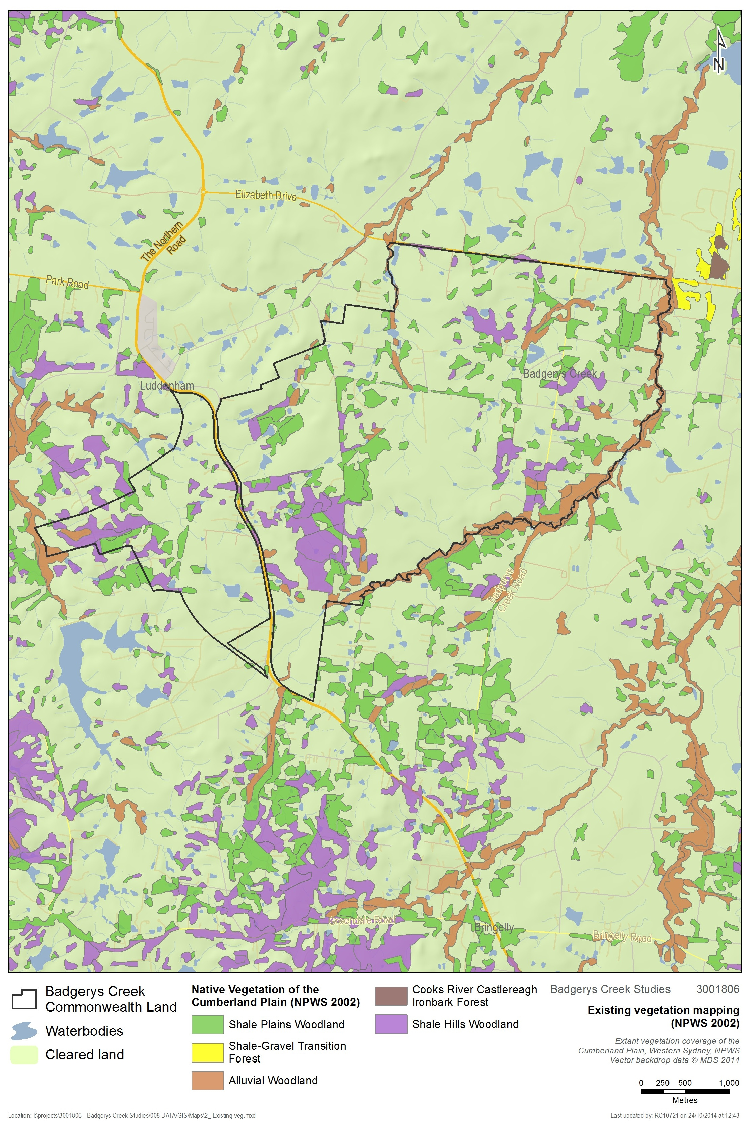
Figure 2: Existing vegetation mapping (NPWS 2002f)
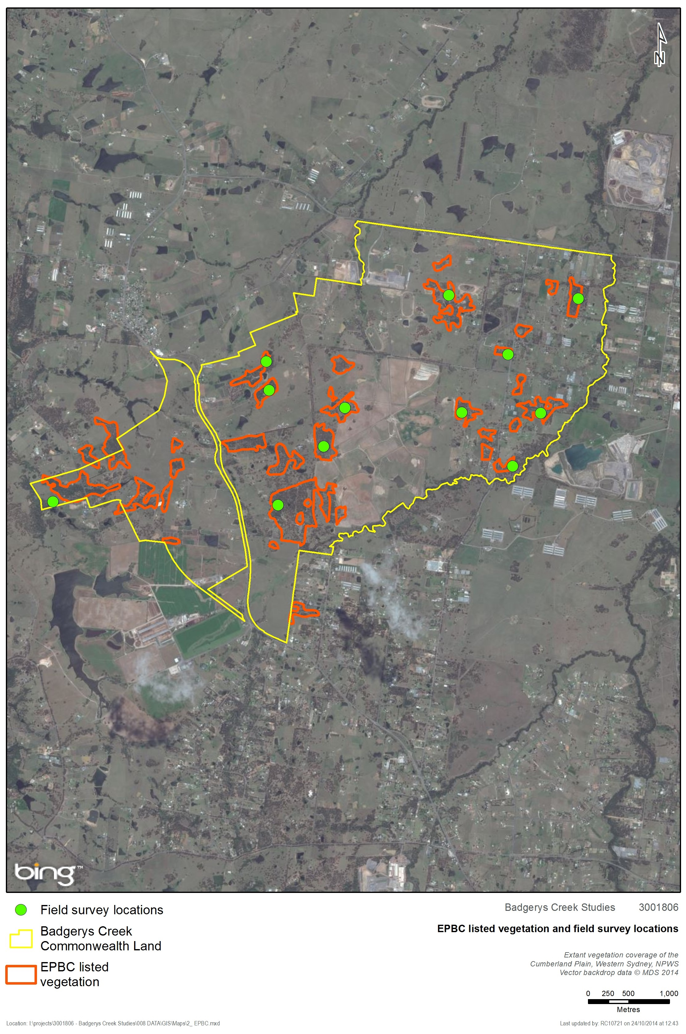
Figure 3: Survey sites and candidate EPBC listed CPW
- Existing Environment
  - Landscape context
The study area is located in the Hawkesbury-Nepean catchment and the Cumberland subregion of the Sydney Basin bioregion. The study area is within the Liverpool City Council local government area (LGA).
The topography of the study area is generally level with undulating areas associated with drainage lines. There are two main watercourses on the site: Badgerys Creek and Oaky Creek. Badgerys Creek itself runs broadly along the eastern margin of the study area, from the south-west to the north, and is moderately vegetated. Several large farm dams are present throughout the study area.
The western side of the site is transected by the Luddenham Dyke, a natural subsurface wall two to three metres wide and approximately eight kilometres long, forming an elevated ridge (DTRD 1997).
Elevation across the site varies between approximately 49 m and 97 m.
The underlying geology of the study area is Wianamatta Shale, which is overlain by Quaternary alluvial gravel, sand, silt and clay. Large-scale mapping of Soil Landscape Series Sheet 9030 (Bannerman & Hazelton 1990) indicate the influence of three Soil Landscape Groups in the study area: the Luddenham, Blacktown and South Creek Soil Landscape Units. The likelihood of the presence of Acid Sulphate Soils is considered to be low (DTRD 1997).
The Commonwealth-owned land at Badgerys Creek is located in the south-west portion of the Cumberland Plain, on the eastern side of the elevated ridge system dividing the catchments of the Nepean River and South Creek. The Cumberland Plain has an average elevation of about 20 metres above sea level in the north, rising to about 150 metres in the south around Bringelly, Camden and Campbelltown, a distance of about 50 kilometres. The elevated ridge system on which the site is located begins to rise at Orchard Hills in the north and extends to Bringelly and Cobbitty, where it broadens into an elevated plain.
  - Land use
The study area is largely comprised of small to medium sized rural holdings, with the majority of these dedicated to grazing of livestock. Part of the south eastern portion of the site is industrial-agricultural with the presence of a poultry hatchery facility. The area includes some residential areas, as well as community facilities such as Badgerys Creek Public School, Badgerys Creek Park and Hubertus Country Club.
The Boral Badgerys Creek Brickworks is located outside the Commonwealth land, within the south-east portion of the study area. The brickworks includes several disused quarry areas, a large tailings dam, the kiln building and a large brick storage area. The site was closed for production purposes in 2012, though still operates as a brick selection centre.
Areas of remnant vegetation are present generally as fragments amongst otherwise cleared agricultural areas. Large portions of the study area’s remnant vegetation are composed of native overstorey with cleared/grassland understorey.
The study area is zoned Commonwealth Land and nearby land is zoned R1.
  - Vegetation communities
Native vegetation in the study area comprises mostly Shale Plains Woodland in varying condition with Alluvial Woodland present along Badgerys Creek and other drainage lines in the study area. There are also small areas of Shale Gravel Transition Forest and Moist Shale Woodland. The extent of particularly these latter two communities would need to be verified with more detailed survey of remnant vegetation.
The Native Vegetation of the Cumberland Plain undertaken by NPWS (2002f) identifies three native plant communities within the study area (Figure 2):
- Shale Plains Woodland (MU10)
- Shale Hills Woodland (MU9)
- Alluvial Woodland (MU11)
Field surveys undertaken by SMEC in 2014 also identified the presence of:
- Shale Gravel Transition Forest (MU103), and
- Moist Shale Woodland (MU14).
Equivalent EPBC Act, NSW TSC Act and NSW Plant Community Type names are provided in Appendix 1.
The Shale Plains Woodland and Shale Hills Woodland vegetation communities mapped in the study area meet the definition of Cumberland Plain Shale Woodlands and Shale-Gravel Transition Forest, a Critically Endangered Ecological Community under the Commonwealth EPBC Act. This vegetation is also listed as a Critically Endangered Ecological Community under the NSW TSC Act and its listed name is Cumberland Plain Woodland in the Sydney Basin Bioregion. Shale Plains Woodland is also equivalent to the NSW Plant Community Type 849 Grey Box - Forest Red Gum grassy woodland on flats of the Cumberland Plain, Sydney Basin in the NSW Vegetation Types Database (OEH 2012). Shale Hills Woodland is equivalent to NSW PCT 850 Grey Box - Forest Red Gum grassy woodland on shale of the southern Cumberland Plain, Sydney Basin. This vegetation type occurs across most of the study area.
The Shale Gravel Transition Forest observed in the study area during field survey also meets the definition of Cumberland Plain Shale Woodlands and Shale-Gravel Transition Forest under the EPBC Act. It is listed under the TSC Act as Shale Gravel Transition Forest and is equivalent to NSW PCT 724 Broad-leaved Ironbark - Grey Box - Melaleuca decora grassy open forest on clay/gravel soils of the Cumberland Plain, Sydney Basin.
The Moist Shale Woodland observed in the study area during field survey also meets the definition of Western Sydney Dry Rainforest and Moist Woodland on Shale listed under the EPBC Act. It is listed under the TSC Act as Moist Shale Woodland and is equivalent to NSW PCT 830 Forest Red Gum - Grey Box shrubby woodland on shale of the Cumberland Plain, Sydney Basin.
The Alluvial Woodland vegetation mapped in the study area is not listed under the EPBC Act, however it is listed at the state level under the NSW TSC Act as River Flat Eucalypt Forest on Coastal Floodplains of the NSW North Coast, Sydney Basin and South East Corner Bioregions.
Further detail on vegetation of the study area is provided below in Section 5.3.1 and 5.5.
    - Field Survey Results
Field survey broadly confirmed the accuracy of the NPWS (2002f) mapping, with most sites being confirmed as Shale Plains Woodland (MU10) or Alluvial Woodland (MU11) along drainage lines. However there did seem to be some departure from the mapped vegetation community and what was observed on the ground for some of the sites.
One of the sites surveyed (Plot 3) appeared to be a better match with Moist Shale Woodland (MU14).
Shale Gravel Transition Forest (MU103) was also observed at Plot 5. This community was not mapped in the study area by NPWS (2002f). Further delineation of vegetation at the site was undertaken based on observed condition.
The vegetation type and condition shown in Figure 4 is largely based upon existing vegetation mapping but also incorporates results of the twelve vegetation plot assessments undertaken during field survey in September 2014.
Table 3: Description of vegetation within each zone
Plot | 1
Location | 55 Longleys Road. Rural property cattle grazing.  Blacktown soil landscape.
Condition | Moderate.
Description | Moderate condition patch of advanced regeneration Shale Plains Woodland canopy 12 m to 15 m high comprised Cabbage Gum (Eucalyptus amplifolia) and Broad-leaved Ironbark (Eucalyptus fibrosa). No hollow-bearing trees observed. Open mid-storey comprised of Blackthorn (Bursaria spinosa) and Dillwynia sieberi. Mixed native and exotic groundcover with dominant grasses being Weeping Meadow Grass (Microlaena stipoides), Kangaroo Grass (Themeda australis) and Barbed Wire Grass (Cymbopogon refractus). Wattle Mat-rush (Lomandra filiformis) and Blue Trumpet (Brunoniella australis) are also common. Total native species richness in a 20m x 20m plot = 30.  Main weeds present in the groundcover include Fireweed (Senecio madagascariensis), Paddys Lucerne (Sida rhombifolia) and Scotch Thistle (Onopordum acanthium).  Resilience moderate, likely to have viable soil seed bank, regeneration would require ongoing management including fencing, weed control and appropriate fire management. No dead trees observed in the canopy.
NPWS (2002) veg community | Shale Plains Woodland (MU10).
EPBC name | Cumberland Plain Shale Woodlands and Shale-Gravel Transition Forest.
TSC name | Cumberland Plain Woodland.
NSW PCT | Grey Box - Forest Red Gum grassy woodland on flats of the Cumberland Plain, Sydney Basin (BioMetric code: HN528, NSW plant community type: 849).
Photo | 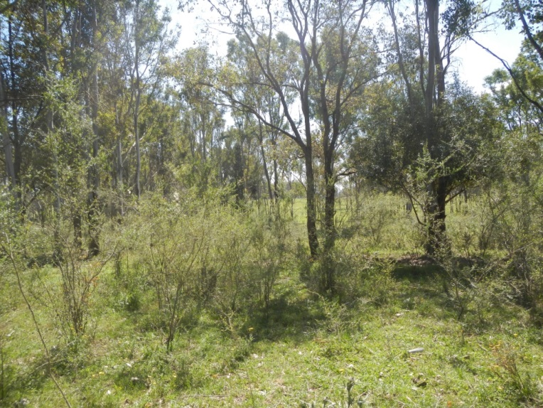

Plot | 2
Location | 55 Longleys Road. Rural property cattle grazing.  Blacktown soil landscape.
Condition | Moderate.
Description | Moderate condition patch of advanced regeneration Shale Plains Woodland, canopy 5 m to 20 m high comprised of Forest Red Gum (Eucalyptus tereticornis) and Grey Box (Eucalyptus moluccana). No hollow-bearing trees observed. Moderately dense mid-storey (about 40% cover) comprised of Blackthorn (Bursaria spinosa). Predominantly native groundcover with Weeping Meadow Grass (Microlaena stipoides), Blue Trumpet (Brunoniella australis) and Indian Pennywort (Centella asiatica). Total native species richness = 22.  Low weed cover with only scattered weeds in the mid-storey and groundcover such as African Olive (Olea europaea ssp. cuspidata) Fireweed (Senecio madagascariensis) and Paddys Lucerne (Sida rhombifolia).  Resilience moderate, likely to have viable soil seed bank, regeneration would require ongoing management including fencing, weed control and appropriate fire management. No dead trees observed in the canopy. Adjoining patch of vegetation has significant infestation of African Boxthorn (Lycium ferocissimum) and Apple of Sodom (Solanum linnaeanum).
NPWS (2002) veg community | Shale Plains Woodland (MU10).
EPBC name | Cumberland Plain Shale Woodlands and Shale-Gravel Transition Forest.
TSC name | Cumberland Plain Woodland.
NSW PCT | Grey Box - Forest Red Gum grassy woodland on flats of the Cumberland Plain, Sydney Basin (BioMetric code: HN528, NSW plant community type: 849).
Photo | 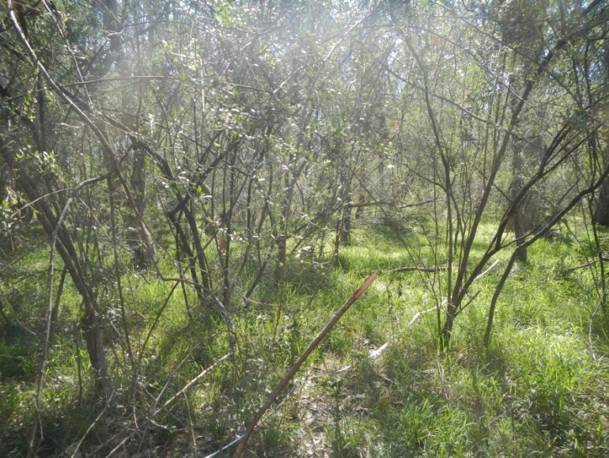

Plot | 3
Location | 1850 The Northern Road. Rural property, horse agistment.  Blacktown soil landscape.
Condition | Moderate.
Description | Moderate condition patch of advanced regeneration Moist Shale Woodland, canopy 15 m to 20 m high comprised of Grey Box (Eucalyptus moluccana). No hollow-bearing trees observed. Moderately dense mid-storey comprised of Blackthorn (Bursaria spinosa) of about 50% cover. Mixed native and exotic groundcover with Weeping Meadow Grass (Microlaena stipoides), Plump Windmill Grass (Chloris ventricosa) and Winter Apple (Eremophila debilis). Total native species richness = 29.  There is some African Olive (Olea europaea ssp. cuspidata) present in the mid-storey (about 10% cover). Main weeds present in the groundcover include Paddys Lucerne (Sida rhombifolia) and Bridal Creeper (Asparagus asparagoides).  Resilience moderate, likely to have viable soil seed bank, regeneration would require ongoing management including fencing, weed control and appropriate fire management. No dead trees observed in the canopy.
NPWS (2002) veg community | Moist Shale Woodland (MU14).
EPBC name | Western Sydney Dry Rainforest and Moist Woodland on Shale.
TSC name | Moist Shale Woodland
NSW PCT | Forest Red Gum - Grey Box shrubby woodland on shale of the Cumberland Plain, Sydney Basin (BioMetric code: HN524, NSW plant community type: 830).
Photo | 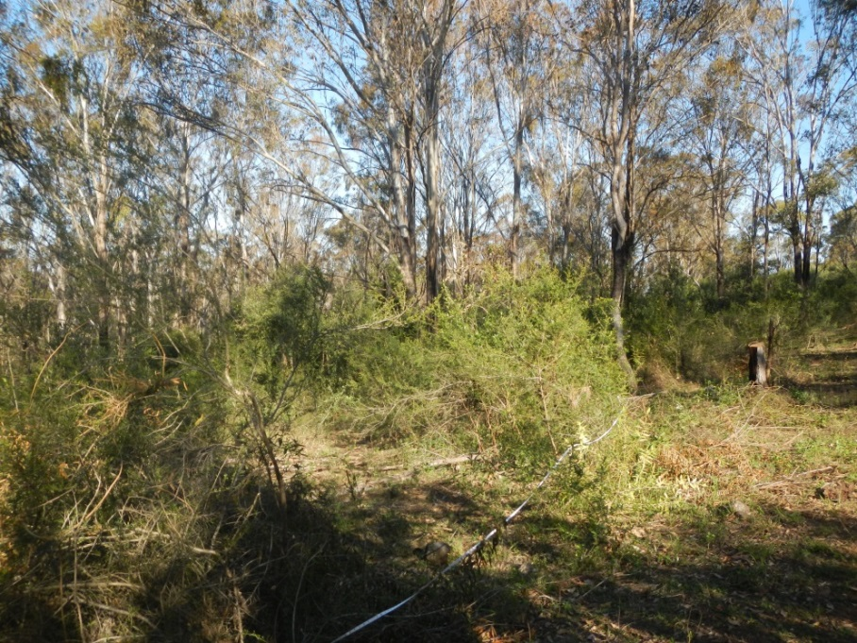

Plot | 4
Location | 365 Willowdene Ave. Low intensity horse grazing. Property largely natural. Luddenham soil landscape.
Condition | Moderate to Good.
Description | Moderate to good condition patch of advanced regeneration Cumberland Plain Woodland, canopy 6 m to 25 m high comprised of Grey Box (Eucalyptus moluccana) and Forest Red Gum (E. tereticornis). One hollow-bearing tree observed. Open mid-storey comprised of Blackthorn (Bursaria spinosa). Mostly native grassy understorey dominated by Weeping Meadow Grass (Microlaena stipoides), Plump Windmill Grass (Chloris ventricosa) and Kangaroo Grass (Themeda australis). Slender Tick-trefoil (Desmodium varians), Berry Saltbush (Einadia hastata) and Forest Nightshade (Solanum prinophyllum) are also present. Total native species richness = 23.  Some patches of the property mainly near the creekline have African Olive (Olea europaea ssp. Cuspidata) infestation.  Resilience good, likely to have viable soil seed bank, regeneration would require ongoing management including fencing, weed control and appropriate fire management. No dead trees observed in the canopy. Adjoining areas cleared of canopy are high probability derived native grasslands.
NPWS (2002) veg community | Shale Plains Woodland (MU10).
EPBC name | Cumberland Plain Shale Woodlands and Shale-Gravel Transition Forest.
TSC name | Cumberland Plain Woodland.
NSW PCT | Grey Box - Forest Red Gum grassy woodland on flats of the Cumberland Plain, Sydney Basin (BioMetric code: HN528, NSW plant community type: 849).
Photo | 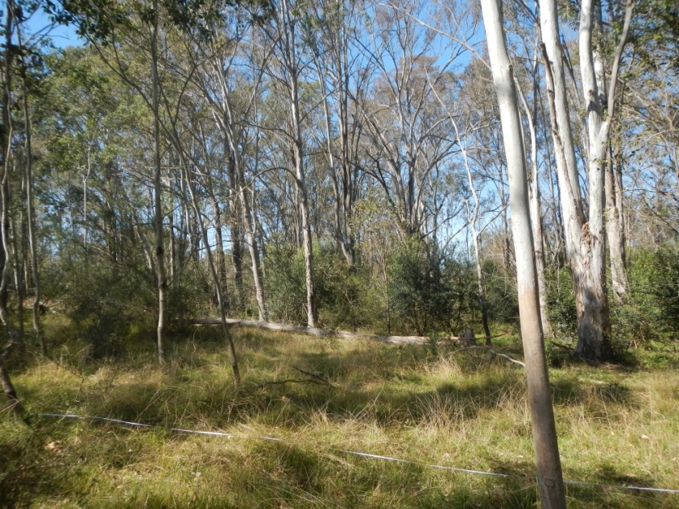

Plot | 5
Location | 60 Gardiner Street. Vacant property formerly grazed. High level of recreational use – quad/trail bikes.  Blacktown soil landscape.
Condition | Moderate.
Description | Uneven aged patch of Shale Gravel Transition Forest, canopy 8m to 18m high comprised of Broad-leaved Ironbark (Eucalyptus fibrosa), Stringybark (E. eugenioides) and Melaleuca decora. No hollow-bearing trees observed. Open mid-storey comprised of Blackthorn (Bursaria spinosa) and Prickly-leaved Paperbark (Melaleuca nodosa). Mostly native understorey dominated by Weeping Meadow Grass (Microlaena stipoides), Cryptandra spinescens and Blackthorn seedlings, with Wiry Panic (Entolasia stricta) and Threeawn Speargrass (Aristida vagans) also present. Total native species richness = 33.  Very low weed cover (about 2%) scattered in the groundcover.  Resilience moderate, likely to have viable soil seed bank, regeneration would require ongoing management including fencing, weed control and appropriate fire management. No dead trees observed in the canopy, but no juvenile eucalypt regeneration observed. Disturbed area of former grazing and quad/trail bike tracks.
NPWS (2002) veg community | Shale Gravel Transition Forest (MU103).
EPBC name | Cumberland Plain Shale Woodlands and Shale-Gravel Transition Forest.
TSC name | Shale Gravel Transition Forest.
NSW PCT | Broad-leaved Ironbark - Grey Box - Melaleuca decora grassy open forest on clay/gravel soils of the Cumberland Plain, Sydney Basin (BioMetric code: HN512, NSW plant community type: 724).
Photo | 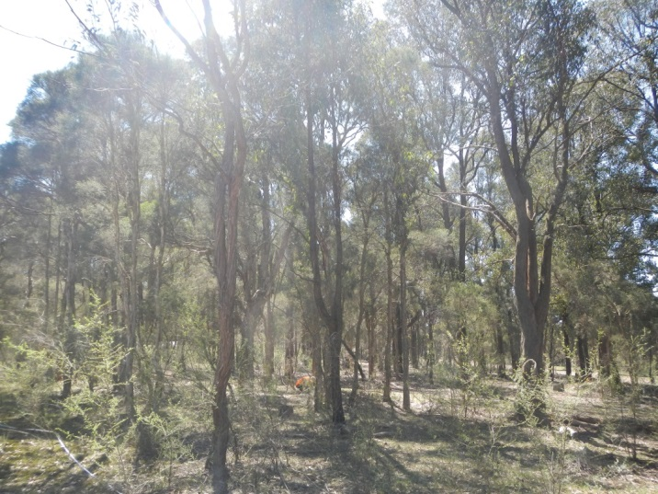

Plot | 6
Location | 65 Leggo Street. Vacant property, occasional horse grazing.  South Creek soil landscape.
Condition | Moderate to Good.
Description | Alluvial Woodland, canopy 5 m to 20 m high comprised of Cabbage Gum (Eucalyptus amplifolia) and Melaleuca decora. No hollow-bearing trees observed. Open mid-storey comprised of Prickly-leaved Paperbark (Melaleuca nodosa) and scattered Rice Flower (Ozothamnus diosmifolius). Mostly native understorey dominated by Kangaroo Grass (Themeda australis), Threeawn Speargrass (Aristida vagans), Weeping Meadow Grass (Microlaena stipoides) and wattle Mat-rush (Lomandra filiformis). Total native species richness = 25.  Exotic species are scattered at low abundance in the mid-storey and groundcover with the main weeds present consisting of African Love Grass (Eragrostis curvula), Fireweed (Senecio madagascariensis) and Paddys Lucerne (Sida rhombifolia).  Resilience good, likely to have viable soil seed bank, regeneration would require ongoing management including fencing, weed control and appropriate fire management. No dead trees observed in the canopy. Adjoining areas cleared of canopy are high probability derived native grasslands.
NPWS (2002) veg community | Alluvial Woodland (MU11)
EPBC name | n/a
TSC name | River Flat Eucalypt Forest on Coastal Floodplains
NSW PCT | Forest Red Gum - Rough-barked Apple grassy woodland on alluvial flats of the Cumberland Plain, Sydney Basin (BioMetric code: HN526, NSW plant community type: 835).
Photo | 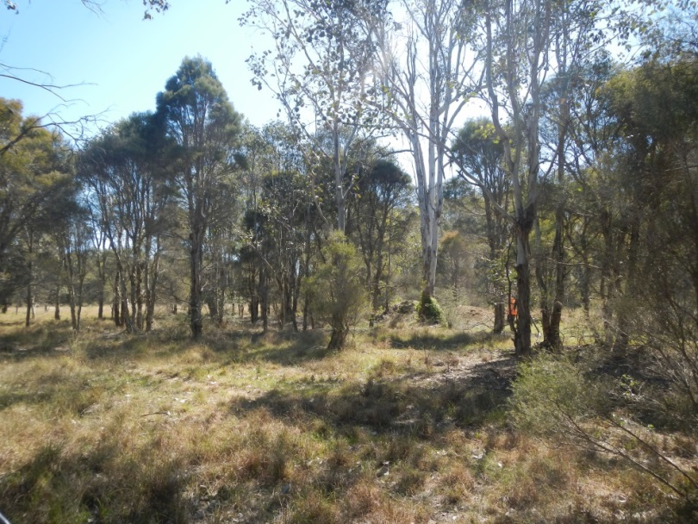

Plot | 7
Location | 595 Badgerys Creek Road. Rural property, horse agistment.  South Creek soil landscape.
Condition | Moderate to Good.
Description | Advanced regeneration Alluvial Woodland, canopy 10 m to 20 m high comprised of Forest Red Gum (Eucalyptus tereticornis), Grey Box (E. moluccana) and Swamp Oak (Casuarina glauca). No hollow-bearing trees observed. Open mid-storey comprised of Blackthorn (Bursaria spinosa), Swamp Oak and Forest Red Gum saplings. Mostly native grassy understorey dominated by Weeping Meadow Grass (Microlaena stipoides) and Kangaroo Grass (Themeda australis), with Indian Pennywort (Centella asiatica), Oxalis perennans and Slender Tick-trefoil (Desmodium varians) also present. Total native species richness = 23.  Exotic species present were mainly in the groundcover (about 15% cover) consisting of Panic Veldt Grass (Ehrharta erecta), Slender Pigeon Grass (Setaria parviflora), Fireweed (Senecio madagascariensis) and Paddys Lucerne (Sida rhombifolia).  Resilience good, likely to have viable soil seed bank, regeneration would require ongoing management including fencing, weed control and appropriate fire management. No dead trees observed in the canopy.
NPWS (2002) veg community | Alluvial Woodland (MU11)
EPBC name | n/a
TSC name | River Flat Eucalypt Forest on Coastal Floodplains
NSW PCT | Forest Red Gum - Rough-barked Apple grassy woodland on alluvial flats of the Cumberland Plain, Sydney Basin (BioMetric code: HN526, NSW plant community type: 835).
Photo | 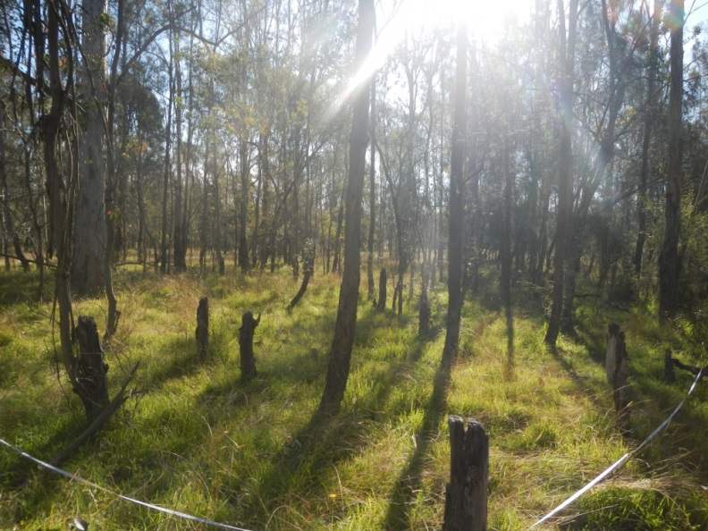

Plot | 8
Location | 75 Jagelman Road. Rural property, horse agistment.  Blacktown soil landscape.
Condition | Moderate.
Description | Moderate condition patch of advanced regeneration Cumberland Plain Woodland, canopy 6 m to 28 m high comprised of Grey Box (Eucalyptus moluccana), Forest Red Gum (E. tereticornis) and Cherry Ballart (Exocarpos cupressiformis). No hollow-bearing trees observed. Moderately dense mid-storey comprised of Blackthorn (Bursaria spinosa). Mostly native grassy understorey dominated by Weeping Meadow Grass (Microlaena stipoides), Plump Windmill Grass (Chloris ventricosa) and Carex inversa with Forest Nightshade (Solanum prinophyllum), Bear’s Ear (Cymbonotus lawsonianus) and Einadia spp also present. Total native species richness = 27.  African Olive (Olea europaea ssp. Cuspidata) occurs in the mid-storey at about 3% cover within the plot but is dense in parts of the property. Other weeds scattered in the groundcover include Fireweed (Senecio madagascariensis) and Paddys Lucerne (Sida rhombifolia).  Resilience moderate, likely to have viable soil seed bank, regeneration would require ongoing management including fencing, weed control and appropriate fire management. No dead trees observed in the canopy. A fenced area of native vegetation adjoining the site where the plot was located was in good condition.
NPWS (2002) veg community | Shale Plains Woodland (MU10)
EPBC name | Cumberland Plain Shale Woodlands and Shale-Gravel Transition Forest
TSC name | Cumberland Plain Woodland
NSW PCT | Grey Box - Forest Red Gum grassy woodland on flats of the Cumberland Plain, Sydney Basin (BioMetric code: HN528, NSW plant community type: 849).
Photo | 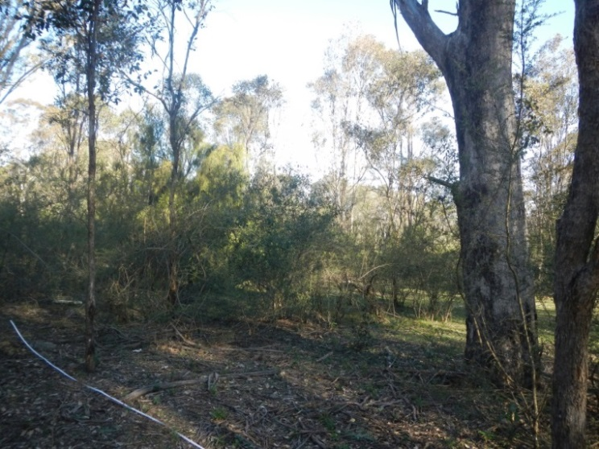

Plot | 9
Location | 70 Anton Road. Rural property, horse agistment and cattle grazing.  Blacktown soil landscape.
Condition | Moderate
Description | Moderate condition patch of advanced regeneration Shale Plains Woodland, canopy 5 m to 15 m high comprised of Forest Red Gum (Eucalyptus tereticornis) canopy. One hollow observed in a large dead stag just outside of the plot. The only native species present in the mid-storey was Blackthorn (Bursaria spinosa) at low abundance. Predominantly native groundcover with Weeping Meadow Grass (Microlaena stipoides), Kangaroo Grass (Themeda australis) and Kidney Weed (Dichondra repens). Total native species richness = 20.  African Olive (Olea europaea ssp. cuspidata) dominates the mid-storey at about 30% cover. Other weeds scattered in the groundcover include Fireweed (Senecio madagascariensis), Paddys Lucerne (Sida rhombifolia) and Bridal Creeper (Asparagus asparagoides).  Resilience moderate, likely to have viable soil seed bank, regeneration would require ongoing management including fencing, weed control and appropriate fire management. Small number of dead trees in the canopy.
NPWS (2002) veg community | Shale Plains Woodland (MU10).
EPBC name | Cumberland Plain Shale Woodlands and Shale-Gravel Transition Forest.
TSC name | Cumberland Plain Woodland.
NSW PCT | Grey Box - Forest Red Gum grassy woodland on flats of the Cumberland Plain, Sydney Basin (BioMetric code: HN528, NSW plant community type: 849).
Photo | 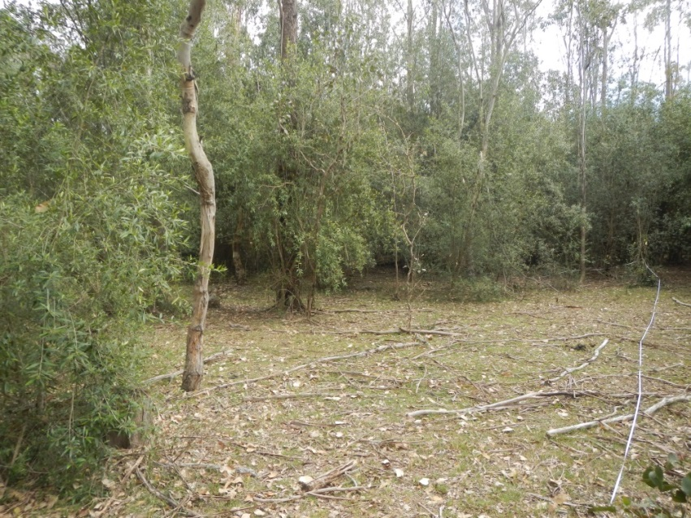

Plot | 10
Location | 50 Anton Road. Rural property, cattle grazing.  Blacktown soil landscape.
Condition | Moderate-good.
Description | Moderate condition patch of advanced regeneration Shale Plains Woodland, canopy 5 m to 18 m high comprised of Grey Box (Eucalyptus moluccana) and Forest Red Gum (Eucalyptus tereticornis) canopy. No hollow bearing trees observed. Moderately open mid-storey comprised mainly of Blackthorn (Bursaria spinosa) with Rice Flower (Ozothamnus diosmifolius) present at low abundance. Predominantly native groundcover dominated by with Weeping Meadow Grass (Microlaena stipoides) and Threeawn Speargrass (Aristida vagans). Kidney Weed (Dichondra repens), Wattle Mat-rush (Lomandra filiformis), Blue Trumpet (Brunoniella australis), Winter Apple (Eremophila debilis) and Bordered Panic (Entolasia marginata) are also common. Total native species richness = 23.  There is some African Boxthorn (Lycium ferocissimum) and African Olive (Olea europaea ssp. Cuspidata) present in the mid-storey at about 3% cover. Other weeds scattered in the groundcover include Fireweed (Senecio madagascariensis), Apple of Sodom (Solanum linnaeanum), Bridal Creeper (Asparagus asparagoides) and Panic Veldt Grass (Ehrharta erecta).  Resilience moderate, likely to have viable soil seed bank, regeneration would require ongoing management including fencing, weed control and appropriate fire management. No dead trees observed in the canopy.
NPWS (2002) veg community | Shale Plains Woodland (MU10).
EPBC name | Cumberland Plain Shale Woodlands and Shale-Gravel Transition Forest
TSC name | Cumberland Plain Woodland
NSW PCT | Grey Box - Forest Red Gum grassy woodland on flats of the Cumberland Plain, Sydney Basin (BioMetric code: HN528, NSW plant community type: 849).
Photo | 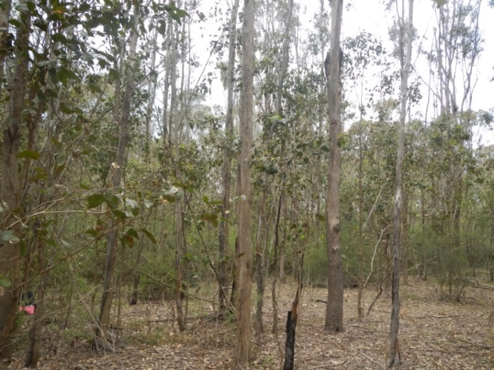

Plot | 11
Location | 540 Badgerys Creek Road. Rural property, cattle grazing.  Blacktown soil landscape.
Condition | Moderate-poor
Description | Poor to moderate condition patch of advanced regeneration Shale Plains Woodland, canopy 6 m to 20 m high comprised of Grey Box (Eucalyptus moluccana) and Forest Red Gum (Eucalyptus tereticornis) canopy. No hollow bearing trees observed. Moderately open mid-storey comprised mainly of Blackthorn (Bursaria spinosa) with Australian Indigo (Indigofera australis) also present. About 50/50 mixed native and exotic groundcover with main native species including Weeping Meadow Grass (Microlaena stipoides), Plump Windmill Grass (Chloris ventricosa), Kangaroo Grass (Themeda australis) and Berry Saltbush (Einadia hastata). Total native species richness = 17.  There is some African Olive (Olea europaea ssp. cuspidata) and Lantana (Lantana camara) present in the mid-storey at about 10% cover. Main weeds present in the groundcover include Panic Veldt Grass (Ehrharta erecta), Paddys Lucerne (Sida rhombifolia) and Bridal Creeper (Asparagus asparagoides).  Small, disturbed patch of vegetation. Resilience low to moderate, likely to have some viable soil seed bank, regeneration would require significant investment in ongoing management including fencing, weed control and appropriate fire management. No dead trees observed in the canopy.
NPWS (2002) veg community | Shale Plains Woodland (MU10).
EPBC name | Cumberland Plain Shale Woodlands and Shale-Gravel Transition Forest
TSC name | Cumberland Plain Woodland
NSW PCT | Grey Box - Forest Red Gum grassy woodland on flats of the Cumberland Plain, Sydney Basin (BioMetric code: HN528, NSW plant community type: 849).
Photo | 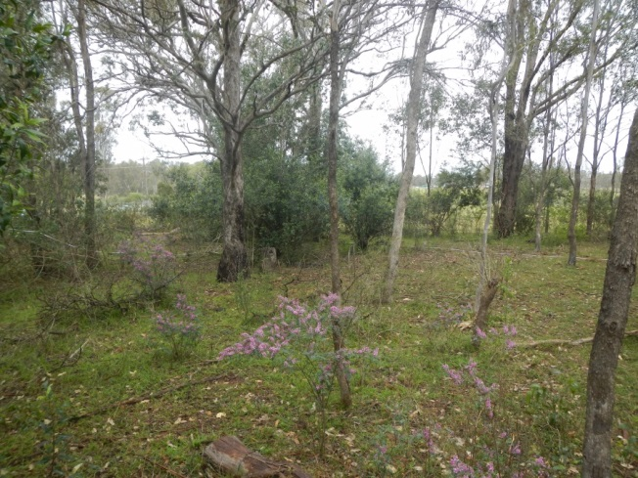

Plot | 12
Location | 2300 Elizabeth Drive. Rural property, cattle grazing.  Blacktown soil landscape.
Condition | Poor.
Description | Poor condition patch of advanced regeneration Shale Plains Woodland, canopy 10 m to 15 m high comprised of Forest Red Gum (Eucalyptus tereticornis) canopy. No hollow bearing trees observed. Weedy mid-storey with no native species present. Mostly exotic groundcover with only scattered native species present, the main ones being Weeping Meadow Grass (Microlaena stipoides), Berry Saltbush (Einadia hastata) and Carex inversa. Total native species richness = 11.  The main exotic species present in the mid-storey at about 20% cover are African Boxthorn (Lycium ferocissimum) and Apple of Sodom (Solanum linnaeanum). The main weeds dominating the groundcover include Panic Veldt Grass (Ehrharta erecta), Fireweed (Senecio madagascariensis), Paddys Lucerne (Sida rhombifolia) and Flatweed (Hypochaeris radicata).  Disturbed patch of vegetation, historically heavily grazed. Resilience low, likely to limited capacity for regeneration. Would require significant investment in ongoing management including fencing, weed control and planting. Significant tree death observed in the canopy. Vegetation on properties over the southern fence looks to be in better condition.
NPWS (2002) veg community | Shale Plains Woodland (MU10).
EPBC name | Cumberland Plain Shale Woodlands and Shale-Gravel Transition Forest.
TSC name | Cumberland Plain Woodland.
NSW PCT | Grey Box - Forest Red Gum grassy woodland on flats of the Cumberland Plain, Sydney Basin (BioMetric code: HN528, NSW plant community type: 849).
Photo | 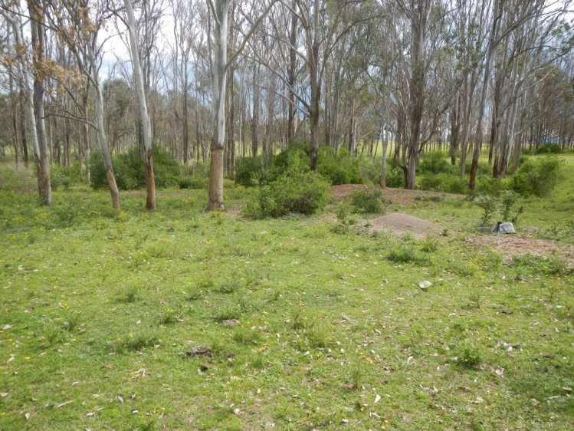

  - Resilience of vegetation in the study area
Ground-truthing during field surveys confirmed that the study area contains a mix of disturbed former grazing land, varying condition shale woodland and poor condition riparian vegetation. African Olive is particularly prevalent in gullies and agricultural and environmental weeds are present in the groundcover and mid-storey to varying degrees throughout much of the study area. However, there is still good native species diversity in the remnants visited in September 2014, with the majority of sites visited meeting the condition thresholds of EECs listed under the EPBC Act.
    - Weeds
A number of Weeds of National Significance (WoNS) were observed during field survey of the site. National Management Guides are available for these species. Table 4 lists weeds identified in the field in September 2014, whether they are WoNS, whether they are declared as noxious in the Liverpool LGA under the Noxious Weeds Act (1993), class and control requirements.
Table 4: Weeds of National Significance
Species name | Common name | Class | Legal requirements
Asparagus asparagoides | Bridal Creeper | WoNS, 4 | The plant must not be sold, propagated or knowingly distributed.
Bryophyllum species | Mother of Millions | 4 | The growth of the plant must be managed in a manner that continuously inhibits the ability of the plant to spread and the plant must not be sold, propagated or knowingly distributed.
Cestrum parqui | Green Cestrum | 3 | The plant must be fully and continuously suppressed and destroyed.
Lantana camara | Lantana | WoNS, 4 | The growth of the plant must be managed in a manner that continuously inhibits the ability of the plant to spread.
Lycium ferocissimum | African Boxthorn | WoNS
Olea europaea subspecies cuspidata | African Olive | 4 | The growth of the plant must be managed in a manner that continuously inhibits the ability of the plant to spread and the plant must not be sold, propagated or knowingly distributed.
Opuntia sp. | Prickly Pear | WoNS, 4 | The growth of the plant must be managed in a manner that continuously inhibits the ability of the plant to spread and the plant must not be sold, propagated or knowingly distributed
Rubus fruticosus agg | Blackberry | WoNS, 4 | The growth of the plant must be managed in a manner that continuously inhibits the ability of the plant to spread and the plant must not be sold, propagated or knowingly distributed.
Senecio madagascariensis | Fireweed | WoNS | The plant must not be sold, propagated or knowingly distributed.

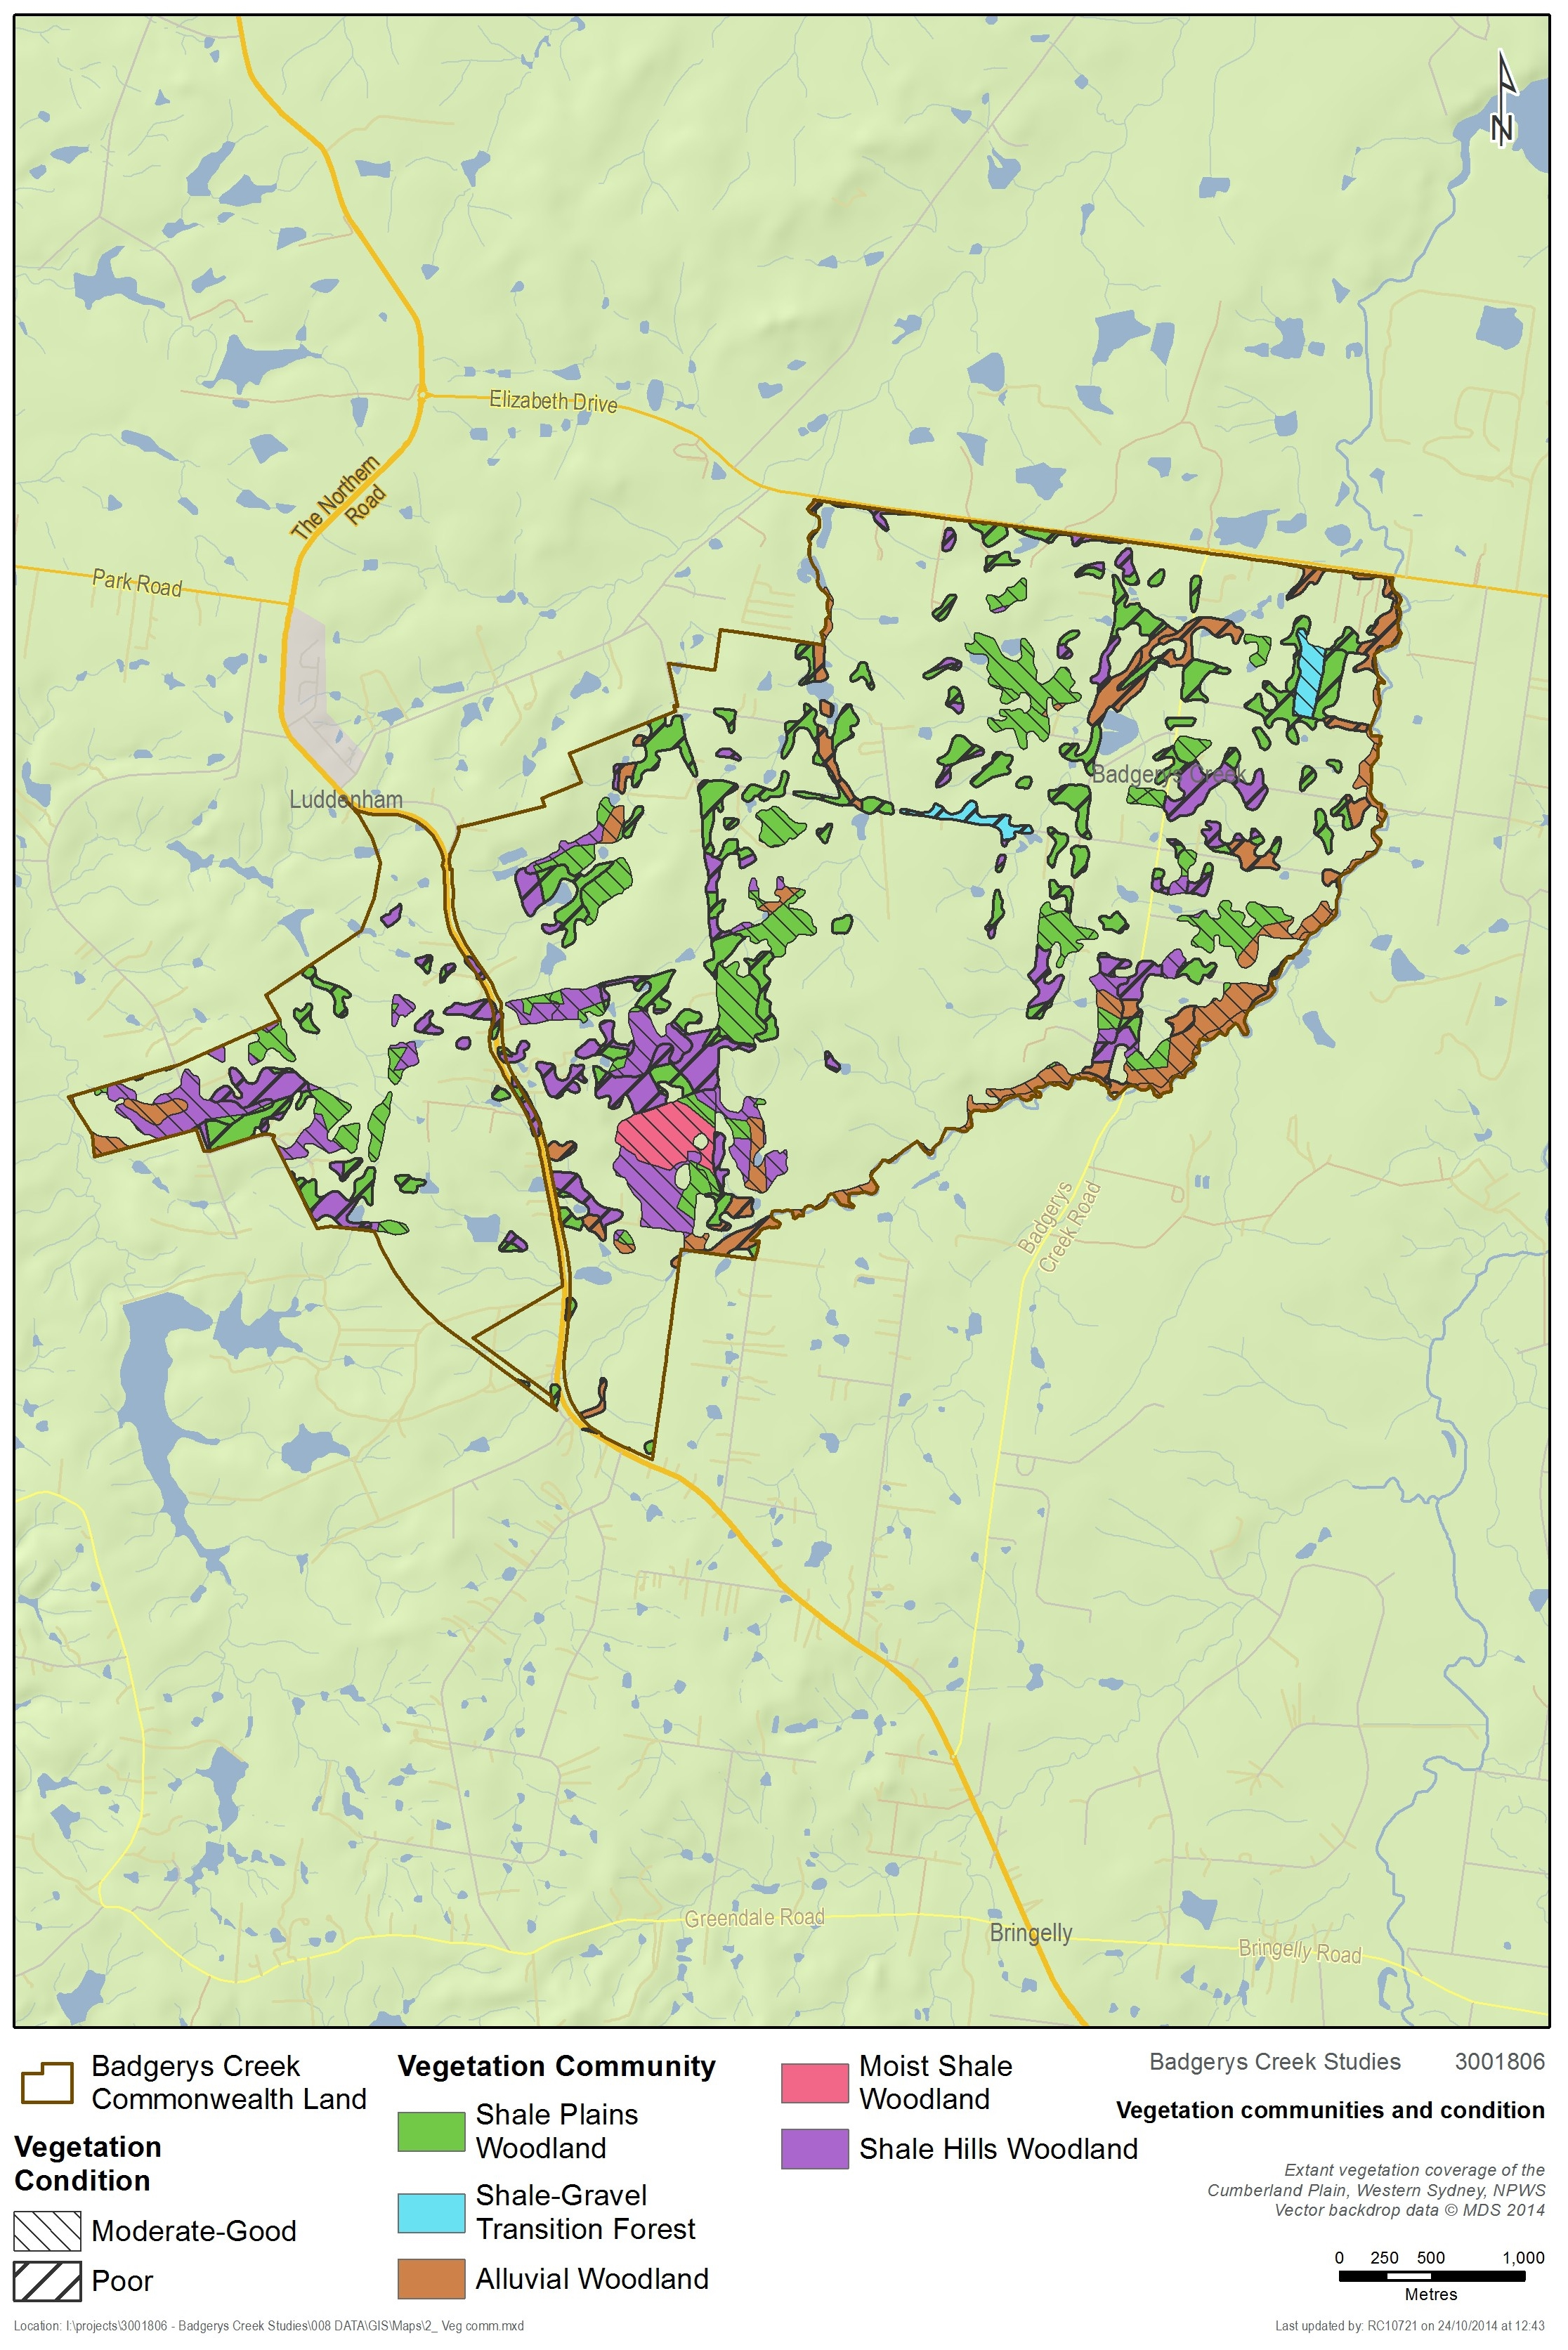
Figure 4: Vegetation communities and condition
  - Fauna habitat
    - Field Survey Results
Fauna habitat present within the study area is moderately to highly modified. Much of this disturbance is due to the presence of grazing of livestock, which has been occurring within the study area for several decades. It is likely that much of the original vegetation within the area was directly cleared to facilitate grazing and other agricultural infrastructure, with remaining vegetation clearing and suppression of regeneration accounted for by grazing itself.
Despite this, several native fauna habitats persist within the study area. Such habitats can be classified into the three broad categories, open woodland, grassland and aquatic habitat. Each category exhibits is a high degree of variation in its vegetation composition across the study area, however, the structural elements relevant to native fauna are generally consistent.
  - Open woodland
Pockets of open woodland habitat are scattered across the study area, separated by large expanses of grassland. Such pockets are of varying age, with some likely to be remnant, while others have regenerated since clearing. The presence of large tree stumps within remnant patches indicates that within these areas many of the large trees have been selectively removed. The overall result of such clearing is the general scarcity of trees old or large enough to produce usable hollows for arboreal mammals, reptiles and diurnal and nocturnal birds and other native fauna. As such habitat value of this layer is considered to be low.
Within remnant/regenerating patches mid-storey vegetation varies from non-existent to native shrubs of varying density to dense African Olive infestations. It should be noted that mid-storey vegetation within the native plant communities types present within the study area is typically sparse and usually dominated by Bursaria spinosa.
Whilst the abundant African Olive provides a certain degree of habitat structure within the mid-storey (e.g. shelter and foraging opportunities for reptiles and small birds) this generally comes at the expense of native mid-storey vegetation which is likely to provide better structure, as well as increased opportunity for hosting food resources for native wildlife. Of the open woodland sites surveyed it was noted that a couple of sites contained mid-storeys dominated by African Olive and African Boxthorn. As such the overall habitat value of this layer within remnant/regenerating patches is generally considered to be moderate to low.
Vegetative ground covers within some remnant/regenerating patches of open woodland are often sparse or less than five centimetres in height as a result of ongoing grazing pressure. Leaf litter is thin, although many sites are littered with debris and fallen/cut logs. Parts of the study area are also infested with non-native groundcovers such as African lovegrass. However there are some remnants where there is good native species diversity and there were some fenced areas with reduced grazing pressure where the native grass cover was intact. It is likely that populations of the threatened Cumberland Plain Land Snail persist in these areas; however, no targeted searches were undertaken. The habitat value within this layer across the broader study area is considered to be moderate to low.
  - Grassland
The grassland habitat present exhibits a mixture of native and exotic grasses. Occasional emerging eucalypts are present where there is reduced grazing pressure. Isolated mature canopy trees and logs occur sporadically amongst pastures. The overall habitat value of grasslands throughout the site is considered to be low to moderate.
  - Aquatic habitat
There are numerous farm dams within the study area. These are generally vegetated around the edge except where the banks have been degraded by livestock access.
Badgerys Creek flows through the eastern portion of the study area in a northerly direction and has a relatively well vegetated riparian corridor. Large portions of the waterway are infested with weeds and natural water flow is significantly altered in certain locations, particularly through the actions of livestock and other agricultural activities. Despite this highly degraded state the creek is likely to provide suitable habitat for a variety of native fauna species.
    - Threatened fauna habitat
No threatened fauna species were directly or indirectly observed during the field surveys, though surveys were not undertaken in sufficient detail to normally detect such species. Habitat assessment undertaken as part of the field surveys indicates that likely habitat for threatened species is present in certain locations. This includes potential habitat for the Cumberland Plain Land Snail, woodland and migratory birds, microbats, the Grey-headed Flying-fox and amphibians such as the Green and Golden Bell Frog, among others.
The 1999 Supplement to the Draft EIS makes reference to the Badgerys Creek Community Hall as important roosting habitat for two species of microbats: Chalinolobus gouldi (Goulds Wattled Bat) and Mormopterus sp. This site was not specifically targeted during these surveys as it is understood that the building has since been removed.
While the quality and quantity of habitat features for threatened fauna varies throughout the site, specific species requirements indicate it is likely that the site supports at least a subset of the threatened species with potential to occur in the area (see Appendix 3). Important features present within the site likely to support such populations include waterways, wetlands, riparian corridors, hollow bearing trees, native and exotic grasslands, vegetative litter and native vegetation generally. Ongoing management of the site should take account and provide for threatened species habitat wherever possible. This should include management of Key Threatening Processes such as clearing of native vegetation, grazing of livestock and the presence of weeds (see section 5.13 for further detail).
Further targeted surveys for threatened species are recommended in support of any future environmental assessment.
  - Threatened ecological communities
    - Fragmentation analysis
An analysis of the spatial configuration of remnant vegetation within the study area was undertaken to provide a better understanding of remnant size and distribution.
The fragmentation analysis was undertaken within the boundaries of the Commonwealth land at Badgerys Creek. Only vegetation mapped in the good condition classes (“A”, “B” and “C”) of NPWS (2002f) was used in the fragmentation analysis, excluding scattered tree condition classes (“TX”, “TXR”, “TXU” and “X”). The fragmentation just applies to vegetation identified via desktop as most likely to meet the definition of EPBC listed Cumberland Plain Shale Woodlands and Shale-Gravel Transition Forest (CPW) or Western Sydney Dry Rainforest and Moist Woodland on Shale.
The results of the fragmentation analysis reveal a high degree of fragmentation in the study area (Table 5). Some 33 individual remnants of candidate EPBC listed vegetation are present, ranging in size from <1 ha to 35 ha. Vegetation remnants in the 1-2 and 5-10 hectares class ranges are the most common with 33% of remnants being 1-2 ha in size and 27% of remnants being between 5 and 10 hectares.
The majority of candidate EPBC listed vegetation in the study area is contained with larger patches of vegetation with over 76% of the total area of candidate EPBC listed vegetation in patches of greater than five hectares.
Table 5: Fragmentation analysis of candidate EPBC listed vegetation
Size class range (ha) | No. of remnants | % of total no. of remnants | Area of vegetation | % of total area of vegetation
<1 | 2 | 6 | 1.3 | 0.7
>1 <2 | 11 | 33 | 17.7 | 9.9
>2 <3 | 3 | 9 | 7.4 | 4.2
>3 <4 | 3 | 9 | 10.5 | 5.9
>4 <5 | 1 | 3 | 4.7 | 2.6
>5 <10 | 9 | 27 | 62.3 | 35.0
>10 <25 | 3 | 9 | 39.3 | 22.1
>25 <50 | 1 | 3 | 34.7 | 19.5
Total | 33 |  | 177.9

    - Commonwealth and NSW listed EECs
Desktop searches identified 22 Threatened Ecological Communities as occurring or potentially occurring within a ten kilometre radius of the study area (Appendix 3). Ecological Communities identified as having a medium to high likelihood of occurrence in the study area include:
- Cooks River/Castlereagh Ironbark Forest in the Sydney Basin Bioregion.
- Cumberland Plain Woodland in the Sydney Basin Bioregion.
- Freshwater Wetlands on Coastal Floodplains of the New South Wales North Coast, Sydney Basin and South East Corner Bioregions.
- Moist Shale Woodland in the Sydney Basin Bioregion.
- River-Flat Eucalypt Forest on Coastal Floodplains of the New South Wales North Coast, Sydney Basin and South East Corner Bioregions.
- Shale Gravel Transition Forest in the Sydney Basin Bioregion.
- Western Sydney Dry Rainforest in the Sydney Basin Bioregion.
All of the remnant vegetation present in the study area is listed as threatened ecological communities (TECs) under either the EPBC Act or TSC Act (Figure 4).
Two EPBC-listed critically endangered communities were found to be present within the study area:
- Cumberland Plain Shale Woodlands and Shale-Gravel Transition Forest.
- Western Sydney Dry Rainforest and Moist Woodland on Shale.
Four TSC-listed TECs were found to be present in the study area:
- Cumberland Plain Woodland in the Sydney Basin Bioregion
- Shale Gravel Transition Forest in the Sydney Basin Bioregion
- River-Flat Eucalypt Forest on Coastal Floodplains of the New South Wales North Coast, Sydney Basin and South East Corner Bioregions
- Moist Shale Woodland in the Sydney Basin Bioregion
There is some overlap with these listings and further detail is provided in Appendix 1 Table 12.
It is estimated that approximately 437 hectares of native vegetation occurs in the study area. Estimates of the area of the different vegetation communities present are provided in Table 6. These estimates are derived from the Native Vegetation of the Cumberland Plain map (NPWS 2002f) (including vegetation mapped as having both greater than and less than ten per cent canopy cover) and limited field survey undertaken by SMEC in September 2014.
The majority of mapped vegetation in the study area is Shale Plains Woodland and Shale Hills Woodland (124.5 and 208 hectares respectively), both components of Cumberland Plain Woodland and included in the EPBC listing for Cumberland Plain Shale Woodlands and Shale-Gravel Transition Forest and the TSC Act listing for Cumberland Plain Woodlands. Based on the limited field work undertaken by SMEC in September 2014 it is evident that some of the mapped Shale Hills Woodland is Shale Plains Woodland in lower parts of the study area. This does not affect estimates for area of TECs as both communities are included in the Commonwealth and State EEC determinations.
Only the larger, higher condition remnants of Cumberland Plain Woodlands are likely to meet the condition thresholds of the EPBC Act determination.
A small amount of Shale Gravel Transition Forest (9.1 ha) was identified in the current SMEC field survey of the study area, associated with small patches of Tertiary alluvium and/or high concentrations of iron-hardened gravels. This community has not previously been mapped in the study area and it is likely that additional patches could occur. Further field survey and verification is recommended to identify and map any additional remnants. Shale Gravel Transition Forest is listed separately under the TSC Act but is included in the EPBC listing for Cumberland Plain Shale Woodlands and Shale-Gravel Transition Forest.
A small area of Moist Shale Woodland (13.5 ha) was identified in the study area during the current SMEC field survey at higher elevations on rolling topography south-east of Luddenham. Moist Shale Woodland has not been previously mapped in the study area. It is possible that additional areas could occur on the Commonwealth-owned land and further field survey and verification is required. This vegetation community is listed separately under the TSC Act and is part of the EPBC listing for Western Sydney Dry Rainforest and Moist Woodland on Shale.
Table 6: Vegetation communities in the study area
Vegetation community (NPWS 2002f) | EPBC Act | TSC Act | Area in the study area (ha) | Locality (10km)²
Shale Plains Woodland | Y (part) | Y | 124.5 | 4556.7
Shale Hills Woodland | Y (part) | Y | 208.0 | 3515.7
Shale Gravel Transition Forest | Y (part) | Y | 9.1 | 191.2
Moist Shale Woodland | Y (part) | Y | 13.5 | 75.0
Alluvial Woodland | - | Y | 81.7 | 2322.5
Total |  |  | 436.9

Table 7: Threatened Ecological Communities in the study area
EEC name | Area within the study area (ha)
EPBC Act
Cumberland Plain Shale Woodlands and Shale-Gravel Transition Forest | 147.9
Western Sydney Dry Rainforest and Moist Woodland on Shale | 13.5
Total | 161.4
TSC Act
Cumberland Plain Woodland | 332.5
Shale Gravel Transition Forest | 9.1
Moist Shale Woodland | 13.5
River Flat Eucalypt Forest on Coastal Floodplains | 81.7
Total | 436.9

  - Cumberland Plain Shale Woodlands and Shale-Gravel Transition Forest (EPBC Act)
General
Cumberland Plain Shale Woodlands and Shale-Gravel Transition Forest is listed as a critically endangered ecological community under the EPBC Act. The community represents occurrences of the coastal plain grassy eucalypt woodlands that are endemic to the shale hills and plains of the Cumberland sub-region within the Sydney Basin Bioregion. It also includes smaller areas of a more shrubby forest known as Shale Gravel Transition Forest occurring in areas where Tertiary alluvium and/or iron-indurated gravels overlies the shale substrate.
Distribution
Cumberland Plain Shale Woodlands and Shale-Gravel Transition Forest occurs on flat to undulating or hilly terrain, at elevations up to around 350 metres above sea level. The community lies in a coastal valley rain shadow that occupies the driest part of the Cumberland Plain with a mean annual rainfall of between 700 and 900 mm.
Vegetation structure and floristics
The community structure is variable ranging from open grassy woodland to forest with the understorey predominantly grassy to predominantly shrubby. This structure may include an upper tree layer, lower tree layer, shrub layer and a ground layer, although one or more of these layers may be absent or degraded depending on disturbance history. Disturbances resulting from clearing, fire, slashing/mowing and grazing regimes directly influence the structure and diversity of the community.
Grey Box Eucalyptus moluccana and Forest Red Gum Eucalyptus tereticornis and Narrow-leaved Ironbark Eucalyptus crebra are the dominant canopy trees, with Spotted Gum Corymbia maculata, Thin-leaved Stringybark Eucalyptus eugenioides and Broad-leaved Ironbark Eucalyptus fibrosa occurring less frequently. A lower tree layer consisting of young eucalypts of upper tree canopy species and species of Acacia, Exocarpos cupressiformis and Melaleuca decora may be present. The understorey layer is generally dominated by Blackthorn Bursaria spinosa with Prickly Parrot Pea Dillwynia sieberi, Sickle Wattle Acacia falcata, Berry Saltbush Einadia hastata and Wedge-leaf Hopbush Dodonaea viscosa subsp. cuneata occurring less frequently. The highest diversity is found in the ground layer where it is common to find abundant grasses and herbs such as Kangaroo Grass Themeda australis, Weeping Meadow Grass Microlaena stipoides var stipoides, Three-awn Grass Aristida species, Kidney Weed Dichondra repens, Glycine species and Blue Trumpet Brunoniella australis.
Threats
Less than 10% of this community remain. The key threats are vegetation clearing, fragmentation of remnants, weed invasion, increased nutrient loads due to fertiliser run-off from nearby developed lands, rubbish dumping, inappropriate management regimes and climate change.
Area and condition of remnants within study area
To meet the definition of Cumberland Plain Shale Woodlands and Shale-Gravel Transition Forest under the EPBC Act, an upper tree layer must be present (with projected foliage cover of canopy trees being 10% or more), patch size of at least 0.5 ha as well as either a shrub or ground layer with predominantly native species (at least 50%) or 30% if the patch is >5ha, contiguous with other native vegetation of 5 ha or more or contains at least one mature tree per hectare.
It is estimated for this report that approximately 148 ha of this critically endangered community occurs within the study area that could meet the definition under the EPBC Act. The degree of fragmentation is high with 33% of remnants being 1-2 ha in size and 27% of remnants being between 5 and 10 hectares. No Conservation Priority Lands as identified in the Cumberland Plain Recovery Plan (2011) occur within the study area.
In the draft EIS (Chapter 14) the Cumberland Plain Woodlands were assessed as being mostly of local conservation significance in consideration of their small size and degraded condition as a result of grazing and weed invasion. Individual sites were predominantly assessed as being in poor to very poor condition except survey sites 17, 19 and 20 that were considered to be in moderate condition. From the limited field survey undertaken by SMEC in September 2014 it was found that remnants were generally in higher condition than reported in the draft EIS with all but two sites assessed as moderate, moderate to good or good condition based on cover/abundance values for upper, mid and ground layers and native species richness in accordance with OEH survey guidelines. A comparison of condition assessment results between sites surveyed in the draft EIS and sites surveyed by SMEC in 2014 is provided in Table 8. Native species richness within 0.04 ha plots was close to or below benchmark. These remnants meet the criteria for listing under the EPBC Act although other small more degraded remnants are unlikely to.
Conservation significance
In view of the above results together with consideration of the revised critically endangered status of the community since the draft EIS, it is concluded that approximately 148 ha of Cumberland Plain Shale Woodlands and Shale-Gravel Transition Forest provisionally identified within the study area is likely to be consistent with the EPBC Act listing and of national significance.
*Information specific to the Shale Gravel Transition Forest component of the community can be found under the Shale Gravel Transition Forest TSC Act listed community.
Table 8: Comparison of condition assessment results draft EIS 1999 and SMEC field survey 2014
Plot number (SMEC 2014) | Condition (SMEC 2014) | Remnant number Draft EIS (1999) | Condition (1999 EIS)
1 | Moderate | 18 | Poor
2 | Moderate | 17 | Moderate
3 | Moderate | 20 | Poor to Moderate
4 | Moderate to Good | 22 | Poor
5 | Moderate | 2 | Poor
6 | Moderate to Good | 53 (closest site) | Poor
7 | Moderate to Good | 3 | Poor
8 | Moderate | 16 | Poor
9 | Moderate | 46 | Poor
10 | Moderate to Good | 46 | Poor
11 | Poor to Moderate | 9 | Poor
12 | Poor | 12 (closest site) | Poor

  - Cumberland Plain Woodland (TSC Act)
General
Cumberland Plain Woodland is listed as a critically endangered ecological community under the TSC Act. The community represents occurrences of the coastal plain grassy eucalypt woodlands that are endemic to the shale hills and plains of the Cumberland sub-region within the Sydney Basin Bioregion. Both Shale Plains Woodland (on flat, lower rainfall areas) and Shale Hills Woodland (at higher elevations mostly in southern districts) are included in the listed community.
Distribution
Cumberland Plain Woodland occurs on flat to undulating or hilly terrain, at elevations up to around 350 metres above sea level across the Cumberland Plain. The community lies in a coastal valley rain shadow that occupies the driest part of the Cumberland Plain with a mean annual rainfall of between 700 and 900 mm.
Vegetation structure and floristics
The vegetation structure and floristics of the TSC Act-listed community is generally the same as for the EPBC Act listed community except for the more shrubby forest occurring on Tertiary alluvium and iron-indurated gravels that is listed separately as Shale Gravel Transition Forest.
Threats
Same as for the EPBC Act listed community.
Area and condition of remnants within study area
It is estimated for this report that approximately 332 ha of the TSC Act listed community occurs within the study area. This does not include areas of derived grasslands that may also meet the EEC definition. The degree of fragmentation is high with 33% of remnants being 1-2 ha in size and 27% of remnants being between 5 and 10 hectares. No Conservation Priority Lands as identified in the Cumberland Plain Recovery Plan (2011) occur within the study area.
Under the TSCA a wider range of condition states are included in the definition of the listed community including tree dominated stands, scattered trees with <10% cover, shrub dominated vegetation and derived grassland. There are no patch size restrictions. Smaller remnants are considered important in a local and regional context (Cumberland Plain Recovery Plan 2011 and NSW Scientific Committee 2009).
In the draft EIS (Chapter 14) Cumberland Plain Woodland was assessed as being mostly of local conservation significance in consideration of their small size and degraded condition as a result of grazing and weed invasion. Individual sites were predominantly assessed as being in poor to very poor condition. From the field survey undertaken by SMEC in September 2014 it was found that remnants were generally in higher condition than reported in the draft EIS with all but two sites assessed as moderate, moderate to good or good condition based on cover/abundance values for upper, mid and ground layers and native species richness in accordance with OEH survey guidelines. Native species richness within 0.04 ha plots was close to or below benchmark. However, the survey focussed on larger remnants and smaller more degraded remnants also occur within the study area. There are no condition thresholds for this community under the TSC Act.
Conservation significance
Cumberland Plain Woodland within the study area is relatively diverse with both Shale Plains Woodland and Shale Hills Woodland, as well as vegetation transitional with Castlereagh Woodlands (Shale Gravel Transition Forest) and representative of a wetter form of shale woodland (Moist Shale Woodland). This diversity reflects variability in topography, geologies and to a lesser extent rainfall from north to south. It also provides habitat for an endangered population of Marsdenia viridiflora subsp. viridiflora.
Based on these considerations, SMEC survey results and analysis together with consideration of the revised critically endangered status of the community since the draft EIS, it is concluded that Cumberland Plain Woodland present within the study area includes remnants of state, regional and/or local significance. Larger remnants in moderate to good condition are considered to be of state significance.
  - Shale Gravel Transition Forest (TSC Act)
Distribution
Shale Gravel Transition Forest is listed separately as an endangered ecological community under the TSC Act. It is restricted to areas of tertiary alluvium overlying shale where soils are more sandy and infertile, often with iron-indurated gravels exposed at the surface. It occurs in low-lying areas of the Cumberland Plain with low rainfall (800-900 mm) in association with Cumberland Plain Woodland and Castlereagh Woodlands. It is found predominantly between Blacktown, Richmond and Windsor with outliers in Liverpool and Bankstown.
Vegetation structure and floristics
Shale Gravel Transition Forest is an open eucalypt forest with a shrubby to grassy understorey transitional between Cumberland Plain Woodland and Castlereagh Ironbark Forest. Typically the canopy is dominated by Broad-leaved Ironbark Eucalyptus fibrosa and Grey Box Eucalyptus moluccana with the Paperbark Melaleuca decora a common smaller tree. The shrub layer is dominated by Native Blackthorn Bursaria spinosa, Gorse Bitter Pea Daviesia ulicifolia and Peach Heath Lissanthe strigosa. The ground layer contains many grasses and herbs typical of Cumberland Plain Woodland as well as those preferring sandier soils such as Entolasia stricta, Lepidosperma laterale, Lomandra multiflora and Dianella revoluta.
Threats
Same as for Cumberland Plain Woodlands and Shale Gravel Transition Forest under EPBC Act.
Area and condition of remnants within study area
Approximately 9.1 ha of Shale Gravel Transition Forest along Longley’s Road and Gardiner Street was identified in the survey undertaken by SMEC (September 2014). It occurs in association with Cumberland Plain Woodland (Shale Plains Woodland) rather than Castlereagh Woodlands within the study area. Shale Gravel Transition Forest has not been recorded previously from the study area although a small patch is known to occur in association with Castlereagh Woodland communities at nearby Kemps Creek. The occurrence along Longley’s Road was identified coincidentally as a result of targeted survey for the endangered shrub Pultenaea parviflora. It is possible that additional patches could occur within the study area particularly in the low-lying northern and central parts.
The Longley’s Road remnant comprises narrow zones on either side of the road with a variable tree canopy and scattered to locally dense shrub regrowth. The ground layer contains a mixture of native and exotic plant species interspersed by open areas of exotic dominated grassland. There has been considerable disturbance along the road embankment as a result of clearing and soil works. A larger remnant at 60 Gardiner Street (extending on to adjoining properties) was assessed as moderate condition with good native species richness (33) close to the biometric benchmark value (34) for this community. The area is currently grazed and frequently used by quad and trail bikes but retains good resilience with minimal weed cover observed.
Conservation significance
The small disturbed remnants of Shale Gravel Transition Forest within the study area are typical of this community. The final determination includes disturbed vegetation including remnants that retain resilience and the ability to regenerate (NSW Scientific Committee 2002a: paragraph 8). Approximately 1600 ha of the community remains across its known range in reasonable condition (Cumberland Plain Recovery Plan 2011) with only 191 ha mapped within the locality (Table 6).
Both the Gardiner Street and Longleys Road remnants are considered to be of state, regional and local significance. The remnant of Shale Gravel Transition Forest and Cumberland Plain Woodland along Longley’s Road although small and narrow, provides an important corridor function within a mostly cleared landscape and provides habitat for one endangered plant species Pultenaea parviflora (national and state) and an endangered population of Marsdenia viridiflora subsp. viridiflora (state).
  - Western Sydney Dry Rainforest and Moist Woodland on Shale (EPBC Act)
Distribution
Western Sydney Dry Rainforest and Moist Woodland on Shale is listed as critically endangered under the EPBC Act. It is generally limited to elevations below 300 metres above sea level in sheltered sites and rugged terrain on clay soils. The moist woodland generally occurs on upper slopes with the dry rainforest on lower slopes and in gullies. It is restricted to small areas in southern parts of the Cumberland Plain. Within the study area the moist woodland form of the community was found at higher elevations on rolling topography south-east of Luddenham (SMEC survey site 3). Additional remnants could be found in this part of the study area. It is possible that small patches of dry rainforest could occur in protected gullies within this area.
Vegetation structure and floristics
Vegetation structure varies from low closed rainforest to open moist woodland. Canopy trees in the woodland (also emergents in the rainforest) include Grey Box Eucalyptus moluccana, Forest Red Gum Eucalyptus tereticornis and Narrow-leaved Ironbark Eucalyptus crebra. Diagnostic smaller trees include Hickory Wattle Acacia implexa, Spotted Gum Corymbia maculata and Prickly-leaved Paperbark Melaleuca styphelioides. A diverse range of both soft-leaved and sclerophyllous species occur in the shrub layer above a fern and herb dominated ground layer although grasses and sedges can also be common in more open and disturbed remnants. Vines and climbers are a characteristic component of the community.
Threats
Clearing and fragmentation are ongoing key threats as well as weed invasion, grazing, increased fire frequency and climate change. African Olive and Lantana are serious weeds commonly found in this community.
Area and condition of remnants within study area
A small area of Moist Woodland on Shale (13.5 ha) has been identified in the study area during field survey. This form of the community has not been recorded previously within or adjoining the study area. It is possible but less likely that dry rainforest occurs within the study area.
The condition of the remnant at SMEC survey site 3 was assessed as moderate with all strata present, good cover values and native species richness just above biometric benchmark value. The mid-storey was species poor and dominated in parts by African Olive as is typical of the community. This remnant meets the condition thresholds for the community under the EPBC Act with patch size more than 0.1 ha, >20 native species in a 0.04 ha plot and non-native perennial plants not making up more than 50% of the total vegetation in the patch.
Conservation significance
Western Sydney Dry Rainforest and Moist Woodland on Shale is critically endangered under the EPBC Act with less than 1000 ha remaining (Approved Conservation Advice, 2012). The identified remnant east of The Northern Road and south of Luddenham (1850 The Northern Road) forms part of the largest remnant (34.7 ha) within the study area and is larger than most known examples of the community with 60% of remnants under one ha (Approved Conservation Advice, 2012). The condition is assessed as moderate and easily meets the condition thresholds. It is considered to be of national and state significance.
  - Moist Shale Woodland (TSC Act)
Distribution
Moist Shale Woodland is listed as endangered under the TSC Act. Although it often occurs with Western Sydney Dry Rainforest it is listed separately. Moist Shale Woodland is generally limited to elevations below 300 metres above sea level in sheltered sites and rugged terrain on clay soils, generally on upper slopes. It is restricted to small areas in southern parts of the Cumberland Plain. Within the study area one larger remnant was found at higher elevations on rolling topography south-east of Luddenham (SMEC survey site 3). Additional remnants could be found in this part of the study area. It is possible that small patches of dry rainforest could occur in protected gullies within this area.
Vegetation structure and floristics
Canopy trees in the woodland include Grey Box Eucalyptus moluccana, Forest Red Gum Eucalyptus tereticornis and Narrow-leaved Ironbark Eucalyptus crebra. Smaller diagnostic smaller trees include Hickory Wattle Acacia implexa, Spotted Gum Corymbia maculata and Hairy Clerodendrum Clerodendrum tomentosum. A diverse range of both soft-leaved and sclerophyllous species occur in the shrub layer above a ground layer dominated by herbs, grasses and ferns. Vines and climbers are a characteristic component of the community.
Threats
Clearing and fragmentation are ongoing key threats as well as weed invasion, grazing, increased fire frequency and climate change. African Olive and Lantana are serious weeds commonly found in this community.
Area and condition of remnants within study area
A small area of Moist Shale Woodland (13.5 ha) has been identified in the study area during field survey. This community has not been recorded previously within or adjoining the study area. It is possible but less likely that dry rainforest occurs within the study area.
The condition of the remnant at SMEC survey site 3 was assessed as moderate with all strata present, good cover values and native species richness just above biometric benchmark value. The mid-storey was species poor and dominated in parts by African Olive as is typical of the community. Disturbed remnants are considered to be part of the community (NSW Scientific Committee 2002b: paragraph 8).
Conservation significance
Moist Shale Woodland is endangered under the TSC Act with about 600 ha remaining in reasonable condition across the Cumberland Plain (Cumberland Plain Recovery Plan 2011) and only 75 ha within the locality (Table 6). The identified remnant east of the Northern Road and south of Luddenham forms part of the largest remnant within the study area and is large in comparison with many known remnants of the community. It is considered to be of state significance.
  - River-flat Eucalypt Forest (TSC Act)
Distribution
River-flat Eucalypt Forest is listed as endangered under the TSC Act. It is a variable community occurring on soils of recent alluvial origin (mostly on the South Creek soil landscape) and is confined to stream lines and adjacent swampy areas that are periodically inundated. Along the smaller creek-lines of the Cumberland Plain the EEC is represented by Riparian Woodland in the wettest zone and Alluvial Woodland in adjoining areas (Tozer 2003). The community occurs extensively across the Cumberland Plain but remnants are generally narrow due to clearing.
Vegetation structure and floristics
Dominant canopy species are Swamp Oak Casuarina glauca, Cabbage Gum Eucalyptus amplifolia and Forest Red Gum E. tereticornis with Grey Box Eucalyptus moluccana and Apples Angophora species occurring less commonly. Common smaller trees include Wattles Acacia species and Paperbarks Melaleuca species. The shrub layer is typically sparse but the ground layer may be dense and include riparian and moisture-loving herbs, sedges and grasses. Common native groundcovers include Weeping Grass Microlaena stipoides, Basket Grass Oplismenus species, Common Rush Juncus usitatus, Knotweed Persicaria species, Native Wandering Jew Commelina cyanea and Whiteroot Pratia purpurascens.
Threats
Clearing often up close to the creek-line, weed invasion, flood mitigation/loss of natural flow and flooding regimes, nutrient enrichment and grazing are key threats to the community and water quality.
Area and condition of remnants within study area
Approximately 82 ha of River-flat Eucalypt Forest has been identified in the study area. Most remnants occur in the north-eastern part of the study area along Badgerys Creek and its tributaries. Remnants typically comprise narrow corridors often adjoining cleared agricultural land although wider remnants occur in the vicinity of the southern end of Badgerys Creek Road. Sites with Alluvial Woodland were surveyed along Leggo Street (site 6) and Badgerys Creek Road (site 7); both were away from the actual creek-line but in periodically wet or damp areas. The condition of these remnants was assessed as moderate to good with good native cover values and native species richness close to the biometric benchmark value (24). The mid-storey was poorly developed due to grazing with most diversity in the ground layer. Disturbed remnants are considered to be part of the community.
Conservation significance
River-flat Eucalypt Forest is endangered under the TSC Act with about 5000 ha remaining in reasonable condition on the Cumberland Plain (Cumberland Plain Recovery Plan 2011) and over 2000 ha within the locality. Most remnants are narrow, function poorly and are degraded. Larger, intact remnants with an active floodplain (natural flooding regimes) are less common and considered to be of state significance. Smaller remnants with important corridor values are considered to be of regional and local significance.

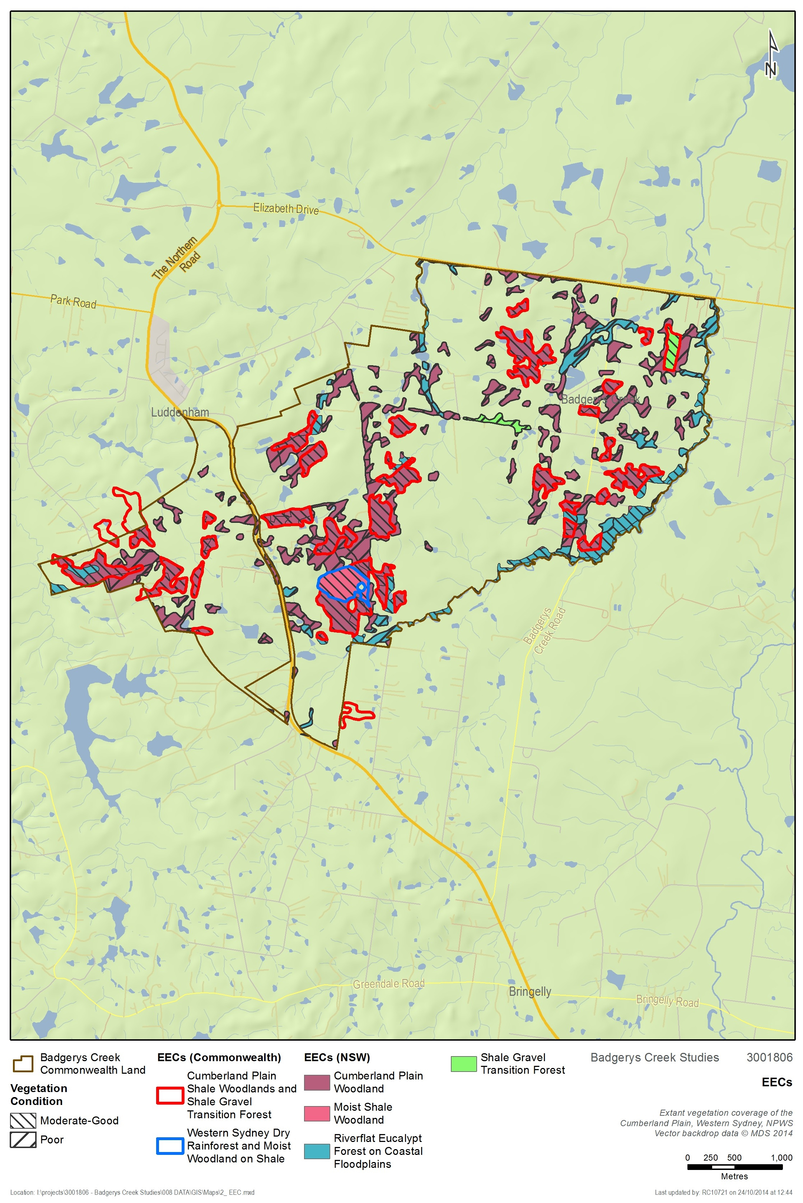
Figure 5: EECs within the study area
  - Threatened species and endangered populations
    - Flora
Ten flora species and two endangered populations listed under the TSC Act and/or EPBC Act have been recorded within 10 kilometres of the study area (OEH 2014a) (Appendix 3). A further twelve threatened flora species are identified as potentially occurring in the study area (OEH 2014a). Using a matrix based approach of the likelihood of occurrence (Appendix 3), the study area is considered to provide suitable habitat for eight of these species as well as the two endangered populations. Those with a medium to high chance of occurring within the study area include:

- Acacia pubescens (EPBC)
- Cynanchum elegans (EPBC)
- Dillwynia tenuifolia
- Dillwynia tenuifolia (population)
- Grevillea juniperina subsp. juniperina
- Grevillea parviflora subsp. parviflora (EPBC)
- Isotoma sessiliflora (Hypsela sessiliflora)
- Marsdenia viridiflora subsp. viridiflora (population)
- Pimelea spicata (EPBC)
- Pultenaea parviflora (EPBC)

Two of the threatened flora species identified in the desktop assessment as having a medium to high likelihood of occurring were specifically targeted and observed at the site during the March 2014 field survey, Pultenaea parviflora (EPBC – V, TSC – E1) and Marsdenia viridiflora subsp. viridiflora (TSC – E2).
Threatened flora recorded within and surrounding the study area are shown in Figure 6. Pultenaea parviflora and Marsdenia viridiflora subsp. viridiflora records within and surrounding the study area are shown in Figure 7. The historical record of Acacia pubescens along Longley’s Road within the study area could not be located on the ground and it is assumed that it is no longer present. The record was not included in the NPWS Wildlife Atlas and was identified in the National Recovery Plan for Acacia pubescens as an ‘excluded record - old and/or inadequate location’. There is an additional 1992 NSW Herbarium record from Elizabeth Drive (NPWS 1997 WSUBBS Flora Appendices 3) that is not included in the NPWS Wildlife Atlas or in the National Recovery Plan for Acacia pubescens but due to lack of location details no targeted search was undertaken.
Pultenaea parviflora has been previously recorded in the study area. Field surveys undertaken by SMEC, confirmed the presence of four (4) individuals of Pultenaea parviflora on the southern side of Longley’s Road between Ferndale and Taylors Road. Sixty-eight (68) individuals had been previously recorded along both sides of Longley’s Road in this location. A significant reduction in the size of this population has occurred since the 1999 survey. This reduction appears most likely due to observed road widening and possibly fencing works between the road reserve and adjoining paddock. It is noted that a good proportion of plants recorded in 1999 were young plants 50 cm or less high indicating that regeneration was occurring (Supplement to Draft EIS, Appendix F3). The life span of Pultenaea parviflora is estimated to be around twenty years (OEH profile) consequently these plants are expected to still be alive under natural conditions. At least 10 of the 68 plants were located on the roadside embankment, the habitat of which has since been lost. A single record located to the northwest of the Longleys Road population was targeted though no individual was found and habitat at the site was deemed to be unsuitable. An additional record to the south of the site was not specifically targeted as it could be seen that habitat at the site was not suitable and as such the individual was assumed to be absent.
Table 9: Recent survey details for Pultenaea parviflora and Marsdenia viridiflora subsp. viridiflora
Species &  clump no. | Location | Coordinates | Details | Vegetation community
Pultenaea parviflora  Clump 1 | Longleys Road (top of road verge c. 5 m from road edge & 1 m from fence within road reserve on southern side) | 289829 N  6248250 E | 1 plant 1 m high x 1.5 m wide. Flowers present. | Shale Gravel Transition Forest regrowth. Associated species: Bursaria spinosa, Dillwynia sieberi, Lissanthe sieberi, Astroloma humifusum, Cheilanthes sieberi, Dianella longifolia Themeda australis, Aristida vagans, Microlaena stipoides
Pultenaea parviflora  Clump 2 | Longleys Road (on adjoining leased property, southern side of road) | 289849 N  6248244 E | One plant 1.5 m high x 80cm wide just on other side of fence. | Shale Gravel Transition Forest regrowth. Associated species as above.
Pultenaea parviflora  Clump 3 | Longleys Road (top of road verge c. 5 m from road edge & 1 m from fence  within road reserve on southern side) | 289862 N  6248241 E | One plant 0.5 m high x 0.5 m wide. | Shale Gravel Transition Forest regrowth. Associated species as above.
Pultenaea parviflora  Clump 4 | Longleys Road (on roadside embankment at edge of zone impacted from road widening, within road reserve on southern side) | 289837 N  6248249 E | One damaged plant 0.3 m high x 0.2 m wide Several larger dead plants observed in close vicinity. Flowers present. | Shale Gravel Transition Forest regrowth. Associated species as above.
Marsdenia viridiflora subsp. viridiflora  Clump 1 | Longleys Road (road reserve on southern side). On upper embankment and above disturbed road edge. | 290039 N  6248218 E | Five plants growing up through Native Blackthorn Bursaria regrowth, climbing to 1-3 m high. | Shale Plains Woodland/Shale Gravel Transition Forest regrowth. Associated species: Bursaria spinosa, Exocarpos cupressiformis, Eucalyptus moluccana, Glycine tabacina, Microlaena stipoides, Exotic species: African Olive, Rhodes Grass & Mother of Millions.
Marsdenia viridiflora subsp. viridiflora  Clump 2 | Longleys Road (road reserve on southern side). On upper embankment and above disturbed road edge. | 290076 N  6248211 E | Three plants growing up through Native Blackthorn Bursaria regrowth, climbing to 1-3 m high. | Shale Plains Woodland/Shale Gravel Transition Forest regrowth. Associated species as above.
Marsdenia viridiflora subsp. viridiflora  Clump 3 | Longleys Road (road reserve on southern side). On upper embankment and above disturbed road edge. | 290123 N  6248201 E | 1 small plant growing among Native Blackthorn Bursaria regrowth. | Shale Plains Woodland/Shale Gravel Transition Forest regrowth. Associated species as above.
Marsdenia viridiflora subsp. viridiflora  Clump 4 | Longleys Road (road reserve on southern side). On upper embankment and above disturbed road edge. | 290082 N  6248210 E | 1 large and 2 small plants growing amongst Bursaria regrowth | Shale Plains Woodland/Shale Gravel Transition Forest regrowth. Associated species as above.
Marsdenia viridiflora subsp. viridiflora | Badgerys Creek Road, fence-line of road reserve on eastern side of road c. 20 m north of Gardiner Rd. | 291217 N  6249048 E | One plant (two stems) growing up fence. Road reserve generally weedy with Rhodes Grass and Verbena. | Disturbed Shale Plains Woodland, more intact on adjoining property. Eucalyptus regeneration and occasional plants of Pultenaea microphylla, Einadia hastata, Dichondra repens, Themeda australis, Aristida vagans & Dianella longifolia.

Marsdenia viridiflora subsp. viridiflora was also previously recorded in the study area. Field surveys undertaken by SMEC, confirmed the presence of one individual of Marsdenia viridiflora subsp. viridiflora along the eastern side of Badgerys Creek, just north of Gardiner Road. New records (12 individuals) were also found during the field survey on the southern side of Longley’s Road between Ferndale and Taylors Road. Details of survey records are summarised in Table 9.
The Pultenaea parviflora population along Longley’s Road is considered to be of low to medium conservation significance at state and national levels. Pultenaea parviflora is restricted to threatened Castlereagh woodlands, Shale Gravel Transition Forest and more rarely shale woodland in mostly central parts of the Cumberland Plain with population size from 1 to several thousand. The population along Longley’s Road is very small with four plants recorded in this survey although a much larger population (68 plants) was previously recorded. Despite the observed damage to habitat through road widening, it is possible that seed is present in areas of undisturbed soil and the population potentially larger than is immediately apparent. Recruitment occurs from seed and is largely dependent on fire. The Longley’s Road site is an outlier population occurring in atypical habitat (marginal occurrence of Tertiary alluvium within dominant shale environment) and could potentially represent a genetic variant important to the survival of the species. The location is close to the species southern geographical limit. Pultenaea parviflora is not well protected across its range outside of Windsor Downs, Castlereagh and Wianamatta Nature Reserves.
It is possible that Pultenaea parviflora occurs elsewhere within the study area in patches of Shale Gravel Transition Forest, an ecological community that was not previously identified in the 1999 EIS. Further targeted survey during spring is recommended.
The Marsdenia viridiflora subsp. viridiflora sub-population along Longley’s Road and Badgerys Creek Road is considered to be of medium conservation significance within the Sydney region and NSW. The TSC listed endangered population is generally restricted to small, fragmented remnants of Cumberland Plain Woodland and Shale Gravel Transition Forest in central to southern parts of the Cumberland Plain, population size is generally small and it is poorly protected in conservation reserves (Scientific Committee 2002, NPWS 1997 WSUBBS, OEH threatened species profile).
The sub-population within the study area is of relatively moderate size and close to the western limit of the endangered population. There is a reasonable probability that this species occurs elsewhere within the study area in view of the extent of potential habitat and the cryptic nature of the plant when growing in stands of Native Blackthorn Bursaria spinosa. Further targeted survey is recommended.
Other species identified as having a medium to high chance of occurring within the study area should also be subject to targeted survey, particularly the more cryptic Pimelea spicata.

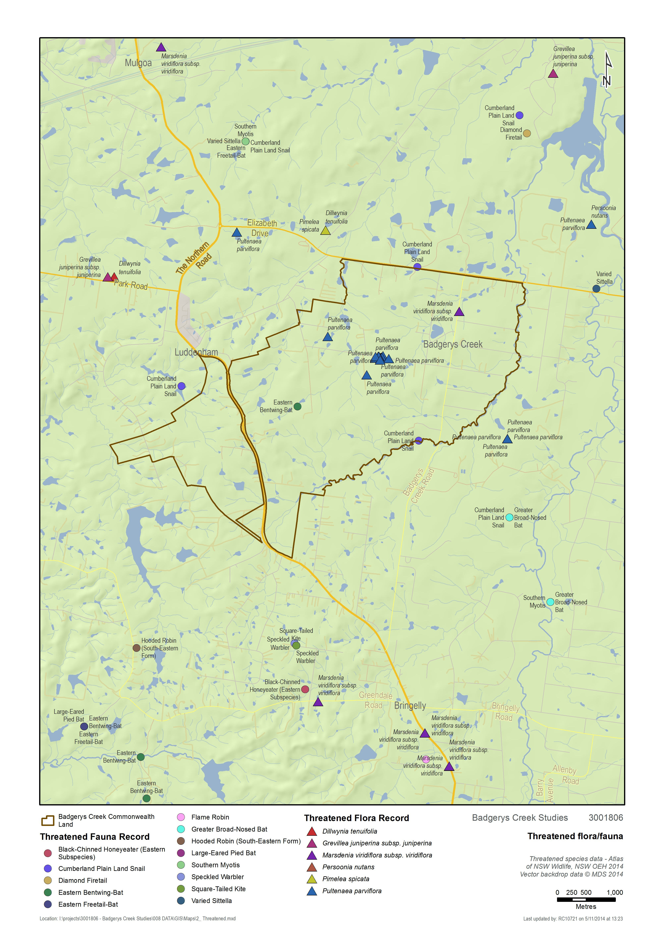
Figure 6: Threatened species records in and surrounding the study area
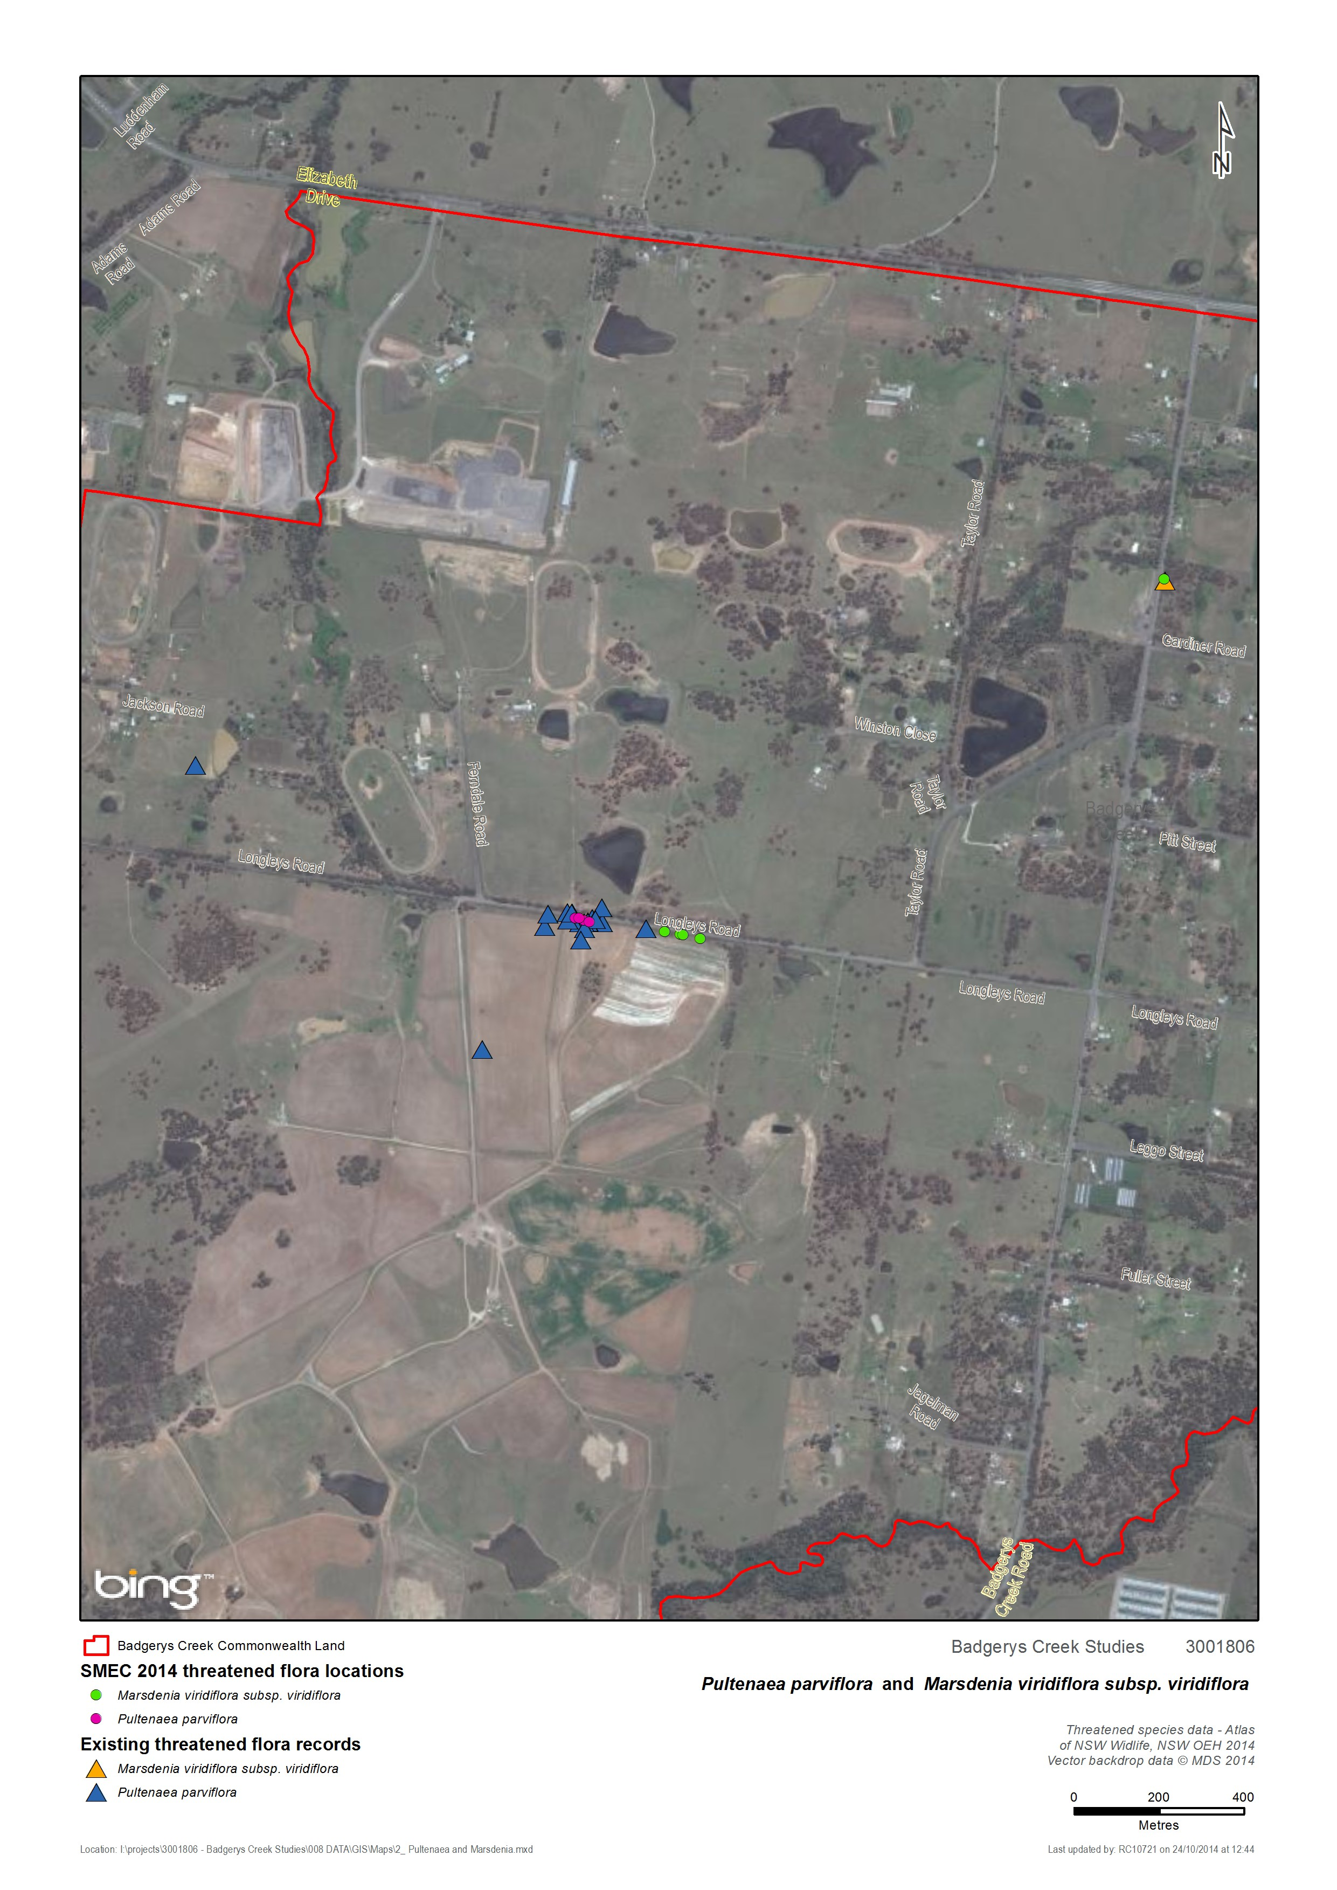
Figure 7: Pultenaea parviflora and Marsdenia viridiflora subsp. viridiflora records in and surrounding the study area
    - Fauna
Thirty-four threatened fauna species listed under the TSC Act and/or EPBC Act have been recorded within 10 kilometres of the study area (OEH 2014a) (Appendix 3). Of these, 33 are listed as threatened under the TSC Act and nine are listed as threatened under the EPBC Act (Appendix 3). A further eight threatened fauna species listed under the EPBC Act are identified as potentially occurring in the study area (DoE 2014b). Using a matrix based approach of the likelihood of occurrence (Appendix 3), the study area is considered to provide suitable habitat and resources for 26 of these species. Species that have a medium to high chance of occurring within the study area include:

- Giant Burrowing Frog (EPBC)
- Green and Golden Bell Frog (EPBC)
- Barking Owl
- Black-chinned Honeyeater
- Diamond Firetail
- Flame Robin
- Gang-gang Cockatoo
- Glossy Black-cockatoo
- Hooded Robin
- Little Eagle
- Little Lorikeet
- Powerful Owl
- Masked Owl
- Regent Honeyeater (EPBC)
- Scarlet Robin
- Speckled Warbler
- Square-tailed Kite
- Swift Parrot (EPBC)
- Varied Sittella
- Cumberland Plain Land Snail
- Eastern Bentwing Bat
- Eastern Freetail Bat
- Greater Broad-nosed Bat
- Grey-headed Flying-fox (EPBC)
- Large-eared Pied Bat (EPBC)
- Southern Myotis

No threatened fauna species were observed during the surveys undertaken by SMEC in September 2014, however no targeted threatened fauna surveys were undertaken. Threatened fauna records in the vicinity of the study area are shown in Figure 6.
There are no records of threatened or protected fish species listed under the FM Act occurring in the Liverpool LGA and no suitable habitat for any listed species occurs within the study area.
Although suitable feed trees for the Koala occur within the study area, it is unlikely suitable habitat is present for this species. Despite this a SEPP 44 and EPBC assessment for Koala habitat has been undertaken for completeness (see Section 5.12).
  - Migratory species
The results of the 10 kilometre database searches included numerous migratory species. Many of these species have not been considered in this biodiversity report due to the unsuitable nature of this terrestrial environment to provide any necessary habitat requirements. Species that may occasionally visit the study area have been included in this report (Appendix 3). Species not considered in this report include pelagic seabirds (i.e. albatross and petrel species) and marine species. This approach deemed the study area likely to provide suitable habitat and resources for seven migratory species listed under the EPBC Act:

- Cattle Egret
- Fork-tailed Swift
- Great Egret
- Latham’s Snipe
- Rainbow Bee-eater
- Rufous Fantail
- White-throated Needletail

No migratory species were observed during the surveys undertaken by SMEC in September 2014, however no targeted fauna surveys were undertaken.
  - Critical habitat
The subject site is not registered as critical habitat under NSW or Commonwealth legislation.
  - Groundwater dependent ecosystems
Badgerys Creek is identified as a groundwater dependent ecosystem (GDE) according to the Groundwater Dependent Ecosystems Atlas (BOM 2014).
The presence of potential GDEs was considered in this biodiversity report in relation to the NSW State Groundwater Dependent Ecosystems Policy (DLWC 2002). Several types of GDEs are recognised in NSW (Office of Water 2012) however the GDE with the most relevance to the study area is ‘terrestrial vegetation’ where forest or woodland may be sustained, either permanently or periodically by shallow groundwater that discharges to local creeks or rivers.
The NSW Office of Water Risk assessment guidelines for groundwater dependent ecosystems indicate that several vegetation communities that occur within the study area are likely to be ‘high probability groundwater dependent ecosystems’. These include:
- Cumberland Moist Shale Woodland
- Cumberland Shale Hills Woodland
- Cumberland Shale Plains Woodland
- Cumberland River Flat Forest
These GDEs are equivalent to vegetation communities described in the study area. As such it is likely that vegetation within these vegetation communities will have a moderate to high dependence upon groundwater at various times, including during low rainfall or drought periods. This will need to be further confirmed during any future environmental assessment for the site, and will need to take into account further site-specific hydrological assessment.
  - Aquatic habitat
Although there are no records of threatened or protected fish species listed under the FM Act occurring in the Liverpool LGA, the study area does contain key fish habitat according to the draft Policy and Guidelines for Fish Habitat Conservation and Management – Update 2013 (DPI 2013). Key fish habitat is shown in Figure 8.
Key fish habitat under this policy is classified by its ‘sensitivity’ and ‘waterway classification’.
‘Sensitivity’ is defined by the importance of the habitat to the survival of fish (noting that ‘fish’ under the FM Act includes all aquatic invertebrates) and its robustness (ability to withstand disturbance). Key fish habitat in the study area is classified as Type 3 - Minimally sensitive key fish habitat.
The waterway classification scheme is adapted from Fairfull and Witheridge (2003) and factors in the functionality of the waterway as fish habitat. Key fish habitat in the study area is classified as Class 3 Minimal Key Fish Habitat: Named or unnamed waterway with intermittent flow and sporadic refuge, breeding or feeding areas for aquatic fauna (e.g. fish, yabbies). Semi-permanent pools form within the waterway or adjacent wetlands after a rain event. Otherwise, any minor waterway that interconnects with wetlands or other CLASS 1-3 fish habitats.
Aquatic habitats within the site have the potential to be adversely affected by future development in the area. Additional and ongoing water quality testing would be recommended in order to provide an adequate baseline against which impacts may be measured. It should be noted in this context that no aquatic ecological assessment was undertaken during field investigations for this report.

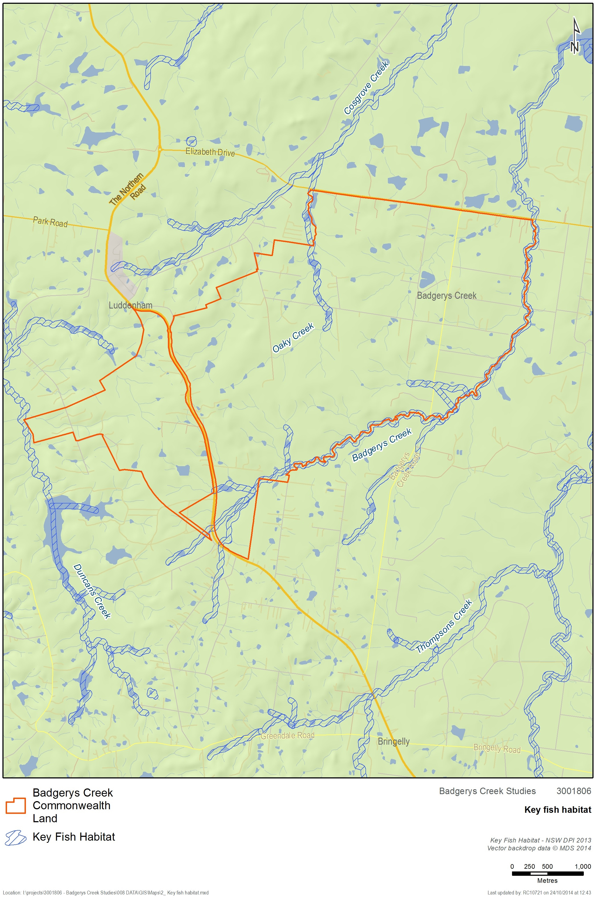
Figure 8: Key fish habitat
  - Wildlife connectivity corridors
Parts of the study area have been identified within the Liverpool City Council Biodiversity Management Plan as ‘regionally connected vegetation’, and ‘riparian corridor’ (Liverpool City Council 2012).
The Draft EIS for the Second Sydney Airport Proposal also identifies Badgerys Creek (the waterway) as a corridor of high local significance. From desktop assessment it is clear that this waterway remains largely vegetated throughout the study area. It is likely that the creek forms an important (broadly) north-south corridor for wildlife movement within the site.
South Creek is located to the east of the study area. As with Badgerys Creek, this waterway was not specifically surveyed during field studies though is likely to provide an important north-south corridor for wildlife movement through western Sydney.
There is a high probability that the vegetation surrounding most waterways within the study area would be of a somewhat degraded condition based upon the prevalence of exotic vegetation generally in the area. Limited results from two sites sampled in the SMEC flora survey (away from the riparian zone but still within River-flat Forest) indicates that vegetation was in moderate condition. A detailed assessment of the condition and corridor value of these and other waterways present within the study area would be recommended to be undertaken as part of any future environmental assessment.
The WSUBBS identifies Badgerys Creek as riparian corridor between The Northern Road and Elizabeth Drive (WSUBBS 1997). The corridor was found to support Swamp Oak Forest dominated by Casuarina glauca intergrading with Red Gum-Cabbage Gum Forest. The report notes that the area has been affected by clearing for agriculture as well as water quality issues associated with chicken farming. It recommends the protection of vulnerable plant species and protection of the riparian corridor.
OEH are undertaking corridor mapping as part of linking landscapes in the locality. They are currently seeking feedback from local Councils (including Liverpool Council) on the draft map layers. The purpose of this mapping is to identifying areas for investment in conservation activities, including offsetting. The mapping is likely to be available in 2015.
  - Koala Habitat
    - Draft EPBC Act referral guidelines for the vulnerable koala
Consideration of these guidelines in this report is limited to identifying whether there is koala habitat in the study area and assessing the potential need for a referral which would need to be confirmed in any future environmental assessment.
In December 2013 the Commonwealth Department of the Environment replaced the Interim koala referral advice for proponents (DoE 2012) with the Draft EPBC Act referral guidelines for the vulnerable koala (DoE 2013a). These guidelines provide specific advice to proponents on how to avoid and mitigate development impacts on the koala. These guidelines set out a process in which the need for referral of the project to the Commonwealth is specified according to the location and habitat attributes of the proposed development site and having regard to the significance of impacts associated with the taking of the proposed action. This process is illustrated in Figure 9.
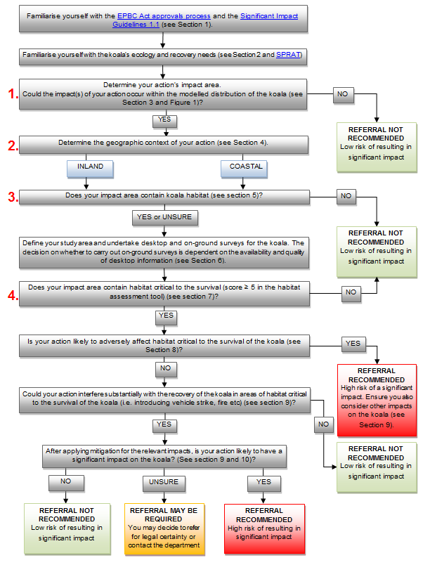
Figure 9: Draft EPBC Act referral guidelines for koala (DoE 2013a)
The process identified in the flowchart was undertaken in order to assess the potential for a significant impact of an action upon the koala or its habitat. The process undertaken is outlined below, with numbers correlating to those on the left of Figure.
- Could the impact(s) of your action occur within the modelled distribution of the koala?
The study area is within an area mapped as ‘Known/Likely to occur’.
- Determine the geographic context of your action
The study area is within the ‘coastal area’, as defined by the guidelines.
- Does your impact area contain koala habitat?
The draft EPBC Act referral guidelines for the vulnerable koala (DoE 2013a) state that: “For the purposes of these guidelines, koala habitat is defined as any forest or woodland containing species that are known koala food trees or shrubland with emergent food trees. This can include remnant or non-remnant vegetation in natural, agricultural and urban environments. Koala habitat is defined based on the plant community present and the vegetation structure; the koala does not necessarily have to be present.”
Based on the above definition and the plant species detected during initial site inspections (Eucalyptus tereticornis), listed as primary and secondary food trees respectively in the Hawkesbury Nepean CMA, the study area may be considered to contain koala habitat.
- Does your impact area contain habitat critical to the survival of the koala (score ≥ 5 in the habitat assessment tool)?
The draft EPBC Act referral guidelines provide a tool whereby a site may be assessed for its potential to be considered critical koala habitat. This tool is provided in Table 10, with the answers relevant to this site highlighted in blue.
Table 10: EPBC koala guidelines habitat assessment tool
Attribute | Score | Inland | Coastal
Koala occurrence | +2 (high) | Evidence of one or more koalas within the last 5 years. | Evidence of one or more koalas within the last 2 years.
 | +1 (medium) | Evidence of one or more koalas within 5 km of the edge of the impact area within the last 10 years. | Evidence of one or more koalas within 5 km of the edge of the impact area within the last 5 years.
 | 0 (low) | None of the above. | None of the above.
Vegetation composition | +2  (high) | Has forest, woodland or shrubland with emerging trees with 2 or more known koala food tree species in the canopy. | Has forest or woodland with 2 or more known koala food tree species in the canopy.
 | +1  (medium) | Has forest, woodland or shrubland with emerging trees with only 1 species of known koala food tree present in the canopy. | Has forest or woodland with only 1 species of known koala food tree present in the canopy.
 | 0 (low) | None of the above. | None of the above.
Habitat connectivity | +2  (high) | Area is part of a contiguous landscape ≥ 1000 ha. | Area is part of a contiguous landscape ≥ 500 ha.
 | +1  (medium) | Area is part of a contiguous landscape < 1000 ha, but ≥ 500 ha. | Area is part of a contiguous landscape < 500 ha, but ≥ 300 ha.
 | 0  (low) | None of the above | None of the above.
Key existing threats | +2  (low) | Little or no evidence of koala mortality from vehicle strike or dog attack at present in areas that score 1 or 2 for koala occurrence. | Little or no evidence of koala mortality from vehicle strike or dog attack at present in areas that score 1 or 2 for koala occurrence.
 | +1  (medium) | Evidence of infrequent or irregular koala mortality from vehicle strike or dog attack at present in areas that score 1 or 2 for koala occurrence. | Evidence of infrequent or irregular koala mortality from vehicle strike or dog attack at present in areas that score 1 or 2 for koala occurrence.
 | 0  (high) | Evidence of frequent or regular koala mortality from vehicle strike or dog attack in the study area at present, or | Areas which score 0 for koala occurrence and have a significant dog or vehicle threat present.
Recovery value | +2 (high) | Habitat is likely to be important for achieving the interim recovery objectives for the relevant context. | Habitat is likely to be important for achieving the interim recovery objectives for the relevant context.
 | +1 (medium) | Uncertainty exists as to whether the habitat is important for achieving the interim recovery objectives for the relevant context. | Uncertainty exists as to whether the habitat is important for achieving the interim recovery objectives for the relevant context.
 | 0 (low) | Habitat is unlikely to be important for achieving the interim recovery objectives for the relevant context. | Habitat is unlikely to be important for achieving the interim recovery objectives for the relevant context.

The koala habitat assessment tool provided an overall score of two for the Badgerys Creek site. Based upon this and the results of the previous flowchart steps it is deemed that a referral to the DoE specifically for potential impacts upon the koala would not be required.
While the result of the above process is likely to be very similar to that undertaken on behalf of future development on the site it is recommended that it is repeated at that stage in order to confirm these findings.
    - SEPP 44
This Policy concerns the protection of core koala habitat, habitat with evidence of koala usage, or areas of native potential habitat. Potential koala habitat within the Liverpool LGA is defined as any area that has at least 15 per cent of trees in the upper and lower strata comprised of Schedule 2 feed tree species: forest red gum (Eucalyptus tereticornis), tallowwood (Eucalyptus microcorys), grey gum (Eucalyptus punctata), manna gum (Eucalyptus viminalis), river red gum (Eucalyptus camaldulensis), broad leaved scribbly gum (Eucalyptus haemastoma), scribbly gum (Eucalyptus signata), white box (Eucalyptus albens), poplar box (Eucalyptus populnea) and swamp mahogany (Eucalyptus robusta).
No individuals, or characteristic scratching or scats, were identified during the initial flora and fauna survey, with no evidence to suggest a resident koala population exists within the study area. Therefore it is unlikely that the study area would be classified as core koala habitat.
One of the feed tree species was recorded within the study area (Eucalyptus tereticornis), and it comprised up to 15 per cent of the upper and lower strata of three of the sites visited, suggesting there is potential koala habitat as defined in SEPP 44 in the study area. Other parts of the study area not visited by SMEC in 2014 may also meet the definition of potential koala habitat under SEPP 44.
  - Key Threatening Processes
The following Key Threatening Processes listed under the TSC Act are likely to be operating within the study area:
- Alteration to the natural flow regimes of rivers and streams and their floodplains and wetlands.
- Clearing of native vegetation.
- Competition and grazing by the feral European rabbit (Oryctolagus cuniculus)
- Infection of frogs by amphibian chytrid causing the disease chytridiomycosis.
- Infection of native plants by Phytophthora cinnamomi.
- Introduction and Establishment of Exotic Rust Fungi of the order Pucciniales pathogenic on plants of the family Myrtaceae.
- Invasion of native plant communities by African Olive (Olea europaea L. subsp. cuspidata).
- Invasion and establishment of exotic vines and scramblers.
- Invasion by native plant communities by exotic perennial grasses.
- Invasion, establishment and spread of lantana (Lantana camara).
- Loss of hollow-bearing trees.
- Loss and degradation of native plant and animal habitat by invasion of escaped garden plants, including aquatic plants.
- Predation by the European Red Fox (Vulpes vulpes).
- Predation by the feral cat (Felis catus).
- Predation by Gambusia holbrooki Girard, 1859 (plague minnow or mosquito fish).
- Removal of dead wood and dead trees.
Management of land within the study area should seek to reduce the impact of these KTPs or at least reduce the likelihood of exacerbating the effect of the KTPs. Other KTPs may be introduced to the study area if there is a land use change.
The following TAPs are likely to be relevant to the study area:
- Predation by the red fox (Vulpes vulpes).
- Predation by Gambusia holbrooki (plague minnow).
Management guidance provided in these documents should be considered in relation to management of land in the study area.

- Key findings and information gaps
  - Overview of key findings
The key findings of this report are as follows:
  - Flora
- Biodiversity values within the study area are of national, state, regional and local significance. A diverse range of threatened vegetation communities occur across low-lying plains and more hilly terrain in the south-west. Most of EPBC listed vegetation in the study area likely to meet condition thresholds occurs as larger remnants with over 76% of the total area in patches of over 5 ha and approximately 40% in patches of over 25 ha. There are no priority conservation lands greater than 50 ha in size, however, as identified in the Cumberland Plain Recovery Plan (DECCW 2011). There is moderate to good connectivity between remnants along both drainage-lines and roadsides, particularly in the northern and western parts. Patch size and connectivity within the study area is generally higher than on adjoining lands to the north and north-west, comparable to lands to the south and lower than to the west and east.
- The majority of mapped vegetation in the study area is Shale Plains Woodland and Shale Hills Woodland (124.5 and 208 hectares respectively), both components of Cumberland Plain Woodland and included in the EPBC listing for Cumberland Plain Shale Woodlands and Shale-Gravel Transition Forest and the TSC Act listing for Cumberland Plain Woodlands. Only the larger, higher condition remnants of Cumberland Plain Woodlands are likely to meet the condition thresholds of the EPBC Act determination.
- A small amount of Shale Gravel Transition Forest (9.1 ha) has been identified from recent field survey in the study area associated with small patches of Tertiary alluvium and/or high concentrations of iron-hardened gravels. This community has not previously been mapped in the study area and it is likely that additional patches could occur. Shale Gravel Transition Forest is listed separately under the TSC Act but is included in the EPBC listing for Cumberland Plain Shale Woodlands and Shale-Gravel Transition Forest.
- A small area of Moist Shale Woodland (13.5 ha) has been identified in the study area during field survey at higher elevations on rolling topography south-east of Luddenham. Moist Shale Woodland has not been previously mapped in the study area. This vegetation community is listed separately under the TSC Act and is part of the EPBC listing for Western Sydney Dry Rainforest and Moist Woodland on Shale.
- The condition of vegetation remnants in the supplement to the Draft EIS was largely described as poor to very poor (48 out of 53 remnants visited). Using current condition assessment methods, including an estimate of native species richness, field survey undertaken in September 2014 found that ten out of the twelve sites visited would be classified as moderate to good condition.
- Field surveys undertaken by SMEC, confirmed the presence of four individuals of Pultenaea parviflora on the southern side of Longley’s Road between Ferndale and Taylors Road. Sixty-eight individuals had been previously recorded along both sides of Longley’s Road in this location. A significant reduction in the size of this population has occurred since the Draft EIS. This reduction appears most likely due to observed road widening and possibly fencing works between the road reserve and adjoining paddock.
- Marsdenia viridiflora subsp. viridiflora was also previously recorded in the study area. Field surveys undertaken by SMEC, confirmed the presence of one individual along the eastern side of Badgerys Creek, just north of Gardiner Road. New records (12 individuals) were also found during the field survey on the southern side both sides of Longleys Road between Ferndale and Taylors Road.
- No other threatened flora species have been found in the study area, however, there is potential habitat for a further seven threatened flora species and one endangered population.
- Six of the threatened flora species with potential habitat in the study area are listed under the EPBC Act. These are Acacia pubescens, Cynanchum elegans, Grevillea parviflora subsp. parviflora, Pultenaea parviflora, Isotoma sessiliflora and Pimelea spicata.
- Nine noxious weeds declared in the Liverpool LGA (Noxious Weeds Act 1993) were observed in the study area, six of these are Weeds of National Significance.
- The NSW Office of Water Risk assessment guidelines for groundwater dependent ecosystems indicate that several vegetation communities that occur within the study area are likely to be ‘high probability groundwater dependent ecosystems’.
- Management strategies have been provided in order to minimise impact on native flora (Section 7.2 ).
  - Fauna
- The study area contains low to moderate quality habitat, including riparian vegetation open woodland and grassland vegetation.
- Badgerys Creek has been identified as a potential wildlife corridor in a number of local and regional planning documents.
- Potential habitat is available within the study area for 26 threatened fauna species including the Cumberland Plain Land Snail, woodland birds, microchiropteran bats and the Grey-headed Flying-fox. No targeted surveys for threatened fauna species were undertaken during the September 2014 surveys.
- Six of the threatened fauna species with potential habitat in the study area are listed under the EPBC Act. These are the Giant Burrowing Frog, Green and Golden Bell Frog, Regent Honeyeater, Swift Parrot, Large-eared Pied Bat and Grey-headed Flying-fox.
- Seven migratory species, Cattle Egret, Fork-tailed Swift, Great Egret, Latham’s Snipe, Rainbow Bee-eater, Rufous Fantail and White-throated Needletail have also been identified as having potential habitat in the study area.
- Management strategies have been recommended in order to minimise impact on native fauna (Section 7.2 ).
  - Information gaps
There are a number of information gaps that exist due to:
- New and improved standards for flora and fauna survey since the Draft EIS and Supplement were prepared.
- Improvement in knowledge of species distribution and significance.
- Changes in legislative status of biodiversity.
The following gaps have been identified that would need to be addressed in any future environmental assessment:
- Vegetation communities have not been accurately described for the study area at the level of detail required for any future environmental assessment. The study area is included in the Native Vegetation of the Cumberland Plain mapping (NPWS 2002f), however, there are some communities that were identified in the study area during SMEC field surveys that have not been previously mapped in the study area. Further vegetation survey is required to determine the extent of these vegetation communities. Areas of potential derived native grassland observed during fieldwork were also mapped as ‘cleared’. Further assessment of the extent of derived native grasslands would also be required.
- Vegetation condition has not been accurately assessed in the study area. There is a large discrepancy between vegetation condition descriptions for vegetation remnants in the 1999 EIS and the vegetation condition observed at a selection of the same remnants by SMEC during field surveys, using current accepted condition assessment methods. Further vegetation survey is required to determine the condition of remnant vegetation in the study area. EPBC Act listing information for EECs specifies patch size and condition thresholds for identification. Detailed vegetation condition information would allow a subset of vegetation that would meet the EPBC definition to be accurately quantified.
- There is a lack of recent survey effort for threatened flora. Suitable habitat exists for eight flora species and two endangered populations (Acacia pubescens, Cynanchum elegans, Dillwynia tenuifolia, Grevillea juniperina subsp. juniperina, Grevillea parviflora subsp. parviflora, Isotoma sessiliflora (Hypsela sessiliflora), Marsdenia viridiflora subsp. viridiflora, Pimelea spicata and Pultenaea parviflora) within the study area. Targeted surveys for these species in areas of suitable habitat would be required for any future environmental assessment.
- There is also a lack of recent survey effort for threatened fauna. A range of fauna survey guidelines have been developed by Commonwealth and State regulatory agencies in recent years to increase the likelihood of detecting a species if present in the study area. Suitable habitat exists for 33 threatened or migratory fauna species within the study area. Targeted surveys for these species in areas of suitable habitat would be required for any future environmental assessment.
- Surveys of the site undertaken in the late 1990s would not be suitable for use as part of future environmental assessment of the site as they are now outdated. This is due to several changes in the site and legislative context in the intervening period including: updates to Commonwealth environmental legislation and supporting regulation (such as threatened flora and fauna survey and assessment guidelines), changes to the suite of listed threatened species (both NSW and Commonwealth), changes in the ecological and physical condition of the site, as well as the nature of land use. Previous surveys may however provide a useful general background of the site and the nature of change over time. Any future surveys would need to adhere to the guidelines outlined in Chapter 3.
- The existing biodiversity information available for the study area would also be inadequate to allow quantification of impacts and possible offsets required as a result of any future development of the site in accordance with either the EPBC Act Environmental Offset Policy and associated Offset Assessment Guide or the NSW Biodiversity Offsets Policy for Major Projects.
- Detail on aquatic flora and fauna is patchy and inconsistently reported in previous studies. Aquatic surveys previously undertaken at the site will require updating prior to any future development. This will include resurveying all relevant waterways including streams, creeks, dam and wetlands within the site.
To fill these gaps the following would be required:
- Further assessment of remnant vegetation is required to accurately determine the extent of vegetation communities present, particularly the extent of Moist Shale Woodland and Shale Gravel Transition Forest components of EPBC listed EECs.
- Further field assessment is required to better detail the extent and condition of EPBC Act listed vegetation as a subset of TSC Act listed vegetation in line with patch size and condition thresholds in the EPBC conservation advice for EECs. Survey methods will need to be consistent with current accepted standards and guidelines.
- Targeted threatened flora and fauna survey for all species listed in Appendix 4 as having a medium to high risk of occurrence would be required to bring the level of information into line with current accepted standards and guidelines. Requirements for survey for each of the 12 flora and 33 fauna species requiring survey including duration, timing and techniques are detailed in Appendix 4.
Recommendations for future survey are provided in Section 7.1 and Appendix 4.

- Recommendations
  - Survey recommendations
To adequately describe the biodiversity values of the study area for any future environmental assessment of the study area, information gaps identified in Section 6.2 would need to be addressed. This would require detailed vegetation survey and mapping, targeted threatened flora searches and seasonal fauna surveys. The following survey activities are recommended:
- Detailed vegetation community and condition mapping of the study area. This would involve additional site stratification and vegetation sampling using plot surveys, including full floristics, to supplement the vegetation plot assessment already undertaken by SMEC in 2014. This additional plot survey would be used to inform preparation of detailed vegetation community and condition mapping.
- Targeted threatened flora survey for ten threatened flora species in areas of potential habitat in the study area during the appropriate flowering season. Species to be surveyed for include, Acacia pubescens (EPBC), Cynanchum elegans (EPBC), Dillwynia tenuifolia, Grevillea juniperina subsp. juniperina, Grevillea parviflora subsp. parviflora (EPBC), Isotoma sessiliflora (Hypsela sessiliflora), Marsdenia viridiflora subsp. viridiflora, Pimelea spicata (EPBC) and Pultenaea parviflora (EPBC).
- Targeted survey for 26 threatened fauna species with potential habitat in the study area. All potential threatened species are listed under the TSC Act, with five of these also listed under the EPBC Act. These are:

Giant Burrowing Frog (EPBC)
Green and Golden Bell Frog (EPBC)
Barking Owl
Black-chinned Honeyeater
Diamond Firetail
Flame Robin
Gang-gang Cockatoo
Glossy Black-cockatoo
Hooded Robin
Little Eagle
Little Lorikeet
Powerful Owl
Masked Owl
Regent Honeyeater (EPBC)
Scarlet Robin
Speckled Warbler
Square-tailed Kite
Swift Parrot (EPBC)
Varied Sittella
Cumberland Plain Land Snail
Eastern Bentwing Bat
Eastern Freetail Bat
Greater Broad-nosed Bat
Grey-headed Flying-fox (EPBC)
Large-eared Pied Bat (EPBC)
Southern Myotis

- Targeted survey for seven migratory species with potential habitat in the study area. Species to be surveyed for include Cattle Egret, Fork-tailed Swift, Great Egret, Latham’s Snipe, Rainbow Bee-eater, Rufous Fantail and White-throated Needletail.
- Further survey of representative aquatic environments throughout the study area, with targeted surveys undertaken for known threatened aquatic flora and fauna.
Specific techniques and timing of surveys for all threatened species described above is provided in Appendix 4.

  - Management recommendations
Within the context of future development plans for the site and to the extent that is practicable and reasonable, consideration should be given to implementing the management measures described in Table 11 to protect and enhance existing ecological assets and values.
Should a formal development proposal for the site come forward, appropriate management measures should be prepared as part of that proposal’s environmental assessment. Any such future recommendations for environmental management should be consistent with best practice guidance and subject to further detailed field investigations. Future management of the Commonwealth land should consider the “avoid/mitigate/offset” hierarchy of impact management.
Where impacts arising from future development are deemed unavoidable or cannot otherwise be mitigated through management actions, consideration should be given to potential offsetting arrangements consistent with relevant legislative and policy requirements.
It should be noted that the management measures below have been prepared on the basis of protecting and enhancing existing ecological assets and values within the study area, including threatened flora and ecological communities, as well as habitat for threatened fauna. As the land within the study area is nearly all Commonwealth owned the measures provided have been primarily prepared for the protection of matters of national environmental significance. In doing so however many NSW state objectives for threatened species management will also be met.
The management measures provided are broadly listed in order of priority for managing ecological values.

Table 11: Recommended management measures for the Badgerys Creek site
Objective | Ref | Management measure
Protection of native vegetation and habitat. | A1 | Protect EPBC listed Cumberland Plain Shale Woodland and Shale-Gravel Transition Forest and Western Sydney Dry Rainforest and Moist Woodland on Shale.
 | A2 | Protect all moderate to good condition native vegetation in the study area.
 | A3 | Protect nectar producing trees and shrubs.
 | A4 | Revegetate/rehabilitated degraded sites with flora species which are native to the local vegetation community and are appropriate to the site’s long term management.
 | A5 | Fence off better condition remnants from grazing.
 | A6 | Restrict informal recreational activities (e.g. off-road motor vehicles) from areas of EEC.
Protection of threatened flora species and their habitat. | B1 | Protect areas where Pultenaea parviflora and Marsdenia viridiflora have been recorded.
 | B2 | Consider seed collection/propagation of P. parviflora and M. viridiflora should these populations be at risk of further clearing.
 | B3 | Ensure road maintenance activities along Longleys and Badgerys Creek Road don’t affect known P. parviflora and Marsdenia viridiflora populations.
 | B4 | Ensure agricultural activities on adjoining properties don’t affect known P. parviflora and M. viridiflora populations.
Protection of threatened fauna and their habitat. | C1 | Retain mature and hollow bearing trees and supplement with nest boxes.
 | C2 | Restrict use of pesticides to control weeds particularly near watercourses and immediately before or during wet weather.
 | C3 | Retain habitat features including dead wood and trees.
 | C4 | Regeneration works in riparian areas should include placement of rocks and logs to enhance existing aquatic habitat.
 | C5 | Undertake regeneration activities in strategic locations to improve habitat connectivity.
 | C6 | Maintain native grasses in pasture.
Weeds | D1 | Undertake noxious weed control in accordance with the Noxious Weeds Act 1993.
 | D2 | Undertake weed control in accordance with best practice, including control of environmental weeds.
Pests and Pathogens | E1 | Implement measures to prevent the spread of chytrid fungus. Adopt hygiene protocol standards for the control of disease in frogs.
 | E2 | Follow protocol to prevent introduction or spread of Phytophthora cinnamomi. The protocols used should be either the Sydney Region Pest Management Strategy or Best Practice Guidelines for Phytophthora cinnamomi (DECC 2008f).
 | E3 | Myrtle Rust is to be managed in accordance with the DPI handout prepared for Myrtle rust response 2010–11: Preventing spread of Myrtle Rust in bushland or the OEH Interim management plan for Myrtle rust in bushland (2011).
 | E4 | Implement pest management control for vertebrate pests.
Hydrology and Drainage | F1 | Implement controls to prevent pollution of local waterways.
 | F2 | Manage riparian and in-stream fish habitat
 | F3 | Restrict access of livestock to riparian areas.
 | F4 | Reduce the potential for diffuse pollution from overland runoff or stock access.
 | F5 | Control sediment at the catchment and local site scale.
 | F6 | Identify and manage point sources of pollution
 | F7 | Undertake further macroinvertebrate survey for the purposes of assessing ongoing water quality
General | G1 | Land management standards, including management measures to support biodiversity as outlined above, to be included as part of new tenancy agreements.

- References and Bibliography
Bannerman S.M. and Hazelton P.A. (1990) Soil Landscapes of the Penrith 1:100,000 Sheet map and report, Soil Conservation Service of NSW, Sydney
BoM (2014) Groundwater Dependent Ecosystems Atlas, Bureau of Meteorology, Melbourne.
Cropper, S.C. (1993) Management of Endangered Plants, CSIRO East Melbourne, Victoria.
DEC (2004) Threatened Biodiversity Survey and Assessment: Guidelines for Developments and Activities, NSW Department of Environment and Conservation NSW, Hurstville.
DEC (2005a) Draft Recovery Plan for the Green and Golden Bell Frog (Litoria aurea). NSW Department of Environment and Conservation, Hurstville.
DEC (2005b) Recovering Bushland on the Cumberland Plain: Best practice guidelines for the management and restoration of bushland, NSW Department of Environment and Conservation, Hurstville.
DEC (2006a) NSW Recovery Plan for the Large Forest Owls: Powerful Owl (Ninox strenua), Sooty Owl (Tyto tenebricosa) and Masked Owl (Tyto novaehollandiae). Department of Environment and Conservation, Sydney.
DEC (2006b) Persoonia nutans R. Br. (Nodding Geebung) Recovery Plan, NSW Department of Environment and Conservation, Sydney.
DEC (2006c) Pimelea spicata R. Br. Recovery Plan, NSW Department of Environment and Conservation, Sydney.
DECC (2008a) About the Priorities Action Statement, Department of Environment and Climate Change NSW, Sydney.
DECC (2008b) Best practice guidelines Cooks River Castlereagh Ironbark Forest, Department of Environment and Climate Change NSW, Sydney.
DECC (2008c) Best practice guidelines for the grey-headed flying fox, Department of Environment and Climate Change NSW, Sydney.
DECC (2008d) Rapid Fauna Habitat Assessment of the Sydney Metropolitan Catchment Management Authority Area, Department of Environment and Climate Change, Hurstville.
DECC (2008e) Recovery Plan for the Koala (Phascolarctos cinereus), Department of Environment and Climate Change NSW, Sydney.
DECC (2008f) Statement of Intent 1: Infection of native plants by Phytophthora cinnamomi. NSW Department of Environment and Climate Change (Sydney NSW. Available from: http://www.environment.nsw.gov.au/resources/threatenedspecies/08119soipc.pdf
DECCW (2010) Draft New South Wales Biodiversity Strategy 2010–2015, Department of Environment, Climate Change and Water NSW, Sydney.
DECCW (2010) Native Vegetation Interim Type Standard, Department of Environment, Climate Change and Water NSW, Sydney.
DECCW (2010) Report on the methodology for identifying priority conservation lands on the Cumberland Plain, Department of Environment, Climate Change and Water NSW, Sydney.
DECCW (2011) Cumberland Plain Recovery Plan, Department of Environment, Climate Change and Water NSW, Sydney.
Department of Environment and Heritage (2003) EPBC Act Administrative Guidelines on Significance - Supplement for the Grey-headed Flying-fox, Department of Environment and Heritage, Canberra.
Department of Environment and Heritage (2006) Threat Abatement Plan: Infection of amphibians with chytrid fungus resulting in chytridiomycosis, Department of Environment and Heritage, Canberra.
Department of Environment and Resource Management (2011) National recovery plan for the large-eared pied bat Chalinolobus dwyeri, State of Queensland, Brisbane.
Department of Sustainability, Environment, Water, Population and Communities (2011a) Survey guidelines for Australia’s threatened fish, Department of Sustainability, Environment, Water, Population and Communities, Canberra.
Department of Sustainability, Environment, Water, Population and Communities (2011b) Survey guidelines for Australia’s threatened mammals, Department of Sustainability, Environment, Water, Population and Communities, Canberra.
Department of Sustainability, Environment, Water, Population and Communities (2011c) Survey guidelines for Australia’s threatened reptiles, Department of Sustainability, Environment, Water, Population and Communities, Canberra.
Department of Transport and Regional Development (DTRD) (1997) Draft Environmental Impact Statement Second Sydney Airport Proposal, (Vols 1, 2) prepared by PPK Environment & Infrastructure, Sydney.
Department of Transport and Regional Services (1999) Supplement to the Draft Environmental Impact Statement Second Sydney Airport Proposal, (Vols 3,4,5 )prepared by PPK Environment & Infrastructure, Sydney.
DEWHA (2008) Threat abatement plan for competition and land degradation by rabbits, Department of the Environment, Water, Heritage and the Arts, Canberra.
DEWHA (2008) Threat abatement plan for predation by the European red fox, Department of the Environment, Water, Heritage and the Arts, Canberra.
DEWHA (2009a) Significant impact guidelines for 36 migratory shorebird species: migratory species. Department of the Environment, Water, Heritage and the Arts, Parkes, ACT.
DEWHA (2009b) Significant Impact Guidelines for the vulnerable Green and Golden Bell Frog, Policy Statement 3.19, Department of Environment, Water, Heritage and the Arts, Canberra.
DEWHA (2010a) Cumberland Plain Shale Woodlands and Shale-Gravel Transition Forest: A guide to identifying and protecting the nationally threatened ecological community, Policy Statement 3.31, Department of Environment, Water, Heritage and the Arts, Canberra.
DEWHA (2010b) Survey Guidelines for Australia’s Threatened Bats, Department of Environment, Water, Heritage and the Arts, Canberra.
DEWHA (2010c) Survey Guidelines for Australia’s Threatened Birds, Department of Environment, Water, Heritage and the Arts, Canberra.
DEWHA (2010d) Survey Guidelines for Australia’s Threatened Frogs, Department of Environment, Water, Heritage and the Arts, Canberra.
DLWC (2002) The NSW State Groundwater Dependent Ecosystems Policy. Department of Land and Water Conservation.
DoE (2013a) Draft EPBC Act referral guidelines for the vulnerable koala (combined populations of Queensland, New South Wales and the Australian Capital Territory), Department of Environment, Canberra.
DoE (2013b) Draft survey guidelines for Australia's threatened orchids, Department of Environment, Canberra.
DoE (2013c) Environment Protection and Biodiversity Conservation Act 1999 Environmental Offsets Policy, Department of Environment, Canberra.
DoE (2013d) Significant impact guidelines 1.1: Matters of National Environmental Significance, Department of Environment, Canberra.
DoE (2014a) Cooks River/Castlereagh Ironbark Forest in the Sydney Basin bioregion: draft description, Department of Environment, Canberra.
DoE (2014b) Protected Matters Database - Search Tool Department of Environment, Canberra. Available from: http://www.environment.gov.au/epbc/pmst
DoE (2014c) Threat abatement plan for disease in natural ecosystems caused by Phytophthora cinnamomi, Department of Environment, Canberra.DPI (2013) Draft Policy and Guidelines for Fish Habitat Conservation and Management – Update 2013, Department of Primary Industries, Nelson Bay.
DPI (2013) Draft Policy and Guidelines for Fish Habitat Conservation and Management – Update 2013, Department of Primary Industries, Nelson Bay.
DPI (2014a). Fishing and Aquaculture: Threatened and Protected Species, Hawkesbury/Nepean CMA, NSW Department of Primary Industry. Available from: http://www.dpi.nsw.gov.au/fisheries.
DPI (2014b). Agriculture. Noxious weeds declaration. NSW Department of Primary Industry Available from: http://www.dpi.nsw.gov.au/agriculture/pests-weeds/weeds/noxweed
Fairfull, S. and Witheridge, G. (2003) Why do Fish Need to Cross the Road? Fish Passage Requirements for Waterway Crossings, NSW Fisheries, Cronulla.
Hawkesbury-Nepean Catchment Management Authority (2013) Greater Sydney Local Land Service Transition Catchment Action Plan 2013-2023, Hawkesbury-Nepean Catchment Management Authority, Sydney.
James, T. (1997) Urban bushland biodiversity survey: native flora of western Sydney, flora appendices 2, National Parks & Wildlife Service, NSW, Hurstville.
Liverpool City Council (2012) Liverpool Biodiversity Management Plan, Liverpool City Council, Liverpool.
McDougall, K.L. and Summerell, B.A. (2002). Nomination to list ‘infection of native plants by Phytophthora cinnamomi as a key threatening process. Unpublished nomination to the NSW Scientific Committee prepared by the NSW National Parks and Wildlife Service and the Royal Botanic Gardens, Sydney.
Menkhorst, P., Schedvin, N., Geering, D. (1999) Regent Honeyeater Recovery Plan 1999 - 2003, Department of Natural Resources and Environment Victoria, Melbourne.
Mooney, P.A. and Pedler, L.P. (2005) Recovery Plan for the South Australian subspecies of the Glossy Black (Calyptorhynchus lathami halmaturinus): 2005-2010, Department for Environment and Heritage South Australia, Kingscote.
Natural Resource Management Ministerial Council (2006) Australian Weeds Strategy – A national strategy for weed management in Australia, Department of the Environment and Water Resources, Canberra.
Natural Resource Management Ministerial Council (2010) Australia’s Biodiversity Conservation Strategy 2010 - 2030, Department of Sustainability, Environment, Water, Population and Communities, Canberra.
NPWS (1997) Western Sydney Urban Bushland Biodiversity Survey, NSW National Parks and Wildlife Service, Hurstville.
NPWS (2000) Environmental Impact Assessment Guidelines for the Cumberland Plain Large Land Snail, NSW National Parks and Wildlife Service, Hurstville.
NPWS (2002a) Environmental Impact Assessment Guidelines for Cynanchum elegans, NSW National Parks and Wildlife Service, Hurstville.
NPWS (2002b) Environmental Impact Assessment Guidelines for Dillwynia tenuifolia, NSW National Parks and Wildlife Service, Hurstville.
NPWS (2002c) Environmental Impact Assessment Guidelines for Grevillea juniperina subsp. juniperina, NSW National Parks and Wildlife Service, Hurstville.
NPWS (2002d) Environmental Impact Assessment Guidelines for Grevillea parviflora subsp. parviflora, NSW National Parks and Wildlife Service, Hurstville.
NPWS (2002e) Environmental Impact Assessment Guidelines for Pultenaea parviflora, NSW National Parks and Wildlife Service, Hurstville.
NPWS (2002f) Interpretation Guidelines for the Native Vegetation Maps of the Cumberland Plain, Western Sydney, Final Edition NSW National Parks and Wildlife Service, Hurstville.
NPWS (2003a) Downy Wattle (Acacia pubescens) Recovery Plan, NSW National Parks and Wildlife Service, Hurstville.
NPWS (2003b) Environmental Impact Assessment Guidelines for Acacia pubescens, NSW National Parks and Wildlife Service, Hurstville.
NPWS (2003c) Environmental Impact Assessment Guidelines for the Green and Golden Bell Frog, NSW National Parks and Wildlife Service, Hurstville.
NPWS (2004d) Environmental Impact Assessment Guidelines for Pimelea spicata R. Br., NSW National Parks and Wildlife Service, Hurstville.
NSW Scientific Committee (2002a) Shale gravel transition forest in the Sydney Basin Bioregion - endangered ecological community listing – final determination.
NSW Scientific Committee (2002b) Moist shale woodland in the Sydney Basin Bioregion - endangered ecological community listing – final determination.
NSW Scientific Committee (2009) Cumberland Plain woodland - Critically endangered ecological community determination – final determination.
OEH (2014a) Atlas of NSW Wildlife. Office of Environment and Heritage, Sydney. Available from: http://www.bionet.nsw.gov.au.
OEH (2014b) NSW Biodiversity Offset Policy for Major Projects, Office of Environment and Heritage, Sydney.
OEH (2014c) Sydney Growth Centres Strategic Assessment Commitment 7 Cumberland Plain Woodland HMV and PCLs review: Outcomes Report, Office of Environment and Heritage, Hurstville.
OEH (2014d) The Native Vegetation of the Sydney Metropolitan Area. Version 2. NSW Office of Environment and Heritage, Hurstville.
OEH (2014e) Threatened species advanced search, Office of Environment and Heritage, Sydney. Available from: http://www.environment.nsw.gov.au/threatenedSpeciesAppRoyal Botanic Gardens and Domain Trust (2014) NSW Flora Online Search. PlantNET. Available from: http://plantnet.rbgsyd.nsw.gov.au/floraonline.htm
Royal Botanic Gardens and Domain Trust (2014) NSW Flora Online Search. PlantNET. Available from: http://plantnet.rbgsyd.nsw.gov.au/floraonline.htm
Saunders, D.L. and Tzaros, C.L. (2011) National Recovery Plan for the Swift Parrot Lathamus discolour. Birds Australia, Melbourne.
Serov, P., Kuginis, L., Williams, J.P. (2012) Risk assessment guidelines for groundwater dependent ecosystems, Volume 1 – The conceptual framework, NSW Department of Primary Industries, Office of Water, Sydney.
Tozer, M. (2003) ‘The native vegetation of the Cumberland Plain, western Sydney: systematic classification and field identification of communities’, Cunninghamia 8(1): 1–75.
Walker, P.H. (1960) A soil survey of the county of Cumberland, Sydney region, New South Wales Government Printer, Sydney.

Appendix 1: Vegetation community descriptions
The following vegetation descriptions come from ‘The native vegetation of the Cumberland Plain, western Sydney: systematic classification and field identification of communities’ (Tozer 2003).
Shale Plains Woodland (MU10)
Shale Plains Woodland is dominated by Eucalyptus moluccana and E. tereticornis with E. crebra, E. eugenioides and Corymbia maculata occurring less frequently. These species often form a separate small tree stratum, occasionally including other species such as Exocarpos cupressiformis, Acacia parramattensis subsp. parramattensis and Acacia decurrens. A shrub stratum is usually present and dominated by Bursaria spinosa. Common ground stratum species include Dichondra repens, Aristida vagans, Microlaena stipoides var stipoides, Themeda australis, Brunoniella australis, Desmodium varians, Opercularia diphylla, Wahlenbergia gracilis and Dichelachne micrantha. Shale Plains Woodland is the most widely distributed community on the Cumberland Plain. It predominantly occurs on soils derived from Wianamatta Shale, but also occurs on Holocene alluvium in well drained areas. Isolated patches of Shale Plains Woodland may be found on soils derived from the Mittagong Formation, but only in the vicinity of outcrops of almost pure shale. Very rarely, it may occur on soils derived from Tertiary alluvium, but it is more usual for Shale Plains Woodland to grade into Shale Gravel Transition Forest near the boundary of Shale and Tertiary alluvium. Towards the edge of the Cumberland Plain Shale Plains Woodland grades into Shale Sandstone Transition Forest (Low sandstone influence) as the depth of the shale soil decreases and the influence of the underlying sandstone increases. In the southern half of the study area Shale Plains Woodland grades into Shale Hills Woodland with increasing elevation and ruggedness. This gradation commences on the gentle rises running south from Prospect Reservoir in the centre of the plain, and south of Mulgoa Nature Reserve on the western boundary of the plain.
Shale Hills Woodland (MU9)
Shale Hills Woodland is dominated by Eucalyptus moluccana and E. tereticornis with E. crebra occurring less frequently. A small tree stratum is often present and frequently includes Acacia implexa together with a variety of the commonly occurring Eucalyptus species. Shale Hills Woodland typically has a shrub stratum dominated by Bursaria spinosa, and more rarely includes other species such as A. falcata, Breynia oblongifolia, Indigofera australis and Dodonaea viscosa subsp. cuneata. The ground stratum is variable in cover. A dense cover of grass and herb species is typical, but this may become quite sparse under a dense shrub canopy of B. spinosa or the exotic species Olea europaea subsp. africana. Species include Dichondra repens, Brunoniella australis, Aristida ramosa, Desmodium varians, Microlaena stipoides var. stipoides, Themeda australis and Cheilanthes sieberi subsp. sieberi.
Shale Hills Woodland occurs almost exclusively on soils derived from Wianamatta Shale though may occur occasionally on soils that are alluvial in nature. Shale Hills Woodland is closely related to Shale Plains Woodland but there is a reasonably clear differentiation between the habitats of the two communities. Shale Hills Woodland is largely confined to the southern half of the Cumberland Plain and occurs at higher elevations and on steeper slopes than Shale Plains Woodland. It is most often found on undulating country with a relatively high degree of ruggedness and rarely north of Mulgoa Nature Reserve and Prospect Reservoir. Stand of this vegetation are sometimes difficult to distinguish from Shale Plains Woodland. On very steep, sheltered hillsides Shale Hills Woodland grades into Moist Shale Woodland.
Alluvial Woodland (MU11)
Alluvial Woodland is most often dominated by Eucalyptus amplifolia and E. tereticornis with Angophora floribunda occurring less frequently. Alluvial Woodland often includes a stratum of small trees, frequently including Acacia parramattensis subsp. parramattensis, and less frequently Casuarina glauca, Angophora floribunda and Melaleuca linariifolia. A shrub stratum is usually evident, but is often sparse and invariably dominated by Bursaria spinosa. Alluvial Woodland often has a dense ground cover dominated by grasses such as Oplismenus aemulus, Microlaena stipoides var. stipoides, Entolasia marginata and Echinopogon ovatus. Herb species are also common, including Solanum prinophyllum, Pratia purpurascens and Commelina cyanea.
Shale Gravel Transition Forest (MU103)
Shale Gravel Transition Forest is usually dominated by Eucalyptus fibrosa with E. moluccana and E. tereticornis occurring less frequently, but sometimes dominating in the absence of E. fibrosa. Melaleuca decora is frequently present in a small tree stratum. A sparse shrub stratum is usually present and typically includes species such as Bursaria spinosa, Daviesia ulicifolia and Lissanthe strigosa. A variety of forb species were recorded with high frequency, including Microlaena stipoides subsp. stipoides, Cheilanthes sieberi subsp. sieberi, Themeda australis, Opercularia diphylla, Lomandra multiflora subsp. multiflora, Aristida vagans, Pratia purpurascens and Wahlenbergia gracilis. Shale Gravel Transition Forest occurs primarily in areas where shallow deposits of Tertiary alluvium overlie shale soils, but also in association with localised concentrations of iron-indurated gravel. Ironstone accretions are more resistant to weathering than shale and may become concentrated on ridgelines through the long-term erosion of shale. This community is likely to have been found in the Auburn-Bankstown area in association with the gravels of the Villawood soil series (Walker 1960), although native vegetation in this area has been extensively cleared. Shale Gravel Transition Forest grades into Shale Plains Woodland as alluvial and ironstone influences decline. On thicker deposits of Tertiary alluvium it grades into Castlereagh Ironbark Forest or Castlereagh Scribbly Gum Woodland. South of the Tertiary alluvial deposits at Holsworthy, this community apparently occurs on soils of the Mittagong Formation, and forms complex mosaics with shale/sandstone transitional communities.
Moist Shale Woodland (MU14)
Moist Shale Woodland is dominated by Eucalyptus tereticornis and E. moluccana, with E. crebra and Corymbia maculata occurring more occasionally. A small tree stratum consisting of the same species is often evident, and this may occasionally include species such as Acacia implexa or Acacia parramattensis subsp. parramattensis. A relatively sparse shrub stratum is usually present and dominated by mesophyllic species. Breynia oblongifolia, Clerodendrum tomentosum, Sigesbeckia orientalis subsp. orientalis, Bursaria spinosa and Olearia viscidula are commonly occurring shrub species. The ground stratum is variable in cover and contains species such as Desmodium varians, Cyperus gracilis, Galium propinquum, Cayratia clematidea, Glycine clandestina, Brunoniella australis, Desmodium brachypodum, Dichondra repens, Microlaena stipoides var. stipoides and Solanum prinophyllum.
Moist Shale Woodland occurs exclusively on soils derived from Wianamatta shale and is restricted to rugged areas at higher elevations in the southern half of the Cumberland Plain. This community appears to represent the endpoint of the gradient in increasing elevation, rainfall and ruggedness from the central Cumberland Plain to the Razorback range at Picton. This gradient is paralleled by a transition from Shale Plains Woodland through Shale Hills Woodland with Moist Shale Woodland occurring on the upper portion of very steep sheltered slopes. Moist Shale Woodland is found in very similar environments to Dry Rainforest. Moist Shale Woodland tends to occupy upper slopes while Dry Rainforest is often found on lower slopes and in gullies, which presumably provides a more reliably moist environment for the constituent rainforest species.

Table 12: Vegetation community equivalences
EPBC Name | EPBC Status | TSC Name | TSC status | NPWS (2002)/ Tozer Map Unit | NSW PCT (OEH 2012)
Cumberland Plain Shale Woodlands and Shale-Gravel Transition Forest | CE | Cumberland Plain Woodland | CE | Shale Plains Woodland (MU10) | 849 Grey Box – Forest Red Gum grassy woodland on flats of the Cumberland Plain, Sydney Basin.
 |  |  |  | Shale Hills Woodland (MU9) | 850 Grey Box – Forest Red Gum grassy woodland on shale of the southern Cumberland Plain, Sydney Basin.
 |  | Shale Gravel Transition Forest | E | Shale Gravel Transition Forest (MU103). | 724 Broad-leaved Ironbark – Grey Box – Melaleuca decora grassy open forest on clay/gravel soils of the Cumberland Plain, Sydney Basin.
Western Sydney Dry Rainforest and Moist Woodland on Shale | CE | Moist Shale Woodland | E | Moist Shale Woodland (MU14) | 830 Forest Red Gum – Grey Box shrubby woodland on shale of the Cumberland Plain, Sydney Basin.
n/a | Not listed | River Flat Eucalypt Forest on Coastal Floodplains | E | Alluvial Woodland (MU11) | 835 Forest Red Gum – Rough-barked Apple grassy woodland on alluvial flats of the Cumberland Plain, Sydney Basin.

Appendix 2: Field survey results
Table 13: Data collected during vegetation plot assessments
Plot No. | Location | Date | Easting | Northing | Vegetation Community (NPWS 2002f) |  |  | Dominant Species ( within 0.04 ha quadrat) |  |  |  | Native species richness (within 0.04 ha quadrat)
 |  |  |  |  |  | Stratum | Growth form | Species name | Cover % | Abund | Height to crown (m)
1 | 55 Longleys Rd | 22.9.2014 | 289029 | 6247658 | Shale Plains Woodland | Upper | T | Eucalyptus amplifolia | 25 | 11 | min 12-max 15 | 30
 |  |  |  |  |  | Upper | T | E. fibrosa | 8 | 5
 |  |  |  |  |  | Mid | S | Bursaria spinosa | 20 | 100 | min 1- max 3
 |  |  |  |  |  | Mid | S | Dillwynia sieberi | 4 | 5
 |  |  |  |  |  | Ground | S | Dillwynia sieberi | 4 | 30 | min 0- max 1
 |  |  |  |  |  | Ground | G | Microlaena stipoides | 20 | 500
 |  |  |  |  |  | Ground | G | Themeda australis | 10 | 100
2 | 55 Longleys Rd | 22.9.2014 | 288764 | 6247182 | Shale Plains Woodland | Upper | T | E. tereticornis | 40 | 15 | min 5-max 20 | 22
 |  |  |  |  |  | Upper | T | E. moluccana | 2 | 1
 |  |  |  |  |  | Mid | S | Bursaria spinosa | 40 | 50 | min 1- max 5
 |  |  |  |  |  | Ground | G | Microlaena stipoides | 65 | 1000 | min 0- max 0.2
 |  |  |  |  |  | Ground | O | Brunoniella australis | 5 | 100
 |  |  |  |  |  | Ground | O | Centella asiatica | 4 | 50
3 | 1850 The Northern Rd | 22.9.2014 | 288202 | 6246458 | Moist Shale Woodland | Upper | T | E. moluccana | 18 | 6 | min 15 - max 20 | 29
 |  |  |  |  |  | Mid | S | Bursaria spinosa | 50 | 100 | min 1- max 2.5
 |  |  |  |  |  | Ground | G | Chloris ventricosa | 15 | 50 | min 0- max 30
 |  |  |  |  |  | Ground | G | Microlaena stipoides | 20 | 100
 |  |  |  |  |  | Ground | O | Eremophila debilis | 10 | 50
4 | 365 Willowdene Rd | 23.9.2014 | 285418 | 6246499 | Shale Plains Woodland | Upper | T | E. moluccana | 5 | 3 | min 6-max 25 | 23
 |  |  |  |  |  | Upper | T | E. tereticornis | 20 | 18
 |  |  |  |  |  | Mid | S | Bursaria spinosa | 8 | 10 | min 1- max 3
 |  |  |  |  |  | Ground | G | Chloris ventricosa | 20 | 500 | min 0- max 1
 |  |  |  |  |  | Ground | G | Themeda australis | 10 | 200
 |  |  |  |  |  | Ground | G | Microlaena stipoides | 60 | 100
5 | 60 Gardiner Rd | 23.9.2014 | 291913 | 6249006 | Shale Plains Woodland | Upper | T | E. fibrosa | 5 | 3 | min 8 - max 18 | 33
 |  |  |  |  |  | Upper | T | E. eugenioides | 4 | 2
 |  |  |  |  |  | Upper | T | Melaleuca decora | 40 | 20
 |  |  |  |  |  | Mid | S | Bursaria spinosa | 5 | 50 | min 1-max 3
 |  |  |  |  |  | Mid | S | Melaleuca nodosa | 5 | 10
 |  |  |  |  |  | Ground | G | Microlaena stipoides | 20 | 200 | min 0- max 1
 |  |  |  |  |  | Ground | S | Cryptandra spinescens | 3 | 10
 |  |  |  |  |  | Ground | S | Bursaria spinosa | 4 | 20
6 | 65 Leggo Rd | 23.9.2014 | 291446 | 6247593 | Alluvial Woodland | Upper | T | E. amplifolia | 15 | 10 | min 5-max 20 | 25
 |  |  |  |  |  | Upper | T | Melaleuca decora | 25 | 14
 |  |  |  |  |  | Mid | S | Melaleuca decora | 3 | 3 | min 2- max 2
 |  |  |  |  |  | Ground | G | Themeda australis | 20 | 50 | min 0- max 0.5
 |  |  |  |  |  | Ground | G | Aristida vagans | 20 | 100
 |  |  |  |  |  | Ground | G | Microlaena stipoides | 15 | 50
7 | 595 Badgerys Creek Road | 23.9.2014 | 291101 | 6246935 | Alluvial Woodland | Upper | T | E. tereticornis | 10 | 20 | min 10 - max 20 | 23
 |  |  |  |  |  | Upper | T | E. moluccana | 5 | 8
 |  |  |  |  |  | Upper | T | Casuarina glauca | 5 | 7
 |  |  |  |  |  | Mid | S | Bursaria spinosa | 5 | 10 | min 1- max 3
 |  |  |  |  |  | Mid | T | Casuarina glauca | 2 | 3
 |  |  |  |  |  | Mid | T | E. tereticornis | 3 | 8
 |  |  |  |  |  | Ground | G | Microlaena stipoides | 50 | >1000 | min 0- max 0.7
 |  |  |  |  |  | Ground | G | Themeda australis | 5 | 50
 |  |  |  |  |  | Ground | O | Centella asiatica
8 | 75 Jagelman Rd | 23.9.2014 | 290474 | 6247598 | Shale Plains Woodland | Upper | T | E. moluccana | 30 | 10 | min 6-max 28 | 27
 |  |  |  |  |  | Upper | T | E. tereticornis | 2 | 1
 |  |  |  |  |  | Upper | T | Exocarpos cupressiformis | 3 | 1
 |  |  |  |  |  | Mid | S | Bursaria spinosa | 40 | 50 | min 1- max 3
 |  |  |  |  |  | Ground | G | Microlaena stipoides | 35 | 1000 | -
 |  |  |  |  |  | Ground | G | Chloris ventricosa | 10 | 50
 |  |  |  |  |  | Ground | G | Carex inversa | 4 | 50
9 | 70 Anton Rd | 25.9.2014 | 288091 | 6247875 | Shale Plains Woodland | Upper | T | E. tereticornis | 20 | 20 | min 5 - max 15 | 20
 |  |  |  |  |  | Mid | S | Bursaria spinosa | 3 | 2 | min 0 - max 2
 |  |  |  |  |  | Ground | G | Microlaena stipoides | 35 | 500 | min 0- max 0.5
 |  |  |  |  |  | Ground | G | Themeda australis | 10 | 100
 |  |  |  |  |  | Ground | O | Dichondra repens | 2 | 100
10 | 50 Anton Rd | 25.9.2014 | 288055 | 6248229 | Shale Plains Woodland | Upper | T | E. moluccana | 15 | 20 | min 5 - max 18 | 23
 |  |  |  |  |  | Upper | T | E. tereticornis | 10 | 10
 |  |  |  |  |  | Mid | S | Bursaria spinosa | 15 | 50 | -
 |  |  |  |  |  | Mid | S | Ozothamnus diosmifolius | 1 | 1
 |  |  |  |  |  | Ground | G | Micro strip | 10 | 500 | min 0- max 0.5
 |  |  |  |  |  | Ground | O | Aristida vagans | 5 | 50
 |  |  |  |  |  | Ground | O | Lomandra filiformis | 3 | 100
11 | 540 Badgerys Creek Rd | 25.9.2014 | 291042 | 6248316 | Shale Plains Woodland | Upper | T | E. moluccana | 12 | 11 | min 6 - max 20 | 17
 |  |  |  |  |  | Upper | T | E. tereticornis | 5 | 6
 |  |  |  |  |  | Mid | S | Bursaria spinosa | 10 | 10 | min 1 - max 2
 |  |  |  |  |  | Mid | S | Indigofera australis | 5 | 2
 |  |  |  |  |  | Ground | G | Microlaena stipoides | 500 | 30 | min 0- max 1
 |  |  |  |  |  | Ground | G | Chloris ventricosa | 50 | 5
 |  |  |  |  |  | Ground | G | Themeda australis | 50 | 5
12 | 2300 Elizabeth Dv | 25.9.2014 | 290314 | 6249049 | Shale Plains Woodland | Upper | T | E. tereticornis | 15 | 8 | min 10 - max 15 | 11
 |  |  |  |  |  | Mid | - | No natives | - | - | -
 |  |  |  |  |  | Ground | G | Microlaena stipoides | 10 | 500 | min 0- max 0.7
 |  |  |  |  |  | Ground | O | Einadia hastata | 3 | 50
 |  |  |  |  |  | Ground | O | Carex inversa | 5 | 500

Table 14: Site attributes
Plot No. |  | Cover % | (within 0.04 | ha quadrat) |  |  | Trees with hollows | Woody debris | Woody regeneration | Tree Health | Age Structure | Landuse | Other common native species | Main exotic species present
 | Stratum | Native cover | Exotic cover | Litter | Bare Ground | Cryptogam
1 | Upper | 33 | 0 | 10 | 15 | - | No | No | No | Main Branches Dead | Advanced regeneration | Grazing | Cymbopogon refractus, Lomandra filiformis, Brunoniella australis | Fireweed, Paddys Lucerne, Scotch Thistle
 | Mid | 24 | 5
 | Ground (Grasses) | 40 | 15
 | Ground (Shrubs) | 5 | 5
 | Ground (Other) | 10 | 10
2 | Upper | 42 | 0 | 4 | 4 | 0 | No | Yes | Yes | Main Branches Dead | Advanced regeneration | Grazing |  | African Olive, Fireweed, Paddys Lucerne
 | Mid | 40 | 0
 | Ground (Grasses) | 75 | 2
 | Ground (Shrubs) | 1 | 2
 | Ground (Other) | 10 | 2
3 | Upper | 18 | 0 | 10 | 10 | 0 | No | Yes | Yes | Small Branches Dead | Advanced regeneration | Grazing |  | African Olive, Paddys Lucerne, Bridal Creeper
 | Mid | 50 | 10
 | Ground (Grasses) | 40 | 10
 | Ground (Shrubs) | 0 | 5
 | Ground (Other) | 10 | 15
4 | Upper | 25 | - | 3 | 2 | - | Yes | Yes | Yes | Branchlets Dead | Advanced regeneration | Nature Conservation and Grazing | Desmodium varians, Einadia hastata, Solanum prinophyllum | African Olive
 | Mid | 8 | 5
 | Ground (Grasses) | 80 | 4
 | Ground (Shrubs) | 3 | -
 | Ground (Other) | 4 | 4
5 | Upper | 5 | - | 50 | 10 | 2 | - | Yes | No | no evidence | uneven age | Grazing recreation | Entolasia stricta, Aristida vagans
 | Mid | 10 | -
 | Ground (Grasses) | 25 | -
 | Ground (Shrubs) | 8 | -
 | Ground (Other) | 5 | 2
6 | Upper | 40 | - | 28 | 4 | - | No | Yes | Yes | Branchlets Dead | Advanced regeneration | Grazing vacant | Lomandra filiformis | African Olive, Fireweed, Paddys Lucerne
 | Mid | 3 | 2
 | Ground (Grasses) | 60 | 2
 | Ground (Shrubs) | 1 | -
 | Ground (Other) | 4 | 1
7 | Upper | 20 | - | 7 | 2 | - | No | Yes | Yes | Branchlets Dead | Advanced regeneration | Grazing horses | Oxalis perennans, Desmodium varians | Panic Veldt Grass, Slender Pigeon Grass, Fireweed, Paddys Lucerne
 | Mid | 10 | 1
 | Ground (Grasses) | 65 | 15
 | Ground (Shrubs) | 2 | 3
 | Ground (Other) | 4 | 2
8 | Upper | 35 | - | 16 | 6 | 2 | No | Yes | Yes | Branchlets Dead | uneven age | Grazing | Solanum prinophyllum, Cymbonotus lawsonianus, Einadia spp. | African Olive, Fireweed, Paddys Lucerne
 | Mid | 42 | 2
 | Ground (Grasses) | 60 | 0
 | Ground (Shrubs) | 4 | 4
 | Ground (Other) | 4 | 4
9 | Upper | 20 | - | 17 | 13 | 4 | No | Yes | Yes | Branchlets Dead, Trees Dead | Advanced regeneration | Grazing horses |  | African Olive, Fireweed, Paddys Lucerne, Bridal Creeper
 | Mid | 3 | 35
 | Ground (Grasses) | 50 | 2
 | Ground (Shrubs) | 5 | 1
 | Ground (Other) | 5 | 3
10 | Upper | 25 | - | 60 | 10 | - | No | Yes | Yes | Branchlets Dead | Advanced regeneration | Grazing | Dichondra repens, Brunoniella australis, Eremophila debilis, Entolasia marginata | African Boxthorn, African Olive, Fireweed, Apple of Sodom, Bridal Creeper, Panic Veldt Grass
 | Mid | 17 | 3
 | Ground (Grasses) | 17 | 3
 | Ground (Shrubs) | 3 | 1
 | Ground (Other) | 5 | 1
11 | Upper | 17 | - | 7 | 7 | - | No | Yes | Yes | Branchlets Dead | Advanced regeneration | Grazing | Einadia hastata | African Olive, Lantana, Bridal Creeper, Panic Veldt Grass, Paddys Lucerne
 | Mid | 15 | 10
 | Ground (Grasses) | 40 | 30
 | Ground (Shrubs) | 3 | 4
 | Ground (Other) | 5 | 4
12 | Upper | 15 | - | 5 | 5 | - | No | Yes | No | Trees Dead | Advanced regeneration | Heavy Grazing |  | African Boxthorn, Fireweed, Apple of Sodom, Panic Veldt Grass, Paddys Lucerne, Flatweed
 | Mid | - | 20
 | Ground (Grasses) | 15 | 50
 | Ground (Shrubs) | - | 5
 | Ground (Other) | 5 | 15

Table 15: Fauna species recorded during September 2014 field survey
Scientific Name | Common Name | Observation type
Amphibians
Crinia signifera | Eastern Common Froglet | W
Aves
Tachybaptus novaehollandiae | Australasian Grebe | O
Cracticus tibicen | Australian Magpie | O
Corvus coronoides | Australian Raven | O
Chenonetta jubata | Australian Wood Duck | O
Geopelia humeralis | Bar-shouldered Dove | O
Manorina melanophrys | Bell Miner | O/W
Coracina novaehollandiae | Black-faced Cuckoo-shrike | O
Falco berigora | Brown Falcon | O
Anas castanea | Chestnut Teal | O
Acridotheres tristis* | Common Myna | O
Ocyphaps lophotes | Crested Pigeon | O
Taeniopygia bichenovii | Double-barred Finch | O
Gallinula tenebrosa | Dusky Moorhen | O
Platycercus eximius | Eastern Rosella | O
Eopsaltria australis | Eastern Yellow Robin | O
Fulica atra | Eurasian Coot | O
Cracticus torquatus | Grey Butcherbird | O
Rhipidura albiscapa | Grey Fantail | O
Aythya australis | Hardhead | O
Microeca fascinans | Jacky Winter | O
Dacelo novaeguineae | Laughing Kookaburra | O
Cacatua sanguinea | Little Corella | O
Microcarbo melanoleucos | Little Pied Cormorant | O
Cacatua tenuirostris | Long-billed Corella | O
Grallina cyanoleuca | Magpie Lark | O
Vanellus miles | Masked Lapwing | O
Manorina melanocephala | Noisy Miner | O
Oriolus sagittatus | Olive-backed Oriole | O/W
Anas superciliosa | Pacific Black Duck | O
Phalacrocorax varius | Pied Cormorant | O
Strepera graculina | Pied Currawong | O
Porphyrio porphyrio | Purple Swamphen | O
Anthochaera carunculata | Red Wattlebird | O
Pycnonotus jocosus* | Red-whiskered Bulbul | O
Pachycephala rufiventris | Rufous Whistler | O
Acanthiza lineata | Striated Thornbill | O
Cacatua galerita | Sulphur-crested Cockatoo | O
Malurus cyaneus | Superb Fairy-wren | O/W
Sericornis frontalis | White-browed Scrubwren | O
Egretta novaehollandiae | White-faced Heron | O
Ardea pacifica | White-necked Heron | O
Lichenostomus penicillatus | White-plumed Honeyeater | O
Gerygone albogularis | White-throated Gerygone | O/W
Corcorax melanorhamphos | White-winged Chough | O
Rhipidura leucophrys | Willie Wagtail | O
Acanthiza nana | Yellow Thornbill | O
Platalea flavipes | Yellow-billed Spoonbill | O
Acanthiza chrysorrhoa | Yellow-rumped Thornbill | O
Reptiles
Lampropholis delicata | Dark-flecked Garden Sunskink | O
Varanus varius | Lace Monitor | O
Mammals
Oryctolagus cuniculus* | Rabbit | F/P
Wallabia bicolor | Swamp Wallaby | O
* introduced species
Observation Type:
A | Stranding/beached | I | Subfossil/Fossil Remains | R | Road kill
AR | Acoustic recording | J | Floristics Record from Systematic Flora Survey | S | Shot
B | Burnt | K | Dead | T | Trapped or netted
C | Cat kill | L | Flora Record | U | Ultrasonic recording
D | Dog kill | M | Miscellaneous | V | Fox kill
E | Nest/roost | N | Not located | W | Heard call
F | Tracks, scratchings | O | Observed | X | In scat
FB | Burrow | OW | Observed and Heard call | Y | Bone, teeth or shell
G | Crushed Cones | P | Scat | Z | In raptor/owl pellet
H | Hair, feathers or skin | Q | Camera

Appendix 3: Threatened flora and fauna species with the potential to occur in the study area.
Note: List of threatened species, populations, or ecological communities which may be affected directly or indirectly by the Project is derived from searches of the following databases as well as on ground survey conducted December 2013: Likelihood of occurrence is based on the risk matrix in Appendix 4.
- NSW Office of Environment and Heritage (OEH) Atlas of NSW Wildlife Database
- Protected Matters Report that documents all Matters of National Environmental Significance (MNES) within 10 km of site (Department of Sustainability, Environment, Water, Population and Communities)
- Department of Environment and Conservation (now OEH) Endangered Ecological Community and Threatened Species Profiles (OEH, 2013)
- NSW Flora Online Search – Rare or Threatened Australian Plants (ROTAP) species (The Royal Botanic Gardens and Domain Trust 2013)
- Department of Primary Industries: Fishing and Aquaculture – Profiles for species, populations and ecological communities (NSW Government, 2005)
Likelihood of occurrence is based on the risk matrix in Appendix 4.
V = Vulnerable species or ecological community.
E = Endangered species or ecological community
EP = Endangered population
X = Extinct
CE = Critically endangered species or ecological community

Table 16 Threatened fauna and flora species with the potential to occur in the study area
Scientific Name | Common Name |  |  |  |  |  | TSC Act/  FM Act |  |  |  |  | EPBC Act |  |  |  |  | No. Atlas Records |  |  |  |  | Habitat requirements |  |  | Likelihood – desktop |  |  |  |  |  |  | Likelihood – field survey |  |  | Likelihood of occurrence
FLORA
Flora (24)
Acacia pubescens | Downy Wattle |  |  |  |  |  | V |  |  |  |  | V |  |  |  |  | 12 |  |  |  |  | Occurs on alluviums, shales and at the intergrade between shales and sandstones. Soils are characteristically gravely soils, often with ironstone. Occurs in open woodland and forest, in a variety of plant communities, including Cooks River/Castlereagh Ironbark Forest, Shale/Gravel Transition Forest and Cumberland Plain Woodland. Concentrated around the Bankstown-Fairfield-Rookwood area, also Holroyd-Liverpool and the Pitt Town area. |  |  | B |  |  |  |  |  |  | C |  |  | High
Allocasuarina glareicola |  |  |  |  |  |  | E |  |  |  |  | E |  |  |  |  |  |  |  |  |  | Occurs in Castlereagh woodland on lateritic soil. Primarily restricted to the Richmond (NW Cumberland Plain) district, but with an outlier population found at Voyager Point, Liverpool. |  |  | D |  |  |  |  |  |  | F |  |  | Low
Cryptostylis hunteriana | Leafless Tongue-orchid |  |  |  |  |  | V |  |  |  |  | V |  |  |  |  |  |  |  |  |  | Does not appear to have well defined habitat preferences and is known from a range of communities, including swamp-heath and woodland. The larger populations typically occur in woodland dominated by Scribbly Gum (Eucalyptus sclerophylla), Silvertop Ash (E. sieberi), Red Bloodwood (Corymbia gummifera) and Black She-Oak (Allocasuarina littoralis); appears to prefer open areas in the understorey of this community and is often found in association with the Large Tongue Orchid (C. subulata) and the Tartan Tongue Orchid (C. erecta). |  |  | D |  |  |  |  |  |  | F |  |  | Low
Cynanchum elegans | White-flowered Wax Plant |  |  |  |  |  | E |  |  |  |  | E |  |  |  |  | 3 |  |  |  |  | Usually occurs on the edge of dry rainforest vegetation. Other associated vegetation types include littoral rainforest; Coastal Tea-tree – Coastal Banksia coastal scrub; Forest Red Gum aligned open forest and woodland; Spotted Gum aligned open forest and woodland; and Bracelet Honeymyrtle scrub to open scrub. |  |  | C |  |  |  |  |  |  | D |  |  | Moderate
Dillwynia tenuifolia |  |  |  |  |  |  | V |  |  |  |  |  |  |  |  |  |  |  |  |  |  | In western Sydney, may be locally abundant particularly within scrubby/dry heath areas within Castlereagh Ironbark Forest and Shale-Gravel Transition Forest on tertiary alluvium or laterised clays. May also be common in transitional areas where these communities adjoin Castlereagh Scribbly Gum Woodland. |  |  | B |  |  |  |  |  |  | B |  |  | High
Dillwynia tenuifolia | Dillwynia tenuifolia endangered population of Kemps Creek |  |  |  |  |  | EP,V |  |  |  |  |  |  |  |  |  | 69 |  |  |  |  | In western Sydney, may be locally abundant particularly within scrubby/dry heath areas within Castlereagh Ironbark Forest and Shale-Gravel Transition Forest on tertiary alluvium or laterised clays. May also be common in transitional areas where these communities adjoin Castlereagh Scribbly Gum Woodland. |  |  | A |  |  |  |  |  |  | B |  |  | High
Eucalyptus benthamii | Camden White Gum |  |  |  |  |  | V |  |  |  |  | V |  |  |  |  | 21 |  |  |  |  | Occurs on the alluvial flats of the Nepean River and its tributaries. Requires a combination of deep alluvial sands and a flooding regime that permits seedling establishment. |  |  | C |  |  |  |  |  |  | E |  |  | Low
Genoplesium baueri | Yellow Gnat-orchid |  |  |  |  |  | E |  |  |  |  | E |  |  |  |  |  |  |  |  |  | Occurs in coastal areas. Habitats include heathland, open forest, shrubby forest, heathy forest and woodland with sandy/sandy loam and well-draining soils. |  |  | D |  |  |  |  |  |  | F |  |  | Low
Grevillea juniperina subsp. juniperina | Juniper-leaved Grevillea |  |  |  |  |  | V |  |  |  |  |  |  |  |  |  | 90 |  |  |  |  | Grows on reddish clay to sandy soils derived from Wianamatta Shale and Tertiary alluvium (often with shale influence), typically containing lateritic gravels. |  |  | B |  |  |  |  |  |  | C |  |  | High
Grevillea parviflora subsp. parviflora | Small-flower Grevillea |  |  |  |  |  | V |  |  |  |  | V |  |  |  |  | 12 |  |  |  |  | Occurs in a range of vegetation types from heath and shrubby woodland to open forest. Found over a range of altitudes from flat, low-lying areas to upper slopes and ridge crests. Hunter occurrences are usually 30-70m ASL, while the southern Sydney occurrences are typically at 200-300m ASL. Recorded from transitional communities associated with sandstone and Tertiary alluvium. Often occurs in open, slightly disturbed sites such as along tracks. |  |  | B |  |  |  |  |  |  | E |  |  | Moderate
Haloragis exalata subsp. exalata | Wingless Raspwort |  |  |  |  |  | V |  |  |  |  | V |  |  |  |  |  |  |  |  |  | Square Raspwort occurs in four widely scattered localities in eastern NSW. It is disjunctly distributed in the Central Coast, South Coast and North Western Slopes botanical subdivisions of NSW. Square Raspwort appears to require protected and shaded damp situations in riparian habitats. |  |  | E |  |  |  |  |  |  | E |  |  | Low
Isotoma sessiliflora (Hypsela sessiliflora) |  |  |  |  |  |  | E |  |  |  |  | X |  |  |  |  | 7 |  |  |  |  | Known to grow in damp places, on the Cumberland Plain, including freshwater wetland, grassland/alluvial woodland and alluvial woodland/shale plains woodland (Cumberland Plain Woodland) ecotone. Known in recent years from only two adjacent sites on a single private property at Erskine Park in the Penrith LGA. There is some doubt about the taxonomy of this species and may be part of an Isotoma fluviatilis species complex (D. Albrecht pers. comm.). |  |  | B |  |  |  |  |  |  | D-C |  |  | Moderate to High
Marsdenia viridiflora subsp. viridiflora | Marsdenia viridiflora R. Br. Subsp. viridiflora population in the Bankstown, Blacktown, Camden, Campbelltown, Fairfield, Holroyd, Liverpool and Penrith local government areas |  |  |  |  |  | EP |  |  |  |  |  |  |  |  |  | 22 |  |  |  |  | Grows in vine thickets and open shale woodland. |  |  | A |  |  |  |  |  |  | A |  |  | High: Known to occur
Micromyrtus minutiflora |  |  |  |  |  |  | E |  |  |  |  | V |  |  |  |  |  |  |  |  |  | Grows in Castlereagh Scribbly Gum Woodland, Ironbark Forest, Shale/Gravel Transition Forest, open forest on tertiary alluvium and consolidated river sediments. |  |  | E |  |  |  |  |  |  | C |  |  | Low
Pelargonium striatellum | Omeo Stork’s-bill |  |  |  |  |  | E |  |  |  |  | E |  |  |  |  |  |  |  |  |  | Known from only 3 locations in NSW, with two on lake-beds on the basalt plains of the Monaro and one at Lake Bathurst. Has a narrow habitat that is usually just above the high-water level of irregularly inundated or ephemeral lakes, in the transition zone between surrounding grasslands or pasture and the wetland or aquatic communities. |  |  | E |  |  |  |  |  |  | F |  |  | Extremely low
Persoonia nutans | Nodding Geebung |  |  |  |  |  | E |  |  |  |  | E |  |  |  |  | 10 |  |  |  |  | Restricted to the Cumberland Plain in western Sydney, between Richmond in the north and Macquarie Fields in the south. The species has a disjunct distribution, with the majority of populations (and 99% of individuals) occurring in the north of the species range in the Agnes Banks, Londonderry, Castlereagh, Berkshire Park and Windsor Downs areas. Northern populations are confined to aeolian and alluvial sediments and occur in a range of sclerophyll forest and woodland vegetation communities. The southern and northern populations have distinct habitat differences. |  |  | C |  |  |  |  |  |  | E |  |  | Low
Pimelea curviflora var. curviflora |  |  |  |  |  |  | V |  |  |  |  | V |  |  |  |  |  |  |  |  |  | Confined to the coastal area of the Sydney and Illawarra regions. Occurs on shaley/lateritic soils over sandstone and shale/sandstone transition soils on ridgetops and upper slopes amongst woodlands. Also recorded in Illawarra Lowland Grassy Woodland habitat at Albion Park on the Illawarra coastal plain. There is a recent record from Tertiary alluvium at Castlereagh. |  |  | C |  |  |  |  |  |  | E |  |  | Low
Pimelea spicata | Spiked Rice-flower |  |  |  |  |  | E |  |  |  |  | E |  |  |  |  | 8 |  |  |  |  | Occurs on an undulating topography on well-structured clay soils. On the Cumberland Plain sites it is associated with Grey Box communities (particularly Cumberland Plain Woodland variants and Moist Shale Woodland) and in areas of ironbark. |  |  | B |  |  |  |  |  |  | C |  |  | High
Pomaderris brunnea | Rufous Pomaderris |  |  |  |  |  | E |  |  |  |  | V |  |  |  |  |  |  |  |  |  | Brown Pomaderris grows in moist woodland or forest on clay and alluvial soils of larger flood plains and creek lines. |  |  | D |  |  |  |  |  |  | D |  |  | Low
Pterostylis saxicola | Sydney Plains Greenhood |  |  |  |  |  | E |  |  |  |  | E |  |  |  |  |  |  |  |  |  | Restricted to western Sydney between Freemans Reach in the north and Picton in the south. Most commonly found growing in small pockets of shallow soil in depressions on sandstone rock shelves above cliff lines. |  |  | D |  |  |  |  |  |  | E |  |  | Low
Pultenaea parviflora |  |  |  |  |  |  | E |  |  |  |  | V |  |  |  |  | 103 |  |  |  |  | Endemic to the Cumberland Plain. Core distribution is from Windsor to Penrith and east to Dean Park. May be locally abundant, particularly within scrubby/dry heath areas within Castlereagh Ironbark Forest and Shale Gravel Transition Forest on tertiary alluvium or laterised clays. |  |  | A |  |  |  |  |  |  | A |  |  | High: Known to occur
Streblus pendulinus | Siah’s Backbone |  |  |  |  |  |  |  |  |  |  | E |  |  |  |  |  |  |  |  |  | Found in warmer rainforests, chiefly along watercourses. The species grows in well-developed rainforest, gallery forest and drier, more seasonal rainforest. |  |  | F |  |  |  |  |  |  | F |  |  | Extremely low
Syzygium paniculatum | Magenta Lilly Pilly |  |  |  |  |  | E |  |  |  |  | V |  |  |  |  | 1 |  |  |  |  | Grows in subtropical and littoral rainforest on sandy soils or stabilized dunes near the sea. |  |  | F |  |  |  |  |  |  | F |  |  | Extremely low
Thelymitra kangaloonica | Kangaloon Sun Orchid |  |  |  |  |  | CE |  |  |  |  | CE |  |  |  |  |  |  |  |  |  | Only known to occur on the southern tablelands of NSW in the Moss Vale/Kangaloon/Fitzroy Falls area at 550-700 m above sea level. It is known to occur at three swamps that are above the Kangaloon Aquifer. Found in swamps and sedgelands over grey silty grey loam soils. |  |  | F |  |  |  |  |  |  | F |  |  | Extremely low
Threatened Ecological Communities (22)
Agnes Banks Woodland in the Sydney Basin Bioregion |  |  |  |  |  |  | E |  |  |  |  |  |  |  |  |  | K |  |  |  |  | A low woodland dominated by Eucalyptus sclerophylla and Angophora bakeri with a diverse understorey of sclerophyllous shrubs species including Banksia oblongifolia, Conospermum taxifolium, Leptospermum trinervium, Dillwynia sericea, Monotoca scoparia and Persoonia nutans, and ground stratum species including Lepidosperma urophorum, Platysace ericoides, Pimelea linifolia, Mitrasacme polymorpha, Trachymene incisa and Stylidium graminifolium. |  |  | F |  |  |  |  |  |  | D |  |  | Low
Blue Gum High Forest in the Sydney Basin Bioregion |  |  |  |  |  |  | CE |  |  |  |  | CE |  |  |  |  | K |  |  |  |  | Tall forest typically grows in high rainfall areas, receiving more than 1,100 mm per year and on deep clay soils derived from Wianamatta Shale. It occurs at elevations of 50–178 m above sea level with gentle slopes. |  |  | F |  |  |  |  |  |  | F |  |  | Extremely low
Blue Mountains Shale Cap Forest in the Sydney Basin Bioregion |  |  |  |  |  |  | E |  |  |  |  | CE |  |  |  |  | K |  |  |  |  | Characteristic tree species of this ecological community are Mountain Blue Gum (Eucalyptus deanei), Monkey Gum (E. cypellocarpa) and Turpentine (Syncarpia glomulifera). Other tree species include Sydney Red Gum (Angophora costata), Rough-barked Apple (A. floribunda), Mountain Mahogany (E. notabilis), Sydney Peppermint (E. piperita) and Grey Gum (E. punctata). Tree species composition varies between sites depending on geographical location and local conditions (e.g. topography, rainfall exposure). |  |  | F |  |  |  |  |  |  | F |  |  | Extremely low
Blue Mountains Swamps in the Sydney Basin Bioregion |  |  |  |  |  |  | V |  |  |  |  | E |  |  |  |  | K |  |  |  |  | Characterised by a dense mixture of shrubs and sedges, most of which have sclerophyllous foliage. The shrub stratum typically varies from 0.5 m to over 2.0 m tall and is highly variable in cover. The ground stratum may be up to about 1 m tall and is dominated by a dense sward of sclerophyllous sedges and grasses except in patches where these are displaced by a dense cover of taller shrubs. Ferns, forbs and small shrubs are scattered amongst the sedges and grasses. There is considerable local variation within the swamps in species composition and vegetation structure, which is apparently related to local soil properties and fire history. |  |  | F |  |  |  |  |  |  | F |  |  | Extremely low
Castlereagh Scribbly Gum Woodland in the Sydney Basin Bioregion |  |  |  |  |  |  | V |  |  |  |  |  |  |  |  |  | K |  |  |  |  | Dominated by Eucalyptus parramattensis subsp. parramattensis, Angophora bakeri and E. sclerophylla. A small tree stratum of Melaleuca decora is sometimes present, generally in areas with poorer drainage. It has a well-developed shrub stratum consisting of sclerophyllous species such as Banksia spinulosa var. spinulosa, M. nodosa, Hakea sericea and H. dactyloides (multi-stemmed form). The ground stratum consists of a diverse range of forbs including Themeda australis, Entolasia stricta, Cyathochaeta diandra, Dianella revoluta subsp. revoluta, Stylidium graminifolium, Platysace ericoides, Laxmannia gracilis and Aristida warburgii (Tozer 2003). |  |  | F |  |  |  |  |  |  | D |  |  | Low
Castlereagh Swamp Woodland Community |  |  |  |  |  |  | E |  |  |  |  |  |  |  |  |  | K |  |  |  |  | Generally woodland or may occur as remnant trees. Characteristic tree species are Eucalyptus parramattensis subsp. parramattensis and Melaleuca decora. Small billabongs and/or wetlands may occur within the community.  Species composition at any site depends on local topography and drainage conditions; understorey may be seasonally waterlogged.  Typically is associated with poorly-drained depressions and creek lines on clay soils associated with Tertiary alluvium |  |  | F |  |  |  |  |  |  | D |  |  | Low
Cooks River/Castlereagh Ironbark Forest in the Sydney Basin Bioregion |  |  |  |  |  |  | E |  |  |  |  |  |  |  |  |  | K |  |  |  |  | Predominantly of open-forest to low woodland structure usually with trees of Eucalyptus fibrosa and Melaleuca decora, sometimes with Eucalyptus longifolia. A relatively dense shrub stratum is typical, commonly with Melaleuca nodosa and Lissanthe strigosa, and to a lesser extent Melaleuca decora. A variety of shrub species may occur, including Acacia pubescens, Dillwynia tenuifolia, Daviesia ulicifolia, Pultenaea villosa and Grevillea juniperina. Commonly occurring species in the ground stratum include Entolasia stricta, Lepidosperma laterale, Opercularia diphylla, Dianella revoluta, Themeda australis, Microlaena stipoides and Pratia purpurascens.  Usually occurs on clay soils on Tertiary alluvium, or on shale soils on Wianamatta Shale including the Birrong Soil Landscape and associated shale lowlands. |  |  | C |  |  |  |  |  |  | C |  |  | Moderate
Cumberland Plain Woodland in the Sydney Basin Bioregion |  |  |  |  |  |  | CE |  |  |  |  | CE |  |  |  |  | K |  |  |  |  | Dominant canopy trees are Grey Box (Eucalyptus moluccana) and Forest Red Gum (E. tereticornis), with Narrow-leaved Ironbark (E. crebra), Spotted Gum (Corymbia maculata) and Thin-leaved Stringybark (E. eugenioides) occurring less frequently. The shrub layer is dominated by Blackthorn (Bursaria spinosa), and it is common to find abundant grasses such as Kangaroo Grass (Themeda australis) and Weeping Meadow Grass (Microlaena stipoides var. stipoides). Contains many more species and other references should be consulted to identify these. |  |  | A |  |  |  |  |  |  | A |  |  | High: Know to occur
Elderslie Banksia Scrub Forest |  |  |  |  |  |  | E |  |  |  |  |  |  |  |  |  | K |  |  |  |  | A scrub community dominated by Coastal Banksia (Banksia integrifolia subsp. Integrifolia). Other canopy species include Broad-leaved Apple Angophora subvelutina. The shrubby understorey is diverse and includes species that usually occur in sandstone areas, such as Wedding Bush Ricinocarpus pinifolius, Riceflower (Pimelea linifolia subsp. linifolia) and Daphne Heath Brachyloma daphnoides. Contains many more species and other references should be consulted to identify these. |  |  | F |  |  |  |  |  |  | F |  |  | Extremely low
Freshwater Wetlands on Coastal Floodplains of the New South Wales North Coast, Sydney Basin and South East Corner Bioregions |  |  |  |  |  |  | E |  |  |  |  |  |  |  |  |  | K |  |  |  |  | Associated with coastal areas subject to periodic flooding and in which standing fresh water persists for at least part of the year in most years. Typically occurs on silts, muds or humic loams in low-lying parts of floodplains, alluvial flats, depressions, drainage lines, backswamps, lagoons and lakes but may also occur in backbarrier landforms where floodplains adjoin coastal sandplains. Generally occurs below 20 m elevation on level areas. Dominated by herbaceous plants with very few woody species. Structure and composition varies both spatially and temporally depending on the water regime. The threatened aquatic plants, Aldrovanda vesiculosa and Najas marina, also occur within this community. |  |  | B |  |  |  |  |  |  | D |  |  | Moderate
Moist Shale Woodland in the Sydney Basin Bioregion |  |  |  |  |  |  | E |  |  |  |  | CE |  |  |  |  | K |  |  |  |  | It differs from Cumberland Plain Woodland in having a shrub understorey that contains plants from moist habitats. Dominant canopy trees include Forest Red Gum Eucalyptus tereticornis, Grey Box E. moluccana, Narrow-leaved Ironbark E. crebra and Spotted Gum Corymbia maculata. Small trees, such as Hickory Wattle Acacia implexa and Sydney Green Wattle A. parramattensis subsp. parramattensis are also common. The shrub layer includes Breynia oblongifolia, Hairy Clerodendrum Clerodendrum tomentosum and Indian Weed Sigesbeckia orientalis subsp. orientalis. |  |  | A |  |  |  |  |  |  | A |  |  | High: Known to occur
Montane Peatlands and Swamps of the New England Tableland, NSW North Coast, Sydney Basin, South East Corner, South Eastern Highlands and Australian Alps bioregions |  |  |  |  |  |  | E |  |  |  |  | E |  |  |  |  | K |  |  |  |  | Dense, open or sparse layer of shrubs with soft-leaved sedges, grasses and forbs. The only type of wetland that may contain more than trace amounts of Sphagnum spp., the hummock peat-forming mosses. Small trees may be present as scattered emergents or absent.  Typically has an open to very sparse layer of shrubs, 1-5 m tall, (e.g. Baeckea gunniana, B. utilis, Callistemon pityoides, Leptospermum juniperinum, L. lanigerum, L. myrtifolium, L. obovatum, L. polygalifolium). Species of Epacris (e.g. E. breviflora, E. microphylla, E. paludosa) and Hakea microcarpa are also common shrubs. In some peatlands and swamps, particularly those with a history of disturbance to vegetation, soils or hydrology, the shrub layer comprises dense thickets of Leptospermum species. In other peatlands and swamps with a history of grazing by domestic livestock, the shrub layer may be very sparse or absent. |  |  | F |  |  |  |  |  |  | F |  |  | Extremely low
Newnes Plateau Shrub Swamp in the Sydney Basin Bioregion |  |  |  |  |  |  | E |  |  |  |  | E |  |  |  |  | K |  |  |  |  | Characteristically dominated by shrubs, with a variable cover of sedges. Shrubs have a dense to open cover, and include Baeckea linifolia, Grevillea acanthifolia subsp. acanthifolia, Epacris paludosa and Leptospermum species. The cover of sedges varies inversely with shrub cover. Common sedges include Baloskion australe, Empodisma minus, Lepyrodia scariosa and Lepidosperma limicola, while herbs include Patersonia fragilis and Xanthosia dissecta. Gleichenia dicarpa and Gymnoschoenus sphaerocephalus may occur around drainage lines, while Lomandra longifolia may be prominent around the swamp margins. Floristic composition varies locally in relation to soil moisture gradients within the swamps (Keith and Benson 1988; Benson and Keith 1990). |  |  | F |  |  |  |  |  |  | F |  |  | Extremely low
River-Flat Eucalypt Forest on Coastal Floodplains of the New South Wales North Coast, Sydney Basin and South East Corner Bioregions |  |  |  |  |  |  | E |  |  |  |  |  |  |  |  |  | K |  |  |  |  | Found on the river flats of the coastal floodplains. It has a tall open tree layer of eucalypts, which may exceed 40 m in height, but can be considerably shorter in regrowth stands or under conditions of lower site quality. While the composition of the tree stratum varies considerably, the most widespread and abundant dominant trees include Eucalyptus tereticornis (forest red gum), E. amplifolia (cabbage gum), Angophora floribunda (rough-barked apple) and A. subvelutina (broad-leaved apple). E. benthamii occurs on the Hawkesbury floodplain. |  |  | A |  |  |  |  |  |  | A |  |  | High: Known to occur
Shale-Gravel Transition Forest in the Sydney Basin Bioregion |  |  |  |  |  |  | E |  |  |  |  | CE |  |  |  |  | K |  |  |  |  | Has an open forest structure with a canopy dominated by Broad-leaved Ironbark Eucalyptus fibrosa, with Grey Box E. moluccana and Forest Red Gum E. tereticornis occurring less frequently. Paperbark Melaleuca decora is common in the small tree layer. A sparse shrub layer is usually present which includes Blackthorn Bursaria spinosa, Daviesia ulicifolia and Peach Heath Lissanthe strigosa. |  |  | A |  |  |  |  |  |  | A |  |  | High: Known to occur
Shale/Sandstone Transition Forest |  |  |  |  |  |  | E |  |  |  |  | E |  |  |  |  | K |  |  |  |  | Occurs at the edges of the Cumberland Plain, where clay soils from the shale rock intergrade with earthy and sandy soils from sandstone, or where shale caps overlay sandstone. The boundaries are indistinct, and the species composition varies depending on the soil influences. The main tree species include Forest Red Gum (Eucalyptus tereticornis), Grey Gum (E. punctata), stringybarks (E. globoidea, E. eugenioides) and ironbarks (E. fibrosa and E. crebra). Areas of low sandstone influence (more clay-loam soil texture) have an understorey that is closer to Cumberland Plain Woodland |  |  | D |  |  |  |  |  |  | F |  |  | Low
Southern Sydney sheltered forest on transitional sandstone soils in the Sydney Basin Bioregion |  |  |  |  |  |  | E |  |  |  |  |  |  |  |  |  | K |  |  |  |  | An open forest dominated by eucalypts with scattered subcanopy trees, a diverse shrub layer and a well-developed groundcover of ferns, forbs, grasses and graminoids. The dominant trees include Angophora costata, Eucalyptus piperita and occasionally E. pilularis, particularly around Helensburgh. Corymbia gummifera occurs frequently within the community, although generally at lower abundance than the other eucalypts. Features that distinguish Southern Sydney sheltered forest on transitional sandstone soils from vegetation more typical of sandstone gullies in the eastern Sydney basin include the occurrences of E. pilularis, Acacia binervata, Elaeocarpus reticulatus, Pittosporum undulatum and its relatively dense groundcover of ferns, grasses, rushes, lilies and forbs. There is considerable variation in species composition, richness and structure within the community in response to local soil variation and geographic gradients across the range. The community typically has an open forest structure, although disturbance may result in local manifestations as woodland or scrub. |  |  | F |  |  |  |  |  |  | F |  |  | Extremely low
Sun Valley Cabbage Gum Forest in the Sydney Basin Bioregion |  |  |  |  |  |  | CE |  |  |  |  |  |  |  |  |  | K |  |  |  |  | Sun Valley Cabbage Gum Forest is dominated by Eucalyptus amplifolia (Cabbage Gum) with E. eugenioides (Thin-leaved Stringybark) as an associated tree. Native understorey species include Acacia parramattensis, Imperata cylindrica, Lomandra longifolia and Pteridium esculentum.  Occurs in the Sun Valley in the Blue Mountains City Council local government area. About 15 hectares of the community remains, mostly in poor condition. |  |  | F |  |  |  |  |  |  | F |  |  | Extremely low
Swamp Oak Floodplain Forest of the New South Wales North Coast, Sydney Basin and South East Corner Bioregions |  |  |  |  |  |  | E |  |  |  |  |  |  |  |  |  | K |  |  |  |  | Found on the coastal floodplains of NSW. Dense to sparse tree layer. Species include Acmena smithii (Lilly pili), Glochidion spp. (cheese trees) and Melaleuca spp. (paperbarks) may be present as subordinate species, and are found most frequently in stands of the community northwards from Gosford. Tree diversity decreases with latitude. The understorey is characterised by frequent occurrences of vines, Parsonsia straminea, Geitonoplesium cymosum and Stephania japonica var. discolor, a sparse cover of shrubs, and a continuous groundcover of forbs, sedges, grasses and leaf litter.  The composition of the ground stratum varies depending on levels of salinity in the groundwater. Under less saline conditions prominent ground layer plants include forbs such Centella asiatica, Commelina cyanea, Persicaria decipiens and Viola banksii; graminoids such as Carex appressa, Gahnia clarkei, Lomandra longifolia, Oplismenus imbecillis; and the fern Hypolepis muelleri.  On the fringes of coastal estuaries, where soils are more saline, the ground layer may include the threatened grass species, Alexfloydia repens, as well as Baumea juncea, Juncus kraussii, Phragmites australis, Selliera radicans and other saltmarsh species. |  |  | F |  |  |  |  |  |  | F |  |  | Extremely low
Swamp Sclerophyll Forest on Coastal Floodplains of the New South Wales North Coast, Sydney Basin and South East Corner Bioregions |  |  |  |  |  |  | E |  |  |  |  |  |  |  |  |  | K |  |  |  |  | Has an open to dense tree layer of eucalypts and paperbarks although some remnants now only have scattered trees as a result of partial clearing. The trees may exceed 25 m in height, but can be considerably shorter in regrowth stands or under conditions of lower site quality where the tree stratum is low and dense. For example, stands dominated by Melaleuca ericifolia typically do not exceed 8 m in height. The community also includes some areas of fernland and tall reedland or sedgeland, where trees are very sparse or absent. |  |  | F |  |  |  |  |  |  | F |  |  | Extremely low
Western Sydney Dry Rainforest in the Sydney Basin Bioregion |  |  |  |  |  |  | E |  |  |  |  | CE |  |  |  |  | K |  |  |  |  | This is a dry vine scrub community of the Cumberland Plain with a restricted distribution. It occurs in areas of higher elevation, high rainfall and hilly country in the sheltered lower slopes and gullies. |  |  | C |  |  |  |  |  |  | C |  |  | Moderate
White Box Yellow Box Blakely’s Red Gum Woodland |  |  |  |  |  |  | E |  |  |  |  | CE |  |  |  |  | P |  |  |  |  | An open woodland community in which the most obvious species are one or more of the following: White Box Eucalyptus albens, Yellow Box E. melliodora and Blakely's Red Gum E. blakelyi. Intact sites contain a high diversity of plant species, including the main tree species, additional tree species, some shrub species, several climbing plant species, many grasses and a very high diversity of herbs. The community also includes a range of mammal, bird, reptile, frog and invertebrate fauna species. Intact stands that contain diverse upper and mid-storeys and ground layers are rare. |  |  | F |  |  |  |  |  |  | F |  |  | Extremely low
Fauna (60)
Amphibians (3)
Heleioporus australiacus | Giant Burrowing Frog |  |  |  |  |  | V |  |  |  |  | V |  |  |  |  | 4 |  |  |  |  | Distributed through the Sydney Basin sandstone country in woodland, open woodland and heath vegetation, breeding habitat is generally soaks or pools within first or second order streams, but also 'hanging swamp' seepage lines and where small pools form from the collected water. Spend the majority of time in non-breeding habitat up to 300 m away and burrows in soil surface or leaf litter. |  |  | C |  |  |  |  |  |  | C |  |  | Moderate
Litoria aurea | Green and Golden Bell Frog |  |  |  |  |  | E |  |  |  |  | V |  |  |  |  | 1 |  |  |  |  | Inhabits marshes, dams and stream-sides, particularly those containing bullrushes (Typha spp.) or spikerushes (Eleocharis spp.) |  |  | C |  |  |  |  |  |  | C |  |  | Moderate
Pseudophryne australis | Red-crowned Toadlet |  |  |  |  |  | V |  |  |  |  |  |  |  |  |  |  |  |  |  |  | Occurs in open forests, mostly on Hawkesbury and Narrabeen Sandstones. Inhabits periodically wet drainage lines below sandstone ridges that often have shale lenses or cappings. Shelters under rocks and amongst masses of dense vegetation or thick piles of leaf litter. Breeding congregations occur in dense vegetation and debris beside ephemeral creeks and gutters. Have not been recorded breeding in waters that are even mildly polluted or with a pH outside 5.5 to 6.5. Disperses outside the breeding period, when they are found under rocks and logs on sandstone ridges and forage amongst leaf-litter. |  |  | D |  |  |  |  |  |  | F |  |  | Low
Birds (35)
Anthochaera phrygia | Regent Honeyeater |  |  |  |  |  | CE |  |  |  |  | E |  |  |  |  | 3 |  |  |  |  | Inhabits temperate woodlands and open forests of the inland slopes of south-east Australia. Also found in drier coastal woodlands and forests. Inhabits dry open forest and woodland, particularly Box-Ironbark woodland, and riparian forests of River She-oak with large numbers of mature trees, high canopy cover and abundance of mistletoes. Key eucalypt species include Mugga Ironbark, Yellow Box, Blakely's Red Gum, White Box and Swamp Mahogany. |  |  | D |  |  |  |  |  |  | C |  |  | Moderate
Apus pacificus | Fork-tailed Swift |  |  |  |  |  |  |  |  |  |  | M |  |  |  |  | 3 |  |  |  |  | Aerial space over a variety of habitat types; feeds on insects; breeds in Asia. |  |  | D |  |  |  |  |  |  | C |  |  | Moderate
Ardea alba | Great Egret |  |  |  |  |  |  |  |  |  |  | M |  |  |  |  |  |  |  |  |  | Has been reported in a wide range of wetland habitats (for example inland and coastal, freshwater and saline, permanent and ephemeral, open and vegetated, large and small, natural and artificial). Usually frequents shallow waters. |  |  | D |  |  |  |  |  |  | C |  |  | Moderate
Ardea ibis | Cattle Egret |  |  |  |  |  |  |  |  |  |  | M |  |  |  |  | 20 |  |  |  |  | Occurs in tropical and temperate grasslands, wooded lands and terrestrial wetlands. High numbers have been observed in moist, low-lying poorly drained pastures with an abundance of high grass. Uses predominately shallow, open and fresh wetlands including meadows and swamps with low emergent vegetation and abundant aquatic flora. Often forages away from water on low lying grasslands, improved pastures and croplands. It is commonly found in cattle fields and other farm areas that contain livestock. It is becoming more frequent in drier regions; consuming the ticks of livestock in the absence of other food sources. The species roosts in trees, or amongst ground vegetation in or near lakes and swamps. |  |  | D |  |  |  |  |  |  | C |  |  | Moderate
Botaurus poiciloptilus | Australasian Bittern |  |  |  |  |  | E |  |  |  |  | E |  |  |  |  | 1 |  |  |  |  | Inhabits temperate freshwater wetlands and occasionally estuarine reed beds, with a preference for permanent water bodies with tall dense vegetation. The species prefers wetlands with dense vegetation, including sedges, rushes and reeds. Freshwater is generally preferred, although dense saltmarsh vegetation in estuaries and flooded grasslands are also used by the species. |  |  | D |  |  |  |  |  |  | D |  |  | Low
Burhinus grallarius | Bush Stone-curlew |  |  |  |  |  | E |  |  |  |  |  |  |  |  |  | 2 |  |  |  |  | Inhabits open forests and woodlands with a sparse grassy ground layer and fallen timber. |  |  | D |  |  |  |  |  |  | D |  |  | Low
Callocephalon fimbriatum | Gang-gang Cockatoo |  |  |  |  |  | V |  |  |  |  |  |  |  |  |  | 5 |  |  |  |  | Occupies tall montane forests and woodlands, particularly in heavily timbered and mature wet sclerophyll forests in winter and open eucalypt forests and woodlands, particularly in box-ironbark assemblages, or in dry forest in coastal areas in summer. |  |  | D |  |  |  |  |  |  | C |  |  | Moderate
Calyptorhynchus lathami | Glossy Black-Cockatoo |  |  |  |  |  | V |  |  |  |  |  |  |  |  |  | 13 |  |  |  |  | Occupy coastal woodlands and drier forest areas, open inland woodlands or timbered watercourses where Casuarina and Allocasuarina species are present. This species is dependent on large hollow-bearing eucalypts for nesting. |  |  | D |  |  |  |  |  |  | C |  |  | Moderate
Cthonicola sagittata | Speckled Warbler |  |  |  |  |  | V |  |  |  |  |  |  |  |  |  | 16 |  |  |  |  | Lives in a wide range of Eucalyptus dominated communities that have a grassy understorey, often on rocky ridges or in gullies. Typical habitat would include scattered native tussock grasses, a sparse shrub layer, some eucalypt regrowth and an open canopy. Large, relatively undisturbed remnants are required for the species to persist in an area. |  |  | D |  |  |  |  |  |  | C |  |  | Moderate
Daphoenositta chrysoptera | Varied Sittella |  |  |  |  |  | V |  |  |  |  |  |  |  |  |  | 28 |  |  |  |  | Inhabits most of mainland Australia except the treeless deserts and open grasslands. It inhabits eucalypt forests and woodlands, especially rough-barked species and mature smooth-barked gums with dead branches, mallee and Acacia woodland. |  |  | D |  |  |  |  |  |  | C |  |  | Moderate
Ephippiorhynchus asiaticus | Black-necked Stork |  |  |  |  |  | E |  |  |  |  |  |  |  |  |  | 2 |  |  |  |  | Restricted to coastal and near-coastal habitat. Inhabits wetlands, floodplains and deeper permanent water bodies. Occurs in shallow, permanent freshwater terrestrial wetlands and surrounding marginal vegetation. Nest in tall, live isolated paddock trees near freshwater swamps and construct large nesting platform. |  |  | D |  |  |  |  |  |  | D |  |  | Low
Gallinago hardwickii | Latham's Snipe |  |  |  |  |  |  |  |  |  |  | M |  |  |  |  | 3 |  |  |  |  | Soft wet ground, shallow water with tussocks, inundated parts of paddocks, seepage below dams, saltmarsh and mangrove fringes |  |  | D |  |  |  |  |  |  | C |  |  | Moderate
Glossopsitta pusilla | Little Lorikeet |  |  |  |  |  | V |  |  |  |  |  |  |  |  |  | 1 |  |  |  |  | Mostly occur in dry, open eucalypt forests and woodlands. They have been recorded from both old-growth and logged forests in the eastern part of their range, and in remnant woodland patches and roadside vegetation on the western slopes. Nest in small hollows (entrance approx. 3 cm) of Eucalyptus spp. between 2 - 15 m above the ground. |  |  | D |  |  |  |  |  |  | C |  |  | Moderate
Haliaeetus leucogaster | White-bellied Sea-Eagle |  |  |  |  |  |  |  |  |  |  | M |  |  |  |  |  |  |  |  |  | Coastlines, estuaries, large rivers and lakes; occasionally over adjacent habitats; builds a large stick nest in a tall tree, rarely on artificial structures |  |  | D |  |  |  |  |  |  | D |  |  | Low
Hieraaetus morphnoides | Little Eagle |  |  |  |  |  | V |  |  |  |  |  |  |  |  |  | 2 |  |  |  |  | Occupies habitats rich in prey (birds, reptiles and mammals) within open eucalypt forest, woodland or open woodland. Requires tall living trees for building a large stick nest and preys on birds, reptiles and mammals and occasionally carrion. |  |  | D |  |  |  |  |  |  | C |  |  | Moderate
Hirundapus caudacutus | White-throated Needletail |  |  |  |  |  |  |  |  |  |  | M |  |  |  |  | 1 |  |  |  |  | Aerial space over a variety of habitat types, but prefers to forage over treed habitats as these would provide a greater abundance of insect prey; often forage on the edge of low pressure systems and may follow these systems ; breeds in Asia. |  |  | D |  |  |  |  |  |  | C |  |  | Moderate
Lathamus discolor | Swift Parrot |  |  |  |  |  |  |  |  |  |  | E |  |  |  |  | 6 |  |  |  |  | In NSW mostly occurs on the coast and south west slopes, occurring in areas where eucalypts are flowering profusely or where there are abundant lerp (from sap-sucking bugs) infestations. Favoured feed trees include winter flowering species such as Swamp Mahogany, Spotted Gum, Red Bloodwood, Mugga Ironbark, and White Box. |  |  | B |  |  |  |  |  |  | E |  |  | Moderate
Limosa limosa | Black-tailed Godwit |  |  |  |  |  | V |  |  |  |  | M |  |  |  |  | 1 |  |  |  |  | Estuaries and lagoons with large intertidal sand flats or mudflats |  |  | D |  |  |  |  |  |  | F |  |  | Low
Lophoictinia isura | Square-tailed Kite |  |  |  |  |  | V |  |  |  |  |  |  |  |  |  | 1 |  |  |  |  | Found in a variety of timbered habitats including dry woodlands and open forests. Shows a particular preference for timbered watercourses. |  |  | B |  |  |  |  |  |  | E |  |  | Moderate
Melanodryas cucullata cucullata | Hooded Robin (south-eastern form) |  |  |  |  |  | V |  |  |  |  |  |  |  |  |  | 3 |  |  |  |  | Prefers lightly wooded country, usually open eucalypt woodland, acacia scrub and mallee, often in or near clearings or open areas. Requires structurally diverse habitats featuring mature eucalypts, saplings, some small shrubs and a ground layer of moderately tall native grasses. |  |  | B |  |  |  |  |  |  | E |  |  | Moderate
Melithreptus gularis gularis | Black-chinned Honeyeater (eastern subspecies) |  |  |  |  |  | V |  |  |  |  |  |  |  |  |  | 1 |  |  |  |  | Occupies mostly upper levels of drier open forests or woodlands dominated by box and ironbark eucalypts, especially Mugga Ironbark, White Box, Inland Grey Box, Yellow Box, Blakely's Red Gum and Forest Red Gum. Also inhabits open forests of smooth-barked gums, stringybarks, ironbarks, river she-oaks (nesting habitat) and tea-trees. |  |  | C |  |  |  |  |  |  | F |  |  | Moderate
Merops ornatus | Rainbow Bee-eater |  |  |  |  |  |  |  |  |  |  | M |  |  |  |  | 9 |  |  |  |  | Occurs mainly in open forests and woodlands, shrub lands, and in various cleared or semi-cleared habitats, including farmland and areas of human habitation. |  |  | C |  |  |  |  |  |  | F |  |  | Moderate
Monarcha melanopsis | Black-faced Monarch |  |  |  |  |  |  |  |  |  |  | M |  |  |  |  |  |  |  |  |  | Mainly occurs in rainforest ecosystems, including semi-deciduous vine-thickets, complex notophyll vine-forest, tropical (mesophyll) rainforest, subtropical (notophyll) rainforest, mesophyll (broadleaf) thicket/shrubland, warm temperate rainforest, dry (monsoon) rainforest and (occasionally) cool temperate rainforest. |  |  | D |  |  |  |  |  |  | E |  |  | Low
Myiagra cyanoleuca | Satin Flycatcher |  |  |  |  |  |  |  |  |  |  | M |  |  |  |  |  |  |  |  |  | Inhabit heavily vegetated gullies in eucalypt-dominated forests and taller woodlands, and on migration, occur in coastal forests, woodlands, mangroves and drier woodlands and open forests. |  |  | D |  |  |  |  |  |  | E |  |  | Low
Ninox connivens | Barking Owl |  |  |  |  |  | V |  |  |  |  |  |  |  |  |  | 1 |  |  |  |  | Occurs throughout NSW, where it inhabits dry open sclerophyll forests and woodlands, favouring dense riparian stands of eucalypts or casuarinas along watercourses or around wetlands, where there are many large trees suitable for roosting or breeding. |  |  | B |  |  |  |  |  |  | D |  |  | Moderate
Ninox strenua | Powerful Owl |  |  |  |  |  | V |  |  |  |  |  |  |  |  |  | 16 |  |  |  |  | Inhabits a range of vegetation types, from woodland and open sclerophyll forest to tall open wet forest and rainforest. Require large tracts of forest or woodland habitat but can occur in fragmented landscapes as well. Nest in large tree hollows (at least 0.5m deep), in large eucalypts (diameter at breast height of 80-240 cm) that are at least 150 years old. |  |  | A |  |  |  |  |  |  | E |  |  | Moderate
Pandion haliaetus/Pandion cristatus | Eastern Osprey |  |  |  |  |  | V |  |  |  |  |  |  |  |  |  |  |  |  |  |  | Requires clear estuarine and inshore marine waters and coastal rivers for foraging, and nests in tall (usually dead or dead-topped) trees in coastal habitats from open woodland to open forest, within 1-2 km of water. |  |  | D |  |  |  |  |  |  | E |  |  | Low
Petroica boodang | Scarlet Robin |  |  |  |  |  | V |  |  |  |  |  |  |  |  |  | 3 |  |  |  |  | In NSW it occupies open forests and woodlands from the coast to the inland slopes. Breeds in drier eucalypt forests and temperate woodlands, often on ridges and slopes, within an open understorey of shrubs and grasses and sometimes in open areas. Abundant logs and coarse woody debris are important structural components of its habitat. |  |  | B |  |  |  |  |  |  | D |  |  | Moderate
Petroica phoenicea | Flame Robin |  |  |  |  |  | V |  |  |  |  |  |  |  |  |  | 5 |  |  |  |  | Breeds in upland tall moist eucalypt forests and woodlands, often on ridges and slopes. Prefers clearings or areas with open understoreys. In winter, birds migrate to drier more open habitats in the lowlands (i.e. valleys below the ranges, and to the western slopes and plains). |  |  | B |  |  |  |  |  |  | D |  |  | Moderate
Rhipidura rufifrons | Rufous Fantail |  |  |  |  |  |  |  |  |  |  | M |  |  |  |  |  |  |  |  |  | In east and south-east Australia, the Rufous Fantail mainly inhabits wet sclerophyll forests, often in gullies dominated by eucalypts such as Tallow-wood, Mountain Grey Gum, Narrow-leaved Peppermint, Mountain Ash, Alpine Ash, Blackbutt or Red Mahogany; usually with a dense shrubby understorey often including ferns. |  |  | C |  |  |  |  |  |  | D |  |  | Moderate
Rostratula australis/Rostratula benghalensis (sensu lato) | Australian Painted Snipe |  |  |  |  |  | E |  |  |  |  | E, M |  |  |  |  |  |  |  |  |  | Inhabits shallow inland wetlands, either freshwater or brackish water bodies. Nests on the ground amongst tall reed-like vegetation near water, and feeds near the water’s edge and on mudflats. |  |  | C |  |  |  |  |  |  | E |  |  | Low
Stagonopleura guttata | Diamond Firetail |  |  |  |  |  | V |  |  |  |  |  |  |  |  |  | 4 |  |  |  |  | Found in grassy eucalypt woodlands, open forest, mallee, grassland and riparian areas. |  |  | A |  |  |  |  |  |  | E |  |  | Moderate
Stictonetta naevosa | Freckled Duck |  |  |  |  |  | V |  |  |  |  |  |  |  |  |  |  |  |  |  |  | Prefers heavily vegetated wetlands; uses more open wetlands during drought in non-breeding period. |  |  | D |  |  |  |  |  |  | D |  |  | Low
Tringa nebularia | Common Greenshank |  |  |  |  |  |  |  |  |  |  | M |  |  |  |  | 1 |  |  |  |  | Mudflats, estuaries, saltmarsh, margins of wetlands. |  |  | D |  |  |  |  |  |  | D |  |  | Low
Tyto novaehollandiae | Masked Owl |  |  |  |  |  | V |  |  |  |  |  |  |  |  |  | 9 |  |  |  |  | Occurs throughout NSW, roosting and nesting in heavy forest. Hunts over open woodland and farmland, with a home range of 500 - 1000 ha. The main requirements are tall trees with suitable large hollows for nesting and roosting and adjacent areas for foraging. Feeds on small mammals. |  |  | A |  |  |  |  |  |  | E |  |  | Moderate
Fish (6)
Epinephelus daemelii | Black Cod |  |  |  |  |  | V |  |  |  |  |  |  |  |  |  |  |  |  |  |  | Adult black cod are usually found in caves, gutters and beneath bomboras on rocky reefs. They are territorial and often occupy a particular cave for life. Small juveniles are often found in coastal rock pools, and larger juveniles around rocky shores in estuaries. |  |  | F |  |  |  |  |  |  | F |  |  |  | Extremely low
Macquaria australasica | Macquarie Perch |  |  |  |  |  | E |  |  |  |  | E |  |  |  |  |  |  |  |  |  | Found in both river and lake habitats, especially the upper reaches of rivers and their tributaries. |  |  | D |  |  |  |  |  |  | E |  |  |  | Low
Prototroctes maraena | Australian Grayling |  |  |  |  |  |  |  |  |  |  | V |  |  |  |  |  |  |  |  |  | Occur in freshwater streams and rivers, especially clear gravelly streams with a moderate flow, as well as estuarine areas. |  |  | D |  |  |  |  |  |  | E |  |  |  | Low
Gastropods (1)
Meridolum corneovirens | Cumberland Plain Land Snail |  |  |  |  |  | E |  |  |  |  |  |  |  |  |  | 144 |  |  |  |  | Primarily inhabits Cumberland Plain Woodland. Lives under litter of bark, leaves and logs, or shelters in loose soil around grass clumps. Occasionally shelters under rubbish. Can dig several centimetres into soil to escape drought. |  |  | A |  |  |  |  |  |  | A |  |  |  | High
Insects (2)
Archaeophya adamsi | Adam's Emerald Dragonfly |  |  |  |  |  | E |  |  |  |  |  |  |  |  |  |  |  |  |  |  | Larvae have been found in small creeks with gravel or sandy bottoms, in narrow, shaded riffle zones with moss and rich riparian vegetation. |  |  | D |  |  |  |  |  |  | E |  |  | Low
Austrocordulia leonardi | Sydney Hawk Dragonfly |  |  |  |  |  | E |  |  |  |  |  |  |  |  |  |  |  |  |  |  | The Sydney hawk dragonfly has specific habitat requirements, and has only ever been collected from deep and shady riverine pools with cooler water. Larvae are found under rocks where they co-exist with Austrocordulia refracta. |  |  | D |  |  |  |  |  |  | E |  |  | Low
Mammals (12)
Chalinolobus dwyeri | Large-eared Pied Bat |  |  |  |  |  | V |  |  |  |  | V |  |  |  |  | 8 |  |  | Roosts in disused mine shafts, caves, overhangs and disused Fairy Martin nests for shelter and to raise young. Also potentially roost in tree hollows. Occurs in low to mid-elevation dry open forest and woodlands, preferably with extensive cliffs, caves or gullies. Pied Bat is largely restricted to the interface of sandstone escarpment (for roost habitat) and relatively fertile valleys (for foraging habitat). |  |  |  |  | A |  |  |  |  | E |  |  |  | Moderate
Dasyurus maculatus maculatus | Spotted-tail Quoll (south-eastern mainland population) |  |  |  |  |  | V |  |  |  |  | E |  |  |  |  |  |  |  | Utilises a range of habitat types, including rainforest, open forest, woodland, coastal heath and inland riparian forest, from the sub-alpine zone to the coastline. Individual animals use hollow-bearing trees, fallen logs, small caves, rock crevices, boulder fields and rocky-cliff faces as den sites. |  |  |  |  | D |  |  |  |  | E |  |  |  | Low
Falsistrellus tasmaniensis | Eastern False Pipistrelle |  |  |  |  |  | V |  |  |  |  |  |  |  |  |  | 2 |  |  | This species occupies tall, mature, wet forest and the species have been recorded roosting in stem holes in Eucalyptus and in buildings. Prefers moist habitats, with trees taller than 20 m. Generally roosts in eucalypt hollows, but has also been found under loose bark on trees or in buildings. |  |  |  |  | C |  |  |  |  | E |  |  |  | Low
Miniopterus australis | Little Bentwing Bat |  |  |  |  |  | V |  |  |  |  |  |  |  |  |  | 1 |  |  | This species occurs in moist eucalypt forest, rainforest or dense coastal banksia scrub. Little Bent-wing Bats roost in caves, tunnels and sometimes tree hollows during the day, and at night forage for small insects beneath the canopy of densely vegetated habitats. |  |  |  |  | C |  |  |  |  | E |  |  |  | Low
Miniopterus schreibersii oceanensis | Eastern Bentwing Bat |  |  |  |  |  | V |  |  |  |  |  |  |  |  |  | 25 |  |  | Caves are the primary roosting habitat, but also use derelict mines, storm-water tunnels, buildings and other man-made structures. They form discrete populations centred on a maternity cave that is used annually in spring and summer for the birth and rearing of young. This species tends to hunt in forested areas. |  |  |  |  | A |  |  |  |  | C |  |  |  | High
Mormopterus norfolkensis | Eastern Freetail Bat |  |  |  |  |  | V |  |  |  |  |  |  |  |  |  | 26 |  |  | Habitats preference includes dry eucalypt forest and coastal woodlands but also include riparian zones in rainforest and wet sclerophyll forest. Forages above forest canopy or forest edge and requires roosts including tree hollows. |  |  |  |  | A |  |  |  |  | C |  |  |  | High
Myotis macropus | Southern Myotis |  |  |  |  |  | V |  |  |  |  |  |  |  |  |  | 16 |  |  | This species generally roost in groups of 10 - 15 close to water in caves, mine shafts, hollow-bearing trees, storm water channels, buildings, under bridges and in dense foliage. They forage over streams and pools catching insects and small fish by raking their feet across the water surface. |  |  |  |  | B |  |  |  |  | D |  |  |  | Moderate
Petrogale penicillata | Brush-tailed Rock-wallaby |  |  |  |  |  | E |  |  |  |  | V |  |  |  |  | 1 |  |  | This species prefers rocky habitats, including loose boulder-piles, rocky outcrops, steep rocky slopes, cliffs, gorges, isolated rock stacks and tree limbs. Preference for north-facing slopes and cliff lines. A range of vegetation types are associated with Brush-tailed Rock-wallaby habitat, including dense rainforest, wet sclerophyll forest, vine thicket, dry sclerophyll forest, and open forest. |  |  |  |  | D |  |  |  |  | D |  |  |  | Low
Phascolarctos cinereus | Koala |  |  |  |  |  | V |  |  |  |  | V |  |  |  |  | 2 |  |  | Inhabits a range of eucalypt forest and woodland communities. Adequate floristic diversity, availability of feed trees (primarily Eucalyptus tereticornis and E. viminalis) and presence of mature trees very important. Preferred food tree species vary with locality and there are quite distinct regional preferences. They are able to persist in fragmented habitats, and even survive in isolated trees across a predominantly agricultural landscape. |  |  |  |  | C |  |  |  |  | E |  |  |  | Low
Pseudomys novaehollandiae | New Holland Mouse |  |  |  |  |  |  |  |  |  |  | V |  |  |  |  |  |  |  | Inhabit open heathlands, open woodlands with a heathland understorey, and vegetated sand dunes. Nest in burrows and have a preference for deeper top soils and softer substrates to aid digging. Spends considerable time foraging above-ground for food in areas of high floristic diversity. |  |  |  |  | D |  |  |  |  | E |  |  |  | Low
Pteropus poliocephalus | Grey-headed Flying-fox |  |  |  |  |  | V |  |  |  |  | V |  |  |  |  | 16 |  |  | Occur in subtropical and temperate rainforests, tall sclerophyll forests and woodlands, heaths and swamps as well as urban gardens and cultivated fruit crops. Roosting camps are commonly found in gullies, close to water, in vegetation with a dense canopy. They travel up to 50 km to forage, on the nectar and pollen of native trees, in particular Eucalyptus, Melaleuca and Banksia, and fruits of rainforest trees and vines. |  |  |  |  | B |  |  |  |  | D |  |  |  | Moderate
Scoteanax rueppellii | Greater Broad-nosed Bat |  |  |  |  |  | V |  |  |  |  |  |  |  |  |  | 10 |  |  | Occurs in a variety of habitats including rainforest, dry and wet sclerophyll forest and eucalypt woodland. Large hollow bearing trees required for roosting. |  |  |  |  | B |  |  |  |  | D |  |  |  | Moderate
Reptiles (1)
Hoplocephalus bungaroides | Broad-headed Snake |  |  |  |  |  | E |  |  |  |  | V |  |  |  |  |  |  |  |  |  | Confined to the Sydney basin within a radius of approximately 200 km of Sydney. Preferred habitat of sandstone outcrops with woodland, open woodland and/or heath vegetation. Shelters in rock crevices and under flat sandstone rocks on exposed cliff edges and tree hollows. |  |  | D |  |  |  |  | F |  |  |  |  | Low

Appendix 4: Survey Guidelines for species with a moderate to high likelihood of occurence in the study area

V = Vulnerable species or ecological community.
E = Endangered species or ecological community
EP = Endangered population
X = Extinct
CE = Critically endangered species or ecological community

Scientific Name | Common Name | TSC Act/  FM Act | EPBC Act | No. Atlas Records | Likelihood of occurrence | Survey methods | Survey timing | Source
Flora
Acacia pubescens | Downy Wattle | V | V | 12 | Moderate | 30 minute random meander search in suitable habitat. | Flowers from August to October. | 2
Cynanchum elegans | White-flowered Wax Plant | E | E | 3 | Moderate | 30 minute random meander search in suitable habitat. Low stem numbers and/or highly localised distributions are characteristic of C. elegans sites and consequently, the search effort required to confirm presence or absence of the species is high. | Flowering occurs between August and May, with a peak in November. | 2
Dillwynia tenuifolia | Dillwynia tenuifolia, Kemps Creek | EP,V |  | 69 | High | 30 minute random meander search in suitable habitat. Surveys should initially concentrate in open areas within woodland/open forest, particularly targeting areas possessing laterised gravels, or low rises which have a well-developed or regenerating low shrub layer. Roadsides with suitable habitat should also be surveyed. | Flowering occurs August to March, peaking in September. | 2
Grevillea juniperina subsp. juniperina | Juniper-leaved Grevillea | V |  | 90 | High | 30 minute random meander search in suitable habitat. Potential habitat comprises woodland areas on Wianamatta Shale and Tertiary alluvium (often close to the boundary between the two geologies), and is usually associated with lateritic gravels. Populations are often found in relatively open and/or disturbed sites, including roadsides and wetter areas. | All year. Flowering may occur sporadically throughout the year, but particularly between July and October. | 2
Grevillea parviflora subsp. parviflora | Small-flower Grevillea | V | V | 12 | Moderate | 30 minute random meander search in suitable habitat. Surveys should target flat to gently sloping land within areas of geology with both a shale and sandstone or tertiary alluvium influence as at Kemps Creek. Soils often contain ironstone gravels and are highly infertile andoften poorly drained. Populations are more commonly found in relatively open, disturbed sites along roads and tracks in areas of open-forest or woodland. | Flowering occurs July to December. | 2
Isotoma sessiliflora |  | E | X | 7 | Moderate | 30 minute random meander search in suitable habitat. Surveys should target periodically inundated areas close to creek lines or dams on recent alluvium or shale. | Spring to summer, after good rains. | 2
Marsdenia viridiflora subsp. viridiflora | Marsdenia viridiflora R. Br. subsp. viridiflora population in the Bankstown, Blacktown, Camden, Campbelltown, Fairfield, Holroyd, Liverpool and Penrith local government areas | EP |  | 22 | High | 30 minute random meander search in suitable habitat. Surveys should target woodland or adjoining open areas (including Bursaria regrowth) on Wianamatta Shale or in ecotone between shale and recent alluvium of creek-lines. Roadsides with suitable habitat should also be surveyed. | All year. | 2
Pultenaea parviflora |  | E | V | 103 | High | 30 minute random meander search in suitable habitat. Surveys should initially concentrate in open areas within woodland/open forest, particularly targeting areas possessing laterised gravels, or low rises which have a well-developed or regenerating low shrub layer. Roadsides with suitable habitat should also be surveyed. | Flowering may occur between August and November depending on environmental conditions. Best to survey in September. | 2
Pimelea spicata | Spiked Rice-flower | E | E | 8 | High | A targeted survey should be undertaken using the random meander method, favouring suitable habitat areas (i.e open areas and woodland particularly on lower slopes). Survey effort should be at least one hour per hectare of suitable habitat. | Can appear any time of year but mostly in summer. Difficult to detect when not in flower (typically flowers following periods of rainfall). | 2
FAUNA
Amphibians
Heleioporus australiacus | Giant Burrowing Frog | V | V | 4 | Moderate | Methods: Using spotlight surveys on foot and by road. Best results during and immediately after rainfall. Accompanied by habitat assessment by appropriately experienced personnel. Larvae are distinctive and can be collected by dip netting. Multiple sweeps in pools.  Effort: A minimum of four nights under ideal conditions.  Area to be covered: In the study site, spotlight surveys on foot should cover several square kilometres of track in suitable habitat. In the local area, spotlight road transects should traverse up to 30 km in suitable habitat, repeated sections after a period of about one hour is suitable. | Under optimum weather conditions; that is, wet conditions. At time of peak activity for the species; that is, rainfall in spring and autumn.  Seasonal: September–March  Weather conditions: Within one week of heavy rainfall (September–March) (heavy rainfall is >50 mm in seven days) | 1
Litoria aurea | Green and Golden Bell Frog | E | V | 1 | Moderate | Methods: Using a combination of call detection, call playback and spotlight surveys. Accompanied by habitat assessment by appropriately experienced personnel. Larvae are distinctive but tend to be cryptic in behaviour. Can be collected by dip netting or trapping. Multiple sweeps in pools.  Effort: A minimum of four nights under ideal conditions.  Area to be covered: Small wetlands (<50 metres at greatest length) at the study site should be covered in a period of about one hour. Search banks and emergent vegetation. Larger wetlands (>50 metres) should be searched by sampling multiple units in a systematic manner. Local area study should include reference sites where feasible. | Under optimum weather conditions; that is, warm and windless, following rainfall. At time of peak activity for the species.  Seasonal: September–March  Weather conditions: Within one week of heavy rainfall (October–February)(heavy rainfall is >50 mm in seven days) | 1
Birds
Ninox connivens | Barking Owl | V |  | 1 | Moderate | Methods: Call playback (>5 visits per site, on different nights); Habitat search for suitable nesting sites | Calls at all times of year, but strongest response in March-June. Avoid early nesting period (July-Sept). | 2,6
Melithreptus gularis gularis | Black-chinned Honeyeater (eastern subspecies) | V |  | 1 | Moderate | No specific survey methods. Suggested methods include: Area search (minimum 20 minute/hectare) or point count survey (10 minutes at 5 points on a 500m transect) or random meander until no new species are recorded for 20 minutes | All year | 2,6
Ardea ibis | Cattle Egret |  | M | 20 | High | 20 minute survey at dawn or dusk, for each identified water source. | Partial migrant, more likely to be present in winter. | 3
Stagonopleura guttata | Diamond Firetail | V |  | 4 | Moderate | As per Black-chinned Honeyeater | All year | 2,6
Petroica phoenicea | Flame Robin | V |  | 5 | Moderate | As per Black-chinned Honeyeater | All year | 2,6
Apus pacificus | Fork-tailed Swift |  | M | 3 | Moderate | As per Black-chinned Honeyeater | October to April | 2,3
Callocephalon fimbriatum | Gang-gang Cockatoo | V |  | 5 | Moderate | As per Black-chinned Honeyeater | More likely to occur in the study area during winter. | 2,6
Calyptorhynchus lathami | Glossy Black-Cockatoo | V |  | 13 | Moderate | As per Black-chinned Honeyeater | All year | 2,6
Ardea alba | Great Egret |  | M |  | Moderate | 20 minute survey at dawn or dusk, for each identified water source. | Partial migrant, more likely to be present in winter. | 2,3
Melanodryas cucullata cucullata | Hooded Robin (south-eastern form) | V |  | 3 | Moderate | As per Black-chinned Honeyeater | All year | 2,6
Gallinago hardwickii | Latham's Snipe |  | M | 3 | Moderate | Methods: Area searches or line transects in suitable habitat  Effort: Minimum of four surveys for roosting shorebirds during the period when the majority of shorebirds are present in the area. Replicate surveys over this period are important in obtaining adequate data.  Coverage: At a minimum survey coverage should include:  1) all of the habitat thought to be used by the same population of shorebirds, and 2) the entire area of contiguous habitat where shorebirds may occur.  This will require consideration of the regional context of the wetland and may include multiple discrete roosts and feeding areas. | Surveys should be conducted between October and February | 4
Hieraaetus morphnoides | Little Eagle | V |  | 2 | Moderate | As per Black-chinned Honeyeater | All year | 2,6
Glossopsitta pusilla | Little Lorikeet | V |  | 1 | Moderate | Area search (minimum 20 minute/hectare) or point count survey (10 minutes at 5 points on a 500m transect) | All year | 2,6
Tyto novaehollandiae | Masked Owl | V |  | 9 | Moderate | Methods: Call playback (>8 visits per site, on different nights); Habitat search for suitable nesting sites. | Most easily detected in winter/early spring | 2,6
Ninox strenua | Powerful Owl | V |  | 16 | Moderate | Methods: Call playback (>5 visits per site, on different nights); Habitat search for suitable nesting sites | Probably calls all year but most frequently in winter/early spring | 2,6
Merops ornatus | Rainbow Bee-eater |  | M | 9 | Moderate | As per Black-chinned Honeyeater | All year, more likely to be present in summer. | 2,3
Anthochaera phrygia | Regent Honeyeater | CE | E | 3 | Moderate | Area searches*: 20 hours over 10 days  Targeted searches**: 20 hours over 5 days  * In areas of less than 50 ha  ** Targeting areas of heavily flowering trees and flocks of other blossom feeders | All year | 5
Rhipidura rufifrons | Rufous Fantail |  | M |  | Moderate | As per Black-chinned Honeyeater | December to March | 2,3
Petroica boodang | Scarlet Robin | V |  | 3 | Moderate | As per Black-chinned Honeyeater | All year | 2,6
Chthonicola sagittata | Speckled Warbler | V |  | 16 | Moderate | As per Black-chinned Honeyeater | All year | 2,6
Lophoictinia isura | Square-tailed Kite | V |  | 1 | Moderate | As per Black-chinned Honeyeater | All year | 2,6
Lathamus discolor | Swift Parrot | E | E | 6 | Moderate | Area searches or transect surveys* 20 hours over 8 days  Targeted surveys** 20 hours over 8 days  (* In areas of less than 50 ha ** Targeting areas of heavily flowering eucalypts) | Surveys on the mainland should be conducted between March and July | 5
Daphoenositta chrysoptera | Varied Sittella | V |  | 28 | Moderate | As per Black-chinned Honeyeater | All year | 2,6
Hirundapus caudacutus | White-throated Needletail |  | M | 1 | Moderate | As per Black-chinned Honeyeater | October to February | 2,3
Gastropods
Meridolum corneovirens | Cumberland Plain Land Snail | E |  | 144 | High | Active searches for live individuals and shells around the base of trees/grass clumps and under logs/debris. | All year | 6
Mammals
Miniopterus schreibersii oceanensis | Eastern Bentwing Bat | V |  | 25 | High | Methods: Roost searches and trapping  Effort (per 100 ha of preferred habitat): Harp traps - 4 trap nights over 2 consecutive nights; Ultrasonic call recording - 2 devices for the entire night over 2 nights | Spring, summer, autumn | 2,6
Mormopterus norfolkensis | Eastern Freetail Bat | V |  | 26 | High | Methods: Roost searches, trapping and call survey  Effort (per 100 ha of preferred habitat): as above | Spring, summer, autumn | 2,6
Scoteanax rueppellii | Greater Broad-nosed Bat | V |  | 10 | Moderate | Methods: Roost searches and call survey  Effort (per 100 ha of preferred habitat): as above | Spring, summer, autumn | 2,6
Pteropus poliocephalus | Grey-headed Flying-fox | V | V | 16 | Moderate | Consultants should demonstrate that they have sought information about the location of historic camps from the appropriate authoritative sources as outlined above. It should also be demonstrated that a comprehensive vegetation survey has been completed for the survey area, and a clear assessment of the contribution of the project area in terms of food plants, especially in relation to the broader region, is provided. | Presence will be dependent on food resources. The time and location of flowering and fruiting of diet plants varies among seasons and years. | 8
Chalinolobus dwyeri | Large-eared Pied Bat | V | V | 8 | Moderate | Unattended bat detectors 16 detector nights (minimum 4 nights)  Attended bat detectors 6 detector hours (minimum 3 nights)  Harp traps and/or mistnets 16 trap or net nights (minimum 4 nights) | Surveys are best conducted from October through to March. | 7
Myotis macropus | Southern Myotis | V |  | 16 | Moderate | Methods: Roost searches and trapping  Effort (per 100 ha of preferred habitat): as per Eastern Bentwing Bat | October to March | 2,6

Sources:
- DEWHA (2010d) Survey guidelines for Australia’s threatened frogs. Department of the Environment, Water, Heritage and the Arts, Parkes, ACT.
- DEC (2004) Threatened Biodiversity and Assessment: Guidelines for Development and Activities (Working draft). New South Wales Department of Environment and Conservation, Hurstville, NSW.
- DOE (2012) Species Profile and Threats Database. Department of the Environment, Parkes, ACT.
- DEWHA (2009a) Significant impact guidelines for 36 migratory shorebird species: migratory species. Department of the Environment, Water, Heritage and the Arts, Parkes, ACT.
- DEWHA (2010c) Survey guidelines for Australia’s threatened birds. Department of the Environment, Water, Heritage and the Arts, Parkes, ACT.
- OEH (variable dates) Threatened species profile search. Office of Environment and Heritage, Sydney, NSW.
- DEWHA (2010b) Survey guidelines for Australia’s threatened bats. Department of the Environment, Water, Heritage and the Arts, Parkes, ACT.
- DEH (2003) EPBC Act Administrative Guidelines on Significance - Supplement for the Grey-headed Flying-fox. Department of the Environment and Heritage, Parkes, ACT.

Appendix 5: Risk matrix – species likelihood of occurrence
